St. Michaels Comprehensive Plan
2026
Table of Contents

Town Commissioner’s Adoption Resolution

Planning Commission’s Certification Resolution

Acknowledgements

Introduction: Comprehensive Planning, Values – Visions – Goals, Definitions and Demographics, Historical Background of St. Michaels, Community Character and Appearance

Plan Elements
- Chapter 1: Land Use and Growth Management
- Chapter 2: Municipal Growth and Development Regulations
- Chapter 3: Environmental Resources and Sensitive Areas Protection
- Chapter 4: Water Resources
- Chapter 5: Community Facilities and Public Services
- Chapter 6: Transportation
- Chapter 7: Economic Development
- Chapter 8: Historic and Cultural Resource Protection
- Chapter 9: Parks, Recreation and Open Space
- Chapter 10: Housing
- Chapter 11: Governance and Communications
- Chapter 12: Climate Resilience
- Chapter 13: Implementation Schedule
(There are no mineral resources in St. Michaels to discuss in this Comprehensive Plan)

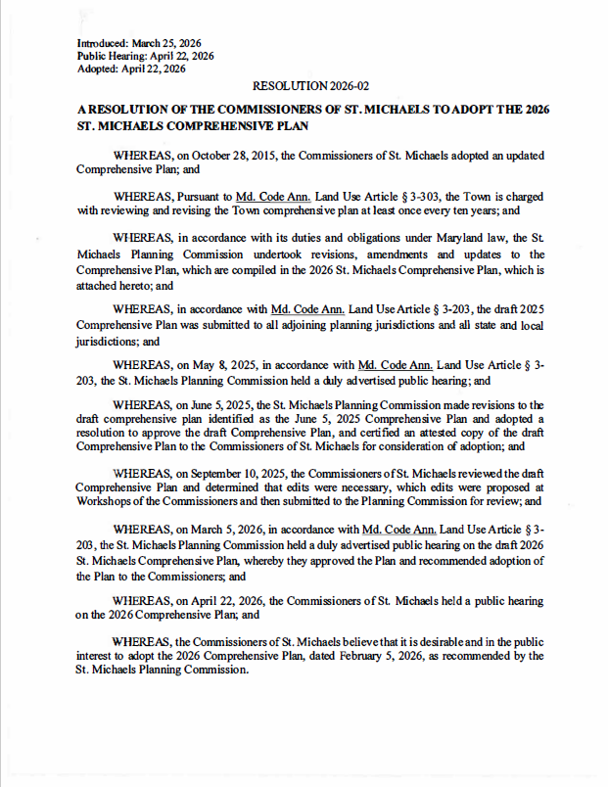
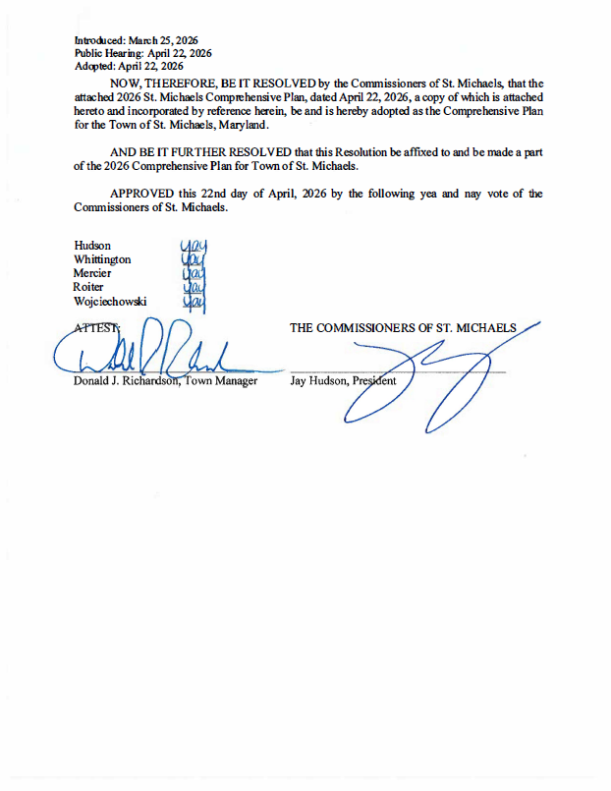
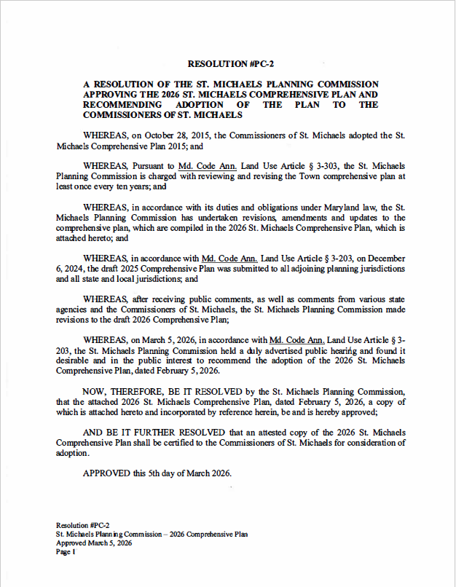

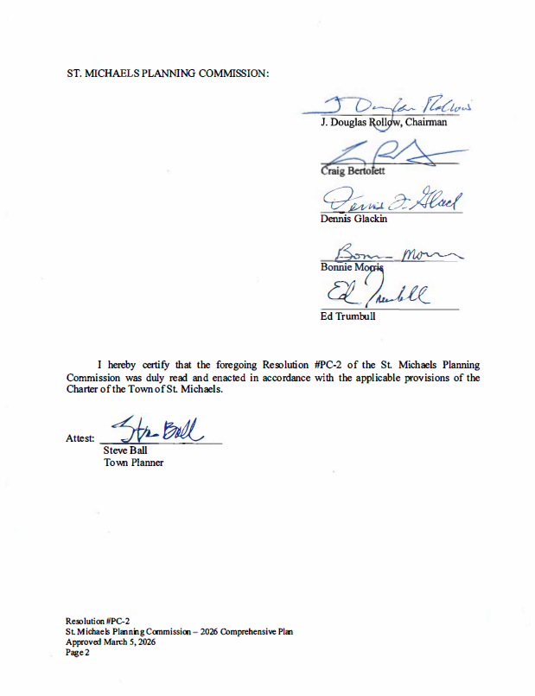

For The Residents of St. Michaels

COMMISSIONERS OF ST. MICHAELS

Jay Hudson, President
Katrina D. Whittington, Vice President
Alexis Roiter, Treasurer
Alfred R. Mercier, Commissioner
David Wojciechowski, Commissioner

ST. MICHAELS PLANNING COMMISSION

J. Douglas Rollow, Chairman
Bonnie Morris, Vice Chairman
Craig R. Bertolett
Ed Trumbull
Dennis Glackin

ST. MICHAELS TOWN ADMINISTRATOR

Donald Richardson

ST. MICHAELS PLANNING AND ZONING OFFICER (Town Planner)

Steve Ball, AICP
(Comprehensive Plan Project Manager)

ST. MICHAELS TOWN MANAGEMENT STAFF

Jen Whiting. General Services Clerk
Kris Kakabar, Customer Services Representative
Kathy Thomas, Code Compliance Officer
Kristen Payne, Town Clerk
Jeff Oswald, Chief of Police
Brian Thompson, Public Works Operations Manager

Additional Map Assistance was provided by

Mark Cahoon, Talbot County GIS Manager

Introduction:

COMPREHENSIVE LAND USE PLANNING:

The Maryland Department of Planning mandates that Maryland counties and municipalities develop 10-year comprehensive plans as a means to provide overarching planning coherence, consistency and guidance that takes into consideration the various other State initiatives (e.g. Sustainable Growth, State Economic Growth Resource Protection and Planning Act of 1992, Requirements of the 2006 Planning Legislation, to name a few).

The 2026 Town of St. Michaels 2026-2036 Comprehensive Plan incorporates elements of the previous 2015 Comprehensive Plan and includes new developments and plans. It is an official long-range policy document adopted and amended through formal resolution by the Town Commissioners. This Plan is a major component of the Town’s planning process as it guides the long-range, comprehensive decision making process involving primarily physical development and those Town actions expected to influence development over the next 10 years. This Plan strengthens the long-standing guiding principles and growth management policies of the Town.

The purpose of this Plan is to give directions to both public and private decision makers so that the most beneficial arrangement of land uses can be accomplished as well as the provision of public services for present and future community needs. This Plan provides a basis for informed discussions by the public and its elected representatives on the future development of their community. It also coordinates decision-making within and between public and private activity as a means to achieve a healthy and balanced environment. To be effective, the Plan must be accepted, understood, and supported by the elected officials who are charged with responsibility for decision making and by citizens who recognize the benefits that can result from good planning. It must also be tailored toward the social, economic, and environmental conditions that prevail today while at the same time promoting a balance between environmental and historical protection and the provision of adequate services and facilities required by the populace in the coming years.

Furthermore, it defines the mission of our local government and a vision for the future of St. Michaels. A core set of values also exist to guide behavior and actions concerning the management of the Town. For staff and residents of St. Michaels, this Plan represents a promise for the future and provides clear direction for the governing bodies of St. Michaels.

The Town has an updated 2024 “Sustainable Communities Plan” that serves as a foundation and enables the Town to qualify for a variety of State revitalization grants related to parks and economic development. The Town recognizes that it has nearly reached complete built-out with few areas (maybe 100 additional homes) left for future growth. Much of Talbot County’s land uses surrounding St. Michaels are designated conservation areas which provide a buffer to effectively prevent sprawl. As a result, any large-scale growth is not expected.

During the comprehensive planning outreach process residents, stakeholders, business owners and others expressed what they most valued about the Town of St. Michaels and identified concerns and issues they wanted to see addressed over the next 10 years. A vision statement and core values were developed as part of the planning process with participation from the public, Town staff and Planning Commission. In addition, updated data gathering and analysis was conducted drawing from 2010-2023 Census Data, 2024 municipal data sources and past planning documents and studies. The following themes emerged from these public input sessions:

- Funding and development of a comprehensive assessment with data, analysis and planning strategy related findings on the impacts of tourism on the fiscal and community resources and aesthetic character and charm of the Town.
- A unified traffic management, parking and pedestrian circulation system that better directs and controls pedestrian and automobile circulation, safety and protects neighborhoods.
- Enhancement of open space, parks and water access. Completion of San Domingo Creek Park and the extension of the north side of the Nature Trail.
- Targeted infill, zoning changes and redevelopment to diversify housing opportunities.
- Enhanced and increased communication between elected officials, County and State staff and community leaders in order to link regional resources with the Town’s financial needs for various public improvements.
- Planning and implementation of mitigation projects related to climate change and sea level rise to keep the viability of the community in the future.

VALUES, VISIONS & GOALS

The Town of St. Michaels continues to be a vibrant and livable community preserving the Town’s strong historic character and long-standing waterfront orientation. We will protect our small-town quality of life by defining and implementing sustainable tourism strategies and promoting environmental stewardship and economic vitality. We value opportunities in housing diversity, arts and culture, connectivity, walkability and transportation options and a limited growth policy concentrating on rehabilitation and redevelopment, quality urban design, parks and open space.

The core values of the Town of St. Michaels are:

Respect: The best quality of life will be achieved when the needs of all of its citizens, taxpayers, business owners and other stakeholders are respected and considered.
Integrity: We will demonstrate honesty and sincerity in all of our dealings, upholding only the highest ethical principles providing open and transparent communications to create informed opinion.
Compassion: We will be sensitive to meeting the requirements of all residents with special needs and interests, and those less fortunate.

Fiscal Responsibility: Elected officials, appointees and staff are always mindful of the need to balance Town services with reasonable fiscal responsibility.
Community Involvement: We will achieve the best quality of life for all of its citizens by ensuring taxpayers, business owners and other stakeholders are actively engaged in the Town’s decision making and work cooperatively to achieve the overall goals as set forth herein.
Innovation and Imagination: We will seek innovative and imaginative ways to address the future, while maintaining the historic character of the Town.

Community Goals are incorporated throughout this plan and are:

- Protect the Town’s historic and cultural resources by continually updating the Town Code and faithfully and fairly enforcing it.
- Invest and keep current with technology and infrastructure that is necessary to serve the Town’s residents, diversify businesses and improve quality of life. The Town should also explore incentives to encourage private investment by technology oriented and service businesses.
- Prioritizing public life and safety improvements when considering budgeting options and trade offs.
- Work with our government partners, in particular Talbot County, to assure decisions regarding new development outside the municipal boundaries of St. Michaels have no adverse impacts on the Town, which includes working with the County to improve the gateway approaches to Town.
- Promote and provide Town services that residents can rely on, and which support the community’s quality of life.
- Strive to make St. Michaels a place where persons of all levels of income and ages can work and live. Promote the development of arts, culture and our historic heritage.
- Continue to promote the health of the harbor and other adjacent waterways.
- Make our Town green through the establishment of programs targeted to tree preservation/planting, stormwater management and recycling.
- Communicate clearly and effectively with the public about Town services and their costs.
- Pursue partnership grant opportunities with State and Federal agencies, non-profits and the public sector which help to fund infrastructure improvements, historic preservation, recreational, educational and cultural enhancements and promote sustainability and resiliency.
The State of Maryland Planning Vision:

On April 8, 2025, Governor Wes Moore signed new legislation into law creating the Sustainable Growth Planning Principles. These 8 principles modernize and replace the former 12 Planning Visions in Maryland law. These new principles guide Maryland's shift from Smart Growth to Sustainable Growth, a more balanced way of managing land use and development. Sustainable Growth focuses on policies that fairly address economic, social, and environmental factors for both current and future generations. The eight Planning Principles aim to make sustainable growth policies simpler, clearer, and easier for everyone involved in planning and development to use effectively.

- Land: Optimize productivity of working landscapes, including farms and forests, and fisheries, and prioritize development within population centers that are in proximity to existing infrastructure and facilities.​

- Transportation: Prioritize transportation networks that create energy efficient, affordable, and reliable access to jobs, housing, and services.​

- Housing: Enable a mix of quality housing types and affordability options to accommodate all who want to live in the state.​

- Economy: Allow for adaptive reuse, mixed–use, and context appropriate new development that responds to changing markets and innovations.

- Equity: Encourage all sectors of the community in the plan development to ensure diverse voices are heard and the needs of underserved populations are prioritized.

- Resilience: Integrate resiliency measures that will minimize the impacts of rapid and unexpected natural– and human–caused threats on communities.

- Place: Provide for public spaces that encourage social interaction and value cultural, historical, and natural resources.

- Ecology: Protect and restore sensitive ecological systems and conserve natural resources, including forests, agricultural areas, and waterways.

The Plan addresses these eight visions through the various chapter elements and is consistent with, and in consideration of, ongoing efforts in the State and Talbot County to work toward these visions.
Ultimately, the Town will be able to guide decisions based on the goals and objectives outlined in the Plan and will continue to develop and move the Town forward cohesively - taking into account the on-going thoughts, concerns and input provided by stakeholders, residents, and businesses alike.
The Plan consists of 12 Chapter elements incorporating the planning visions previously noted by the State of Maryland Planning law. They are carried forward in various chapters of the Plan including Land Use and Growth Management, Municipal Growth and Development Regulations, Environmental Resources and Sensitive Areas Protection, Water Resources, Community Facilities and Public Services, Transportation, Economic Development, Historical and Cultural Concerns, Parks, Recreation and Open Space, Housing, Governance and Communication and Climate Resilience. The Plan concludes with an Implementation schedule (Chapter 13) to be used in phases of the ten-year planning cycle and project budgeting to ensure the objectives and actions are addressed accordingly.
Following adoption of the Plan, the Planning Commission will work with the Town Staff and Commissioners for implementation of the plan as outlined. Priorities are identified as: Priority 1 - occurring in the first five years; Priority 2- between 5 and 6 years; and Priority 3 occurring in 6-10 or more years. Priorities are subject to modification as conditions are likely to change over the next ten years.
In addition to the community planning themes that emerged from public input into the Plan, the Town Commissioners have expressed an interest in making life and safety issues a priority for implementation. This includes pedestrian safety, ADA compliance and sidewalk maintenance, an improved sewer and water services for future demand and system redundancy, broadband internet service, a new public meeting room, and social services provided by the Community Center.
This Plan establishes a framework for sustainability and resiliency for the Town’s future. Competition for limited resources in a small town like St. Michaels means project funding is not always readily available. Considering this, the Town pursues a strategic approach whenever possible. Projects may need to be phased in over time to make them affordable. We utilize the knowledge and commitment of local expertise on various boards and committees, technical assistance from non-profits and consultants, and partnerships with State and Federal agencies to provide grant funding to implement projects which would not otherwise be feasible. Because of these efforts, many of the projects outlined in the Plan are underway and are expected to continue and be completed during the next ten-year planning cycle.
This Plan is the culmination of an inclusive and coordinated planning process with the goal of creating a path forward based on thoughtful decision making. It represents the social, economic, and environmental realities of today, while promoting balanced services, initiatives and infrastructure required for the future. The 2026 Town of St Michaels Comprehensive Plan is intended to fulfill the requirements by the State of Maryland to update the Plan every 10 years. This document fulfills that requirement. Should situations arise interim changes may be made.

DEFINITIONS & DEMOGRAPHICS

Vision Statement. A statement that communicates a compelling vision of the future that is critical to implementing strategies and that answers the question “What will success look like in the effective implementation of the St. Michaels Comprehensive Plan?”
Quality of Life is a condition of one’s existence that can be improved or degraded by land use decisions based on this Comprehensive Plan. For the purpose of this document, Quality of Life includes: health, safety and welfare of the Town; wildlife conservation; clean water in the Bay and its tributaries; clean air and quality drinking water; sufficient and potable water in our aquifers; a low level of crime; employment opportunities; the relative absence of traffic congestion and excessive noise; access to diverse cultural, employment, recreational, education and entertainment activities; convenient access to goods and services and an ethic of personal involvement.
Historic Character. The character or “identity” of a district is established by its form, size, scale and architectural features. Preservation of the integrity of a district or town is based on the retention of historic features, craftsmanship and the tangible evidence of its cultural heritage.
Environmental Stewardship is the philosophy and accompanying actions of valuing and protecting the environment as something held in trust for future generations.
Connectivity. Connecting the community through technology and accessible public transportation, with provisions for safe pedestrian and bicycle access and services which will assure the health and safety of our residents and visitors.
Smart Growth. As per the State of Maryland Smart and Sustainable Growth Act of 2009, Smart Growth concentrates development in areas that have existing or planned infrastructure to avoid sprawl. Smart Growth should support development in areas where infrastructure exists, save our most valuable natural resources, reduce the cost of infrastructure, and provide everyone in St. Michaels with a high quality of life.
Affordable Housing. The U.S. Department of Housing and Urban Development (HUD) defines housing as affordable if the cost of occupying the house does not consume more than 30% of the household’s income. HUD defines housing costs as contract rent plus utilities for renters, and monthly payment (mortgage, taxes, and insurance) for owners. According to HUD, affordable housing is determined based on the Area Median Income (AMI). For homeowners, affordable housing costs do not exceed 30% of the yearly income for those who earn 80% or less of the AMI. For renters, affordable housing costs do not exceed 30% of the yearly income for those who earn 60% or less of the AMI (See Demographic Tables on p. 8).
Workforce Housing. Workforce housing is generally thought of as housing affordable to essential public- and service-sector employees such as teachers, fire fighters, and nurses. It is defined here as housing affordable to households with incomes up to 120% of AMI.
Demographic Overview:

Understanding the population growth of the Town, as well as the trending population dynamics, is critical in identifying future housing, employment, community services and the public infrastructure needs for supporting our vibrant historic community. This information helps inform and ensure that the goals in the Plan serve residents, businesses, and other stakeholders today, tomorrow and in the long-term future.
Drawing upon the 2010 and 2023 Census Data, the population in St. Michaels grew from 1,029 in 2010 to 1,381 in 2023, reflecting a 7% increase. This largely occurred as a result of the COVID 19 pandemic when many part-time homeowners moved out of the cities and were able to work remotely. The 2025 population (American Community Survey census data) was estimated at 1,077. Talbot County’s total population was estimated at 38,750.
The peak Town population since 1850 was in 1960 with 1,484 residents. In 2010 approximately 69% were white and 27% were African American with a slight shift in 2023 to 67% white and 21% African American (although with the COVID 19 influx these numbers are most likely skewed) and 11% Hispanic/Latino. The population of the Town has 70% over the age of 50. For Talbot County there was in 2010 a 23.8% increase from the previous census for those over 65 which rose to a 30.5% increase in 2022 census data indicating an increasingly older population and remains the largest population age group of the community. The median age is 49. Female population accounts for about 60% and male 40%. Eighty percent of the Town’s population have high school degrees and 46% hold bachelor’s degrees or higher.
According to 2020 census data, the Town income levels show 40% of the population fall into the $50k - $100k range, with 5% of the seniors (65+) and 4% of children under 18 living in poverty. If the surrounding the Bay Hundred rural area is included, the poverty numbers are much higher at 9.4% with children at 11% and seniors at 12%. The St. Michaels Community Center provides over 1,000 in-house and delivered meals to the region every month. More of this will be discussed in the subsequent chapters. What this means is there are portions of the population that have difficulty affording to live in this area as well as not having the resources to afford the median priced home valued at $565,600 (2024). The median Town household income is $78,265 while the Talbot County area median income is $106,500 (2024). This data points to the need for affordable and workforce housing and social services support to those struggling families which are discussed in subsequent chapters in this Plan.

St. Michaels Demographic Information Summary Tables

AREA INCOME COMPARISON POPULATION CHANGE

St. Michaels Per Capita Income = $61,244
Talbot County Per Capita Income = $56,059.
Maryland Per Capita Income = $52,979
St. Michaels Median Household Income = $78,265
Talbot County Median Household Income = $106,500
Maryland Median Household Income = $103,678
St. Michaels Median value of owner-occupied housing = $565,600

(1960) = 1,484
(2010) = 1,029
(2023) = 1,381 Covid Era
(2025) = 1,077
Talbot County (2025) = 38,750

ETHNICITY AGE & EDUCATION

Median Age = 49 years of age
Female = 60%
Male = 40%
Largest population group = over 65 age (32.7%)
Education = 80% high school, 46% bachelor’s degree or higher

White: 67%
African American: 21%
Hispanic/Latino: 11%

POVERTY RATES:

St. Michaels = 5.8%
Bay Hundred Area = 9.4%

US Census Reporter & ACS, American Community Survey, 2024
Maryland Department of Planning, 2025

HISTORICAL BACKDROP OF ST. MICHAELS
The Town of St. Michaels is located on the Eastern Shore of Maryland in Talbot County. It has a rich history, is a vibrant community, and a fun place for visitors to come and eat, shop and enjoy the rich culture and surrounding maritime scenery and boating amenities. This section will provide an overview of the history and community character of this place “where land and water meet.”
The earliest mention of St. Michaels by name is in a legal action of 1680 to collect on a bet on a horse race. Earlier, a log building, the first chapel of today's Christ Episcopal Church, was erected on the site of the present church. The parish was named “St. Michaels” after the Archangel, St. Michael. St. Michaels also became the name of the village, the church, and the river (although the river's name eventually evolved to Miles). The actual settlement and development of the Town of St. Michaels did not occur until the middle of the eighteenth century. As with many early settlement churches, the Anglican (now Episcopalian) churches of the time were rural churches designed to be in the center of scattered settlements and not in an identifiable village. St. Michaels is one of the few Eastern Shore communities that actually grew up around its church.
The Town of St. Michaels was laid out as a community by James Braddock in the late 1770s. As an agent for a British merchant firm, Braddock had access to financing and a motive for acquiring the rights of the largest landowner, shipbuilder Philip Wetheral, when he died in 1774. Braddock laid out the Town on the land he bought from Wetheral’s estate and devised a town system of thirty-six lots around a central square. That first square is St. Mary’s Square. He also laid twenty-two other lots on Church Cove and on land along our present harbor. An interesting feature of Braddock’s plan was a special reserved lot for a Methodist church. At the time, Methodism was a breakaway sect from the British crown-supported Anglican Church. By 1783, twenty lots had been sold and several houses built. By 1800, St. Michaels boasted at least thirty dwellings. Braddock’s town was successful and in 1806, the Town was granted its first charter by the State of Maryland. The first two decades of the nineteenth century saw the construction of Federal style homes on Talbot and Mulberry Streets and by the second quarter of the nineteenth century prosperity led to expansion beyond the original boundaries laid out by James Braddock. Development spread north along Talbot Street and into the area of Carpenter Street and Cherry Street. On the south and west side of Town, houses were built in Thompson's Square and Miller's Addition.
St. Michaels continued to grow economically during the first years of the nineteenth century. The main activity was shipbuilding and many of the Town’s residents were employed in the yards or in support activities. Swift schooners, known as “Baltimore Clippers,” were built at St. Michaels. A clipper brig called the “John Gilpin,” launched from the harbor in 1830, set a trans-Pacific speed record which stood for thirteen years, sailing to Canton, China from Callao, Peru.
The importance of the shipyards was demonstrated by the need to protect them from British attack during the War of 1812. An attempt was made to capture the Town and its shipyards in 1813. This raid was repulsed, and the shipyards and the Town saved from further efforts by the British to destroy the yards. The Town’s nickname on the welcome sign says that St. Michaels is the “Town that fooled the British” from the legend that townsfolk hung lanterns in trees outside of Town causing British gunners to overshoot the Town. Following the War of 1812, changes in the national economy and the rise of Baltimore as a ship building town made it difficult for St. Michaels to compete in shipbuilding and the Town went through a period of little growth.
Slavery is also a part of the history of the Town and the County and African Americans were involved in the development of the area as Talbot County had one of the largest populations of “free blacks” as part of that time period. Slavery in Maryland lasted from its beginnings in 1642 to 1864 when Maryland adopted a new State Constitution. Maryland colonists turned to importing enslaved Africans to satisfy the labor demand. The 1850 Federal Census recorded that the Town’s total population was 861 with 723 whites and 138 blacks. Of the 138 blacks 82 blacks were enslaved. During this period African American men were primarily watermen and laborers.
As the prospects of emancipation grew in Maryland, some white landowners sold or gave portions of their property to African Americans. African Americans developed small enclaves of houses and farms that grew in St. Michaels in the late nineteenth and early twentieth centuries. These individuals also built churches, schools, and fraternal organization lodges. A key example of this occurred in St. Michaels when Samuel Hambleton, a War of 1812 veteran, deeded parcels from the Hambleton plantation (which was located on Mitchell St., Lee St., and the Perry Cabin Fields) to Elizabeth Bailey and other slaves. Elizabeth Bailey was Frederick Douglass’ sister, and it is well documented that Frederick Douglas would visit her at her home. As time passed, these areas became St. Michaels neighborhoods that to this day are predominantly African American.
The 1850s brought the beginnings of commercial oystering and fishing in the Chesapeake Bay and in the other rivers of the Eastern Shore. Around that time a new street, Fremont Street, was added to the town. Over the years, several blacks were able to purchase lots there for homes and businesses and important local institutions. For the first time the black community had their own Methodist Episcopal church, a parish house and a school for their children. It was adjacent to the west side of St. Michaels’ main street and had several lots on both sides of the street.
Oystering brought renewed prosperity and a new round of shipbuilding for that industry. Other types of vessels crafted at the boatyards of St. Michaels included pungys, schooners, bugeyes, and skipjacks. Many of these designs are unique to Chesapeake Bay. The area also began to see the development of canneries and processing plants for oysters and later for crabs. Vegetable canneries also became important to the local economy and to farmers in the region.

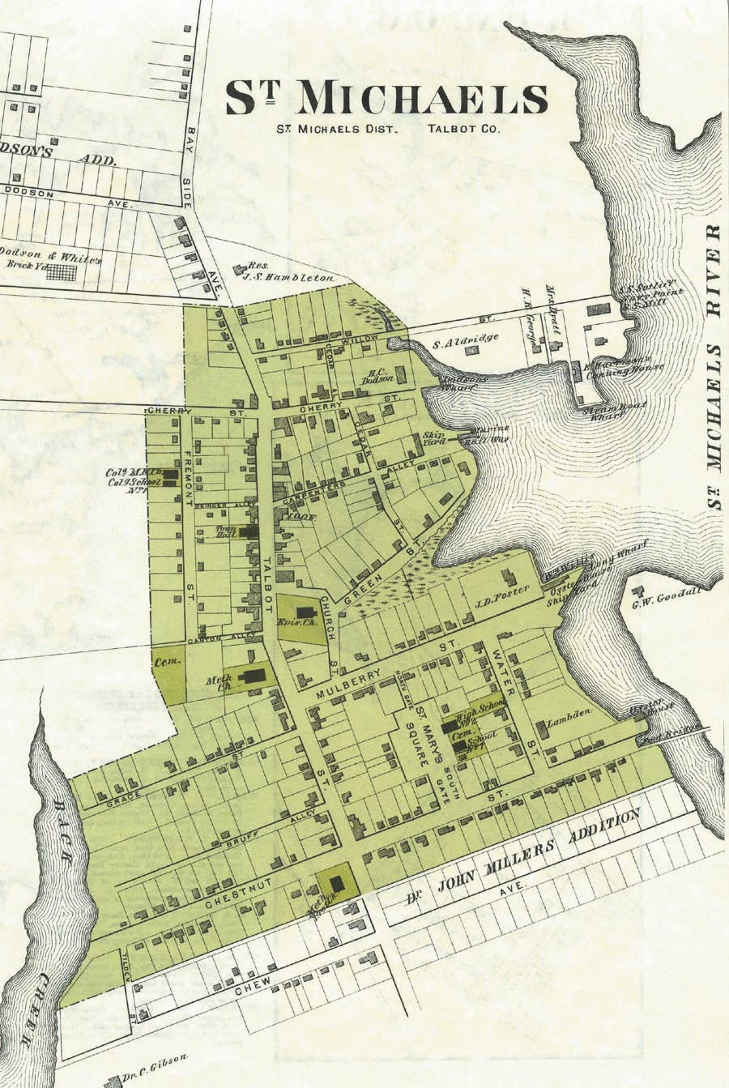
The street system and structural fabric of St. Michaels Downtown and surrounding area have changed very little since 1877 as shown here.

By 1877 the Town showed considerable growth including the development of the northwestern section and the central western area which now makes up the business district. With the exception of growth to the south and west of Town, St. Michaels has changed very little in structural character and design during the past century. Those changes were captured on an agricultural atlas that was published for the Eastern Shore counties in that year, as displayed above.
The extension of the railroad into Talbot County and the advent of steamships stimulated agriculture and fishing by opening markets to the north and across the Bay. In the 1870s, the Episcopal and Methodist congregations built large churches on Talbot Street, and in 1895 the New Union Methodist Episcopal Church was built at the corner of Fremont Street and Railroad Avenue.
By the 1890s, the Town’s population had grown to 1,200 people. St. Michaels continued to grow in the twentieth century, with many bungalows constructed on the south side of Town before the Depression and a number of colonial revival and ranch-style houses built after World War II. However, by 2025 data shows that the Town’s full-time residents had fallen to 1,077, evidence of the changing demographics in the Town with many new retirees and second homeowners. In 2025 there were approximately 300 (19%) part time residents of the Town (See Chapter 10: Housing). Although there are many seasonal residents, the Town also encourages full-time residents to better serve and build a sense of community and continued involvement in activities and decision-making.
Talbot Street, the commercial and main street of St. Michaels, has been the scene of business activity since the eighteenth century. Although no buildings remain from that period, the nineteenth century buildings which line Talbot Street today reflect the influence of architectural styles from the Colonial and Federal periods as well as Greek Revival, Italianate, Gothic Revival and Queen Anne periods. With the exception of a few large public buildings, the architecture of Talbot Street was scaled to residential and pedestrian standards, although evidence exists of combined residential and commercial use from the beginning.
Photographs of Talbot Street from the early twentieth century show large, graceful trees arched over rows of houses and shops with brick sidewalks and an oyster shell roadway in front. The spires of the Episcopal and Methodist churches towered above everything, as they do today. The character of Talbot Street changed radically when modern improvements - water/sewer, curbs, asphalt paving, and utility poles - resulted in the removal of these trees. By the 1920s, Talbot Street looked much like it does today. Recent sidewalk improvements have expanded the red-brick sidewalks in the downtown area to help preserve the character of Town.
The twentieth century brought other changes to St. Michaels. The canneries and the watermen were economic mainstays, but tourism began to play a role in the economy of the Town. The Claiborne Ferry and the construction of the railroad from the ferry to Ocean City helped showcase St. Michaels to visitors from the Western Shore of Maryland. They started to stop in Town and commercial and other services began to cater to their needs.
COMMUNITY CHARACTER AND APPEARANCE
The 1.2 square miles of the Town of St. Michaels is part of the Bay Hundred Area that covers the peninsula area beginning at Royal Oak and ending at Tilghman Island. This region is only accessible through one main road (State Rt. 33) that runs from Easton down the peninsula culminating at Black Walnut Point in Tilghman Island. In one sense this single road feature funnels all traffic through the downtown area benefiting the shops and restaurants, while at the same time, when there are big community events and festivals traffic congestion does occur, especially in the summer months when tourism peaks.
St. Michaels is the only incorporated Town in this larger Bay Hundred Region. The name “Hundred Region” is derived from colonial times and is an English term used to define English “Shires” or “Counties”. It means an area that could produce at least 100 fighting men and was used thereafter to define the “Bay Hundred Region” of the western portion of Talbot County from Claiborne to Tilghman. The Town of St. Michaels serves as the center for commercial services and community facilities for the Town and surrounding communities. Businesses and residents still use this term to define the area and associated services.
St. Michaels is truly a community in every sense of the word. There is a central commercial zone, established residential areas, a well-defined historic district, two protected harbor areas, a library, police and fire departments, restaurants, a community center, museums, parks and nature trails and a K-12 school complex. In addition, the Town residents are quick to volunteer their time to serve on various Boards, Commissions and non-profit organizations. The Town holds a variety of community events, (e.g. Halloween Children’s Parade, Jack Russel Races) and festivals, (e.g. Christmas in St. Michaels, Waterman’s Appreciation Day) that contribute to its sense of place as a small town on the Eastern Shore of the Chesapeake Bay. There is a commitment on the part of the Town to protect its rich history with its maritime past and present, as well as its sense of small town living into the future.
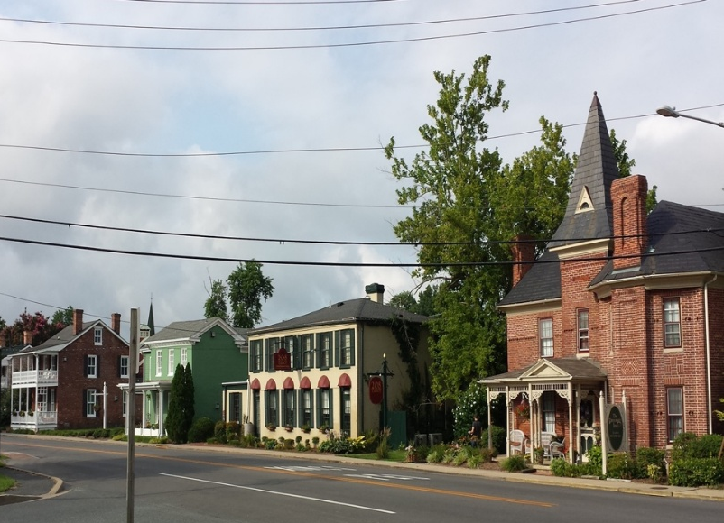
The physical details of the Town, which include building and landscaping elements, walkability and expansive vistas, are important in defining the Town's character. These details influence how residents and visitors feel about the Town, and the Town recognizes the need to preserve and protect these physical details. Throughout this Plan there is discussion of the need to develop town improvements to assist pedestrian circulation, tourism management, signage and streetscape design to mitigate the impacts of tourism on design elements and features important to the community.

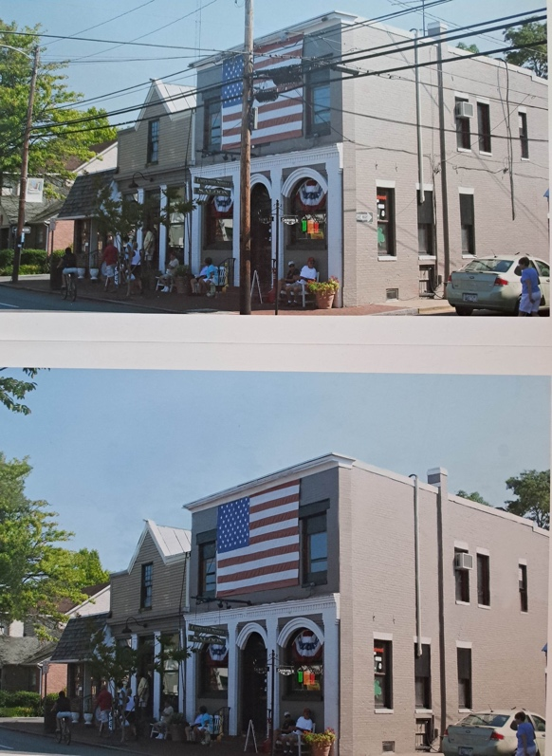
A particular area of ongoing concern is the need to relocate the unsightly above ground utility lines on Talbot Street. The costs of burying them underground or relocating them has been discussed over the years but the costs are prohibitive. Should there be opportunities for this improvement in the future, it will be considered. The photos at left illustrates the effect of removing poles and overhead wires, improving the aesthetic of the main commercial corridor.
The Town’s Zoning Code provides the primary enforcement vehicle for preserving and maintaining the unique town character as discussed in detail in later chapters. For example, the Planning Commission reviews any construction applications or site plan review requests to ensure that new development, redevelopment and infill development are consistent with the design quality of the surrounding development and compatible with the character of the Town. In conserving compatibility, the Planning Commission will take into account setbacks, orientation of buildings, scale, proportion, rhythm, massing, height, materials, roof shape, ornamentation, color, landscaping and accessories among other factors listed in the Zoning Code.
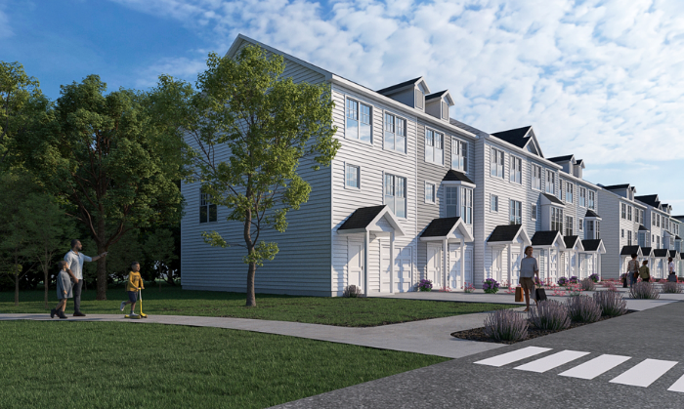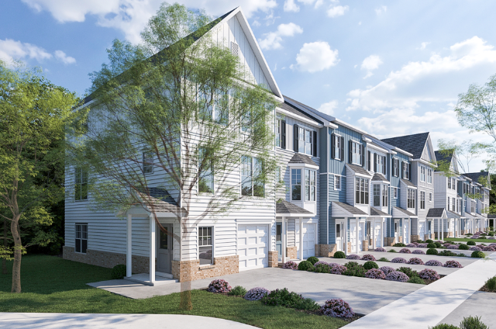
Original Townhouse Design Concept Revised Design after Architectural Review
As we move into the future new challenges include how to best protect our heritage, expand trails and parks with the new waterfront at San Domingo Creek Park, mitigate changes from climate and sea level rise, study the impacts from overuse as a popular tourist destination and the influence and effects of the County on the Town and vice versa. New plans are being considered for a passenger ferry service throughout Chesapeake Bay. Careful planning is needed to manage the additional visitors if that comes to fruition.

In conclusion, the character of St. Michaels is not limited to the historic area or to the physical design or structure of our Town. It is in large measure reflected in the overall quality of its neighborhoods and the neighborliness of our residents. In its most basic aspect, the character of the Town is driven by the character of our people and their willingness to be an active part of this little town.

Chapter 1:
Land Use and Growth Management

INTRODUCTION

The character of St. Michaels has evolved from its rich history as a maritime community to a quaint small waterfront town which provides our residents and visitors a wide array of residential and commercial opportunities. This Plan seeks to maintain our historic character by guiding new development and redevelopment efforts through the creation and implementation of zoning regulations and environmental regulations focused within the Town limits. The Commissioners of St. Michaels continue to support a limited growth policy concentrating primarily on rehabilitation and redevelopment rather than the extension of the Town’s municipal boundaries. There are a few relatively small areas that could be developed within the existing Town limits as further noted in this chapter and also a few other potential annexation areas as shown on the potential growth and annexation map in Chapter 2, Municipal Growth and Development Regulations.
The Town includes a vibrant downtown commercial area as well as a waterfront commercial area consisting of restaurants, marinas and the Chesapeake Bay Maritime Museum. St. Michaels is characterized by a unique blend of waterfront, harbors, public parks, historic structures and wide variety of residential and commercial structures and uses.
Although St. Michaels is a small community, we share some of the same land use, growth, and development issues of larger towns. Our community wants our unique historic water-oriented character preserved. We are concerned about over-development within the Town, as well as inappropriate development in the approaches to the Town. We are also committed to maintaining a healthy environment, protecting our harbors, the Chesapeake Bay, and the Town’s historic feel.
The Land Use Inventory below breaks down the Town’s 1.2 square miles into acreage by zones with a total 791.50 acres of land being used at this time.
Table 1-1
Land Use Area Inventory

Zone | Acres*
Agriculture and Conservation | 144.73
Commercial | 41.55
Maritime | 25.00
Residential | 398.46
Waterfront Development | 26.03
Residential Gateway | 125.77
Public Facilities | 29.96

* Talbot County Public Works, GIS, 2024 Total Town Acres = 791.50
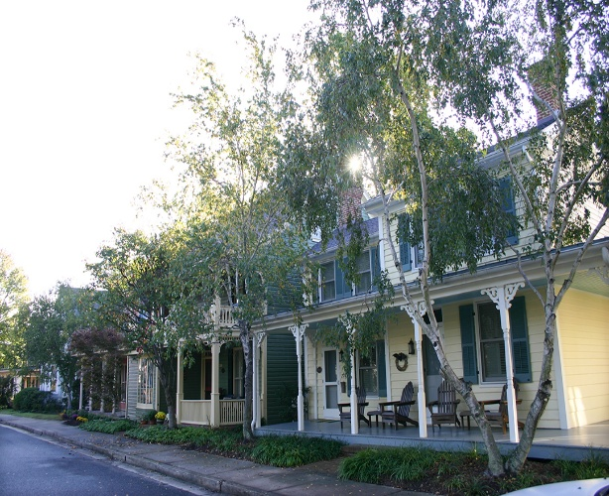
Residential Areas
Approximately half of the Town’s land is devoted to residential use, characterized by single family homes on lots smaller than a quarter acre. As an older community, St. Michaels has many homes and entire neighborhoods that are on very small and/or narrow lots. This gives the Town a village feel while still being in the rural setting of Maryland’s Eastern Shore.

Residential Gateways
Residential gateways include land adjacent to the Perry Cabin ball fields extending to Rolles Range Road at the northern end of the Town and land area known as San Domingo Cove at the southern end of the Town. It is the Town’s intent is to use the Residential Gateway Zone to preserve the existing rural appearance up to the current edges of Town development. This area allows for an entrance into the Town that is gradual and abuts the Talbot County Countryside Preservation Zone, the purpose of which is to slow sprawl by creating a greenbelt.

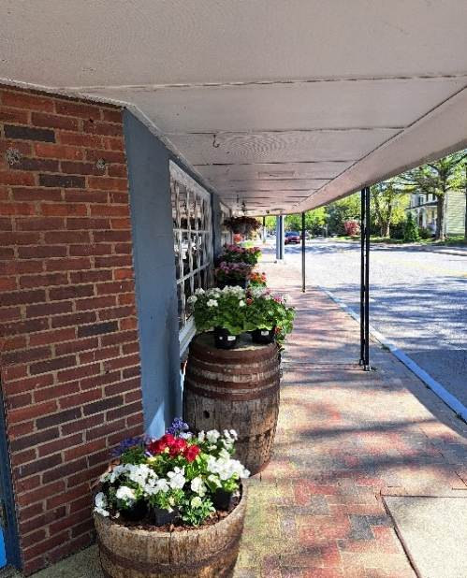
Commercial Areas
St. Michaels has two dominant areas of commercial activity. One commercial section is situated along both sides of Talbot Street and contains most of the shops as well as some restaurants that appeal to tourists. A second area of commercial activity is located adjacent to the harbor. Larger restaurants, inns, and the Chesapeake Bay Maritime Museum are there. Fremont Street, which lies immediately to the west of Talbot Street, has long been recognized as an area suitable for neighborhood commercial redevelopment. In recent years, the Police Station, the St. Michaels Library and several small businesses and restaurants have located in that area. The Town, recognizing the value of this area, invested in stormwater, street and sidewalk upgrades in an effort to promote the continued redevelopment of this street.

Industrial Areas
Much of the industrial activity that existed in the twentieth century has ceased. Some limited manufacturing still occurs in the old mill complex on Talbot Street between East Marengo and East Chew Street. Boat building, electrical fabrication, power generation, and milling either no longer occur or are done at much lower levels of activity. One boat yard has been replaced by the St. Michaels Harbor Inn, reflecting the changing focus away from industry and toward tourism. The only area zoned for industrial use is located at the north end of Grace Street, which is the site of a large building which is utilized for light manufacturing and a power substation.

Waterfront and Maritime Areas
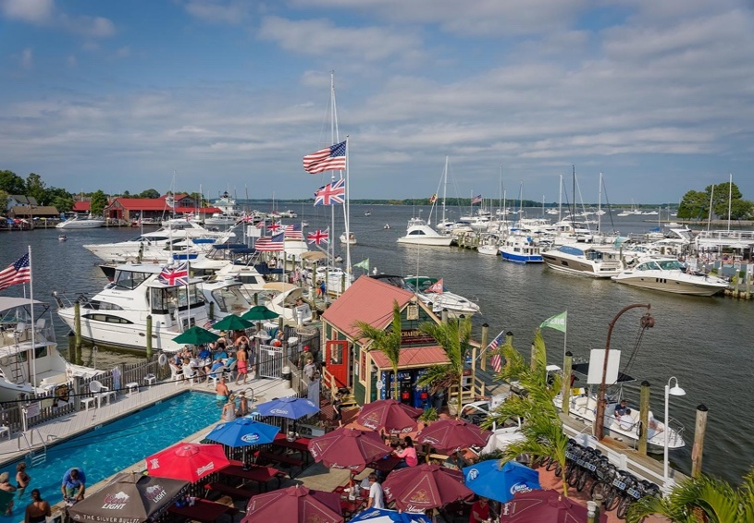
The Maritime Commercial area is a special category of commercial land use related to our waterfront setting which includes commercial activities that are water dependent by their nature. They include a boatyard, fuel dock, marinas, and restaurants and inns that have docks and landings. The Harbor is still a place for traditional Watermen to conduct their business which adds to the local character. Areas designated for loading and unloading commercial shellfish and fin fish should be protected by appropriate zoning and other regulations, as well as, by limiting waterfront commercial activity to the existing restaurants and inns. Currently, both the Chesapeake Bay Critical Area Overlay District (340-27) and the Waterways Management (333) Chapters of the Town Code address water dependent uses and the nature of existing and future development along our waterfront. The Waterfront Zone is intended to promote the development of tourism related activities in the area adjacent to St. Michaels Harbor while preserving historic features and protecting adjacent residential areas.

Museums
St. Michaels is fortunate to have three very different museums: the Chesapeake Bay Maritime Museum, the St. Michaels Museum and the Classic Car Museum. The Chesapeake Bay Maritime Museum is a major presence in the Town, hosting numerous large events and drawing thousands of visitors each year. The Museum’s waterfront campus occupies 20 acres fronting on St. Michaels Harbor. The Museum and its surrounding land carry a Maritime Museum zoning designation which is specific to the use and operation of the Museum. The Museum continues to expand its exhibits and educational programs concentrating on preserving and exploring the history, environment and people of Chesapeake Bay. It recently opened a new visitor’s welcome center with exhibits and outdoor spaces.

The St. Michaels Museum at St. Mary’s Square provides the Town with a window into its past history and character through its ever-increasing collections, three historic buildings and educational walking tours, programs and presentations. It is the keeper of the Town’s history. The Classic Motor Museum located on Marengo Street showcases automotive innovation and adaptation furthering the public’s appreciation of our automotive heritage. In 2025, the Classic Motor Museum acquired the site of an abandoned service station on Talbot Street. It intends to convert the property to an automotive apprentice training facility.

Community Parks
St. Michaels is proud of its myriad of public parks, ranging from small pocket parks located throughout the Town to the three waterfront parks fronting on the Harbor and San Domingo Creek. These parks offer scenic overlooks, passive recreation opportunities, temporary mooring for boaters and a newly created kayak launching ramp. In addition, the Town offers a large children’s park with playground equipment and picnic facilities which lies adjacent to the nature trail which is accessible to pedestrians and cyclists. In 2024, the Town purchased 7.6 acres for a new waterfront park. After extensive public input a master plan was completed for the future development of the San Domingo Creek Park (See Chapter 9, Parks and Recreation and Open Space).

Agricultural and Resource Conservation Areas
Proximity to agricultural and resource conservation activities help anchor the rural setting of St. Michaels and plays an important role in defining the Town's character and sense of place. The transition from agriculture to developed areas establishes a sense of arrival into St. Michaels and is crucial in defining the feel of the Town. The Town has various resource conservation areas near the Town boundaries that limit growth, including Canton Park Farm west of Railroad Avenue. The property known as Miles Point at the northern limit of Town contains 72 acres recently placed under conservation easement and put back into agricultural production, thereby preserving undeveloped lands. Additionally, the Marea Terrace development at the southern entry of Town has a resource conservation covenant along the front portion of the subdivision to help preserve the rural entry on that side of town.

EXISTING LAND USE

Existing land uses typically depict the land uses that are developed or currently designated while the future land uses include all the land uses anticipated for development or growth towards build out. St. Michaels is a small town dating back to the 1600’s with little remaining space for growth. However, there are still a few remaining parcels noted by category below, that provide opportunities for additional future development. (See Future Land Use Map 1-1).

Agriculture Land
There is one agricultural land use property in St. Michaels of approximately 140 acres known as the “Strausburg Farm Property” with an agricultural and conservation land use (see Map 1-1 large green area on north side). It is farmland with a conservation easement over a majority of the site. However, it has an approved 10 lot subdivision which could be developed in the future. There are 60 additional acres of conservation land uses located in the County and sited between the Strausburg Farm property and the main Town boundary that could be added in to the Town in the future but are not anticipated to be annexed at this time. If they were added they would remain in conservation.

Commercial Land
The Town has 41.55 acres of mostly developed commercial land. There are two vacant lots that the Town owned at the corner of Fremont and Canton Street of approximately 13,000 s.f. that were recently sold and anticipated to be developed for commercial uses and one small lot of 4,257 s.f. across the street. There are also some opportunities for redevelopment or second floor additions on existing commercial sites.

Maritime Land
The Maritime Commercial and Maritime Museum areas consist of four commercial sites in town that are developed and currently in use. One site, the Crab Claw Restaurant, was recently sold and is anticipated to be redeveloped and maintained as a restaurant. The Maritime land use also is located on the Town owned property adjacent to the Museum site.

Residential Land
An inventory of vacant residential lots in 2024 found 25 potential vacant residential lots with a majority of those lots located north of Railroad Avenue. Renovation and redevelopment are likely to continue, and some second-floor additions and accessory dwelling units are expected throughout the town.

There is one large Residential Gateway parcel that is undeveloped located on the north side of town adjacent to Perry Cabin Park. It is 27 acres. The zoning restricts this site to 1 unit per acre with a potential of 27 new homes if developed. The property is split by a Department of Transportation right of way currently designated for the future expansion of the existing Nature Trail. There is also a 3 acre (formerly commercial site) located at 929 S. Talbot St. that was recently approved for townhouse development. Twenty seven new housing units were carefully designed to enhance the quality of development at the southern entrance to the Town.

There is a 1.7 acre residentially zoned site on Dodson Avenue. It has a potential of 6-8 new single-family lots. Other sites include a vacant 19,110 s.f. site on Boundary Lane and Talbot St. which the Town is considering selling for residential development and could accommodate several single-family houses or duplexes. Chesapeake Avenue and Miles Avenue also contain a few vacant platted lots but also contain wetlands so new homes would likely be limited to four or five units.

Based on past development trends it is not anticipated to build more than 50 additional residential units in the Town over the next ten-year cycle of the Plan including replacement, new, or accessory housing.
Waterfront Land
The Inn at Perry Cabin is a 24-acre Waterfront Development site. It has a historic main inn with 78 rooms and other recreational amenities. It has a Waterfront Development zoning designation geared towards its particular design with plans to add additional rooms. Master plans include the potential for several smaller hotel or guest buildings that would provide an additional 50 or so guest rooms.

Public Utility Land
Public utility facilities land use includes sanitary sewers and a 29-acre Talbot County Sanitary District sewage treatment site operated by Talbot County. Choptank Electric Cooperative has an electric utility substation on Grace Street. There is a public works storage garage and operations building on Glory Avenue.

The Town provides water service and has two water pumping stations and a water storage tank in Town and plans to develop a third well and pumping station. A site has yet to be selected. It is not anticipated that additional public utility facilities will be developed. The Town administrative office was recently relocated to an existing office building within the San Domingo Creek Park located between W. Chew Ave. and Boundary Lane.
There is not a separate zoning district or land use designation for parks within the Town. They are incorporated into residential land use throughout the Town.

FUTURE LAND USE CHANGES

This Comprehensive Plan focuses on infill, revitalization and redevelopment within the Town’s current boundaries rather than significant expansion of the Town’s municipal boundaries. As such, the in-fill projects previously noted in this chapter have possible changes that may occur for the next 10 years. In accordance with this vision, Talbot County has designated “Countryside Preservation” land uses surrounding the Town as a protective buffer from development. Maintaining that land use designation will ensure the growth of the Town will be focused on in-fill and redevelopment. In Chapter 2, Municipal Growth and Development Regulations areas of potential annexation will be discussed.

Future Land Use depicts the various land uses with the potential for growth as previously outlined. The Growth Tiers Map, Map 1-1 and Map 1-2 are designed to show existing service areas and potential service for future growth. The last part of this chapter includes objectives and strategies to implement the land uses of the Town.

ZONING

While the land use map broadly designates the types of land uses for the various parts of the Town, the Zoning Ordinance stipulates design and development details appropriate for each land use category and implements the Comprehensive Plan. For instance, there is one residential land use category on the land use map, but there are four residential zoning districts in St. Michaels. All these are similar but vary slightly from area to area and the associated detailed requirements for each zone. All of the Town’s zoning districts are described in Section 340-12 of the Zoning Ordinance titled: Enumeration of Districts.

In addition to the standard zoning districts, there are also two “floating zones.” These are a) Growth Allocation Floating Zone and b) Planned Redevelopment Floating Zone. The Growth Allocation Floating Zone can only be applied within the designated Chesapeake Bay Critical Area. It provides opportunities for development uses close to the water and falls under certain environmental protection regulations and standards.

According to the State of Maryland land use regulations, Planned Development Floating Zone is designed to provide flexibility in land use planning and can be applied anywhere in Town. It provides a mechanism to reclassify a land parcel to accommodate new development opportunities or changes in demand. It must meet certain development standards that are compatible with the neighborhood. It allows for flexibility in design not normally provided by regular zoning districts. It also allows the Town to apply conditions for approval based on a conceptual site plan not required under regular zoning rules. It provides an opportunity to review the details of a development plan prior to approval of the rezoning for that property.

VISION

St. Michaels is a town, which, through coordinated and enforced land use management practices, will succeed in protecting and perpetuating its historic character, green spaces, commercial viability, environmental stewardship alongside a vibrant residential community.

OBJECTIVES AND IMPLEMENTATION STRATEGIES

  - Preserve the Town’s unique historic identity in the larger landscape.

    - Support the County’s greenbelt concept to define Town edges and to ensure that County development along the borders of Town does not detract from the community’s image.

    - Continue to participate in the County’s Technical Advisory Committee, providing the Commissioners and Planning Commission an opportunity to comment on any land subdivision or development proposals in locations near Town.

    - Consistent with The Annotated Code of Maryland (2012), establish a process with the County, similar to their existing technical advisory committee, for the purpose of development, annexation and/or rezoning of land within the Town’s “Areas of Interest.”

1.1.4 Schedule regular working sessions with representatives of the Talbot County Planning Commission and the St. Michaels Planning Commission and staff to discuss projects which may affect the Town.

  - Ensure management tools for Town growth are adequate, effective, and consistently executed.

1.2.1. To accommodate planned growth, evaluate existing ordinances and fee structures governing necessary services and community facilities. This includes but is not limited to stormwater management, public water, public sewer, infrastructures, parks, open space, roads and public landscaping.

1.2.2 Continue to review, establish and adopt environmental ordinances as required by State law.

1.2.3 Evaluate policies to ensure that developers pay for all the direct and associated costs of development as well as for independent studies of development impacts when such studies are determined by the Town Commissioners to be necessary.

1.2.4 Ensure that development occurs within those areas as identified on the St. Michaels Growth Tier Map (Map 1-2) as incorporated within the St. Michaels Comprehensive Plan.

1.2.5 Support appropriate infill and mixed-use development projects that are compatible with the existing community fabric.

  - Ensure Town codes are effective, enforced, and simplified to the extent possible.

1.3.1 Review permitting processes and procedures.

1.3.2 Update Zoning Ordinance to implement this Comprehensive Plan as needed.

1.3.3 Update the Subdivision Ordinance to implement this Comprehensive Plan as
needed.

  - Enhance the development of the commercial district.

1.4.1 Continue to work with the County regarding the southern approach to the Town in an effort to implement and strengthen its gateway zoning and to restrict any expansion of this commercial district or intensification of its table of approved uses.

1.4.2 Develop and implement a redevelopment plan for Fremont Street with the goal of re-invigorating this area with commercial activity to include a possible laundromat/dry cleaners and a neighborhood grocery store, for example.

1.4.3 Develop and implement a commercial street plan which encompasses pedestrian corridors, lighting, parking and aesthetics.

1.4.4 Promote the use of funding sources available through the Sustainable Community Program, Legacy Plan and other grant opportunities.

1.4.5 Investigate the benefits to the Town of establishing St. Michaels as a “Main Street Community.”

1.4.6 Encourage business owners to maintain their storefronts in keeping with the historic character of the Town.

1.4.7 Continue to support redevelopment of the Mill area as a mixed-use project.

  - Connectivity.

1.5.1. Continue to evaluate the feasibility of burying or relocating utility lines.

1.5.2 Pursue opportunities to optimize internet accessibility, connectivity and speed for the businesses and residents of the Town in an effort to enhance economic opportunities.

1.5.3 Extend the Nature Trail on the South side to provide safe access to grocery and other shopping. Encourage the upgrade and construction of sidewalks, walking and bike paths, which will allow residents and visitors to pass from one end of St. Michaels to the other with as much ease as possible. Such improvements should enhance the ability of residents and visitors to safely walk or bike to businesses, restaurants, museums and other community amenities.

POLICY

It is the policy of the Town that new development and redevelopment be focused on the core of our Town as to limit outward growth. It is the policy of the Town that existing commercial activity on our harbor shall be protected by limiting commercial waterfront uses to maritime areas.

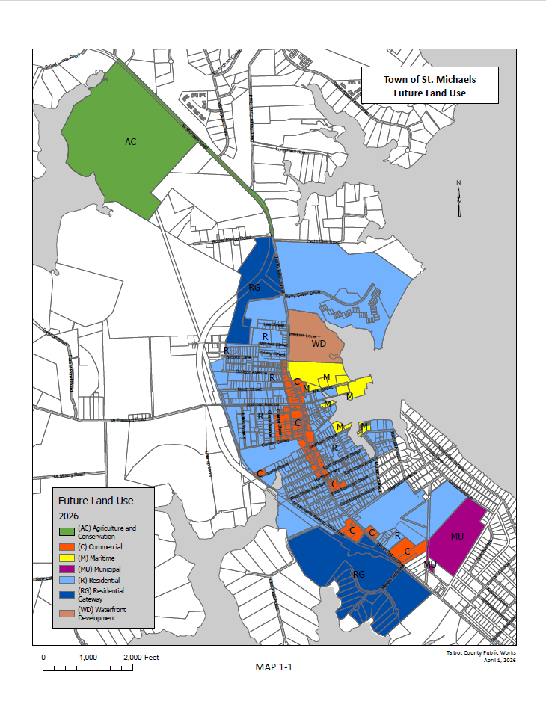
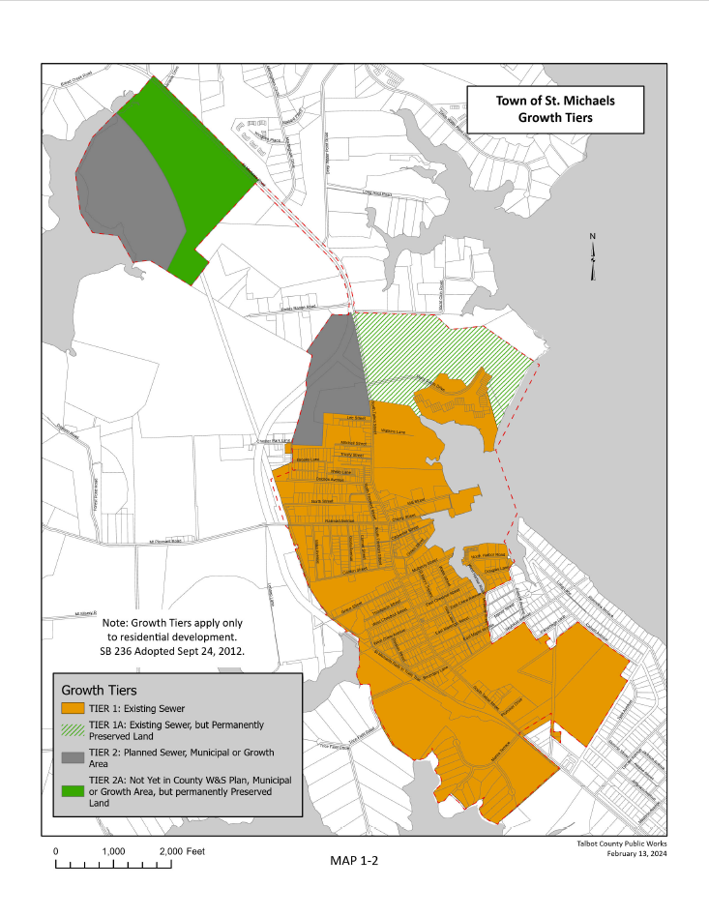

Chapter 2:

Municipal Growth and Development Regulations

INTRODUCTION

This Chapter, Municipal Growth and Development Regulations, is a required chapter and describes the Town’s approach to well thought-out growth and fiscal responsibility. It details a reasonable accommodation for growth, public services needed, protection of sensitive areas, and its broader relationship to the surrounding Talbot County land.

The Municipal Growth Element (MGE) is a required element for municipalities in their comprehensive plans as specified in House Bill 1141 passed in 2006. According to the State of Maryland Department of Planning, the purpose of this requirement is to ensure that communities are realistically planning for growth, that they can serve that growth with public facilities and resources, and they are able to identify the inherent costs to the public. Through the requirement of an MGE, the State is ensuring that all communities are responsibly assessing land annexation for accommodating growth, can serve that growth, and are successfully coordinating with the counties in which they are located. In response to this requirement, this Plan will review development regulations, analyze development capacity of residential and commercial properties, examine areas of potential annexation and mutual interest and assess the impacts of build-out and annexation on infrastructure and services.

Chapter 1 discussed existing land use with a focus on infill, revitalization and redevelopment primarily within the Town’s current boundaries. Chapter 2 seeks to analyze potential growth in the Town of St. Michaels based on existing and projected land use policies pertaining to annexation. It assesses how that growth will impact existing and future facilities and services and examines the impacts of annexation on the capacity of the land and infrastructure particularly in light of the critical nature of wetland preservation and corresponding environmental concerns. Due to the rural nature of Talbot County, water and sewer capacity can pose environmental challenges and are a major component of any plans for growth. The Town of St. Michaels currently receives sewer services from Talbot County and Growth Tiers are mapped consistent with the Talbot County Comprehensive Water and Sewer Plan and comply with the State of Maryland’s SB236 - Growth and Agricultural Preservation Act as it relates to growth tier mapping.

DEVELOPMENT REGULATIONS ARTICLE

The State of Maryland Annotated Code, Land Use Article (Division 1, Title 3, Subtitle 1), which governs the required elements of a comprehensive plan, calls for the inclusion of a ‘Development Regulations Article.’ As such, the Town considers our development regulations to be consistent with Smart Growth-related policies. St. Michaels continues to look for innovative ways to promote social, economic and environmental development and remains flexible in its plans, mostly in the use of general land uses shown in this 2025 Plan and the use of various overlay zones to encourage non-traditional development practices. Development regulations are continuously being reviewed and updated by the Town based on the desires of the community. For instance, in 2023-2024, there were new regulations adopted related to formula or chain store development, tree mitigation, Historic District Commission’s authority, Gateway Commercial design standards, setbacks for accessory uses, cannabis, noise enforcement, outdoor burning and short-term rentals.

ANALYSIS OF DEVELOPMENT CAPACITY AND BUILD-OUT CONDITIONS

As previously discussed, the Town has determined that future growth will be the result of build-outs, in-fills and redevelopment of existing land within Town limits. This section describes the current residential and commercial land use inventory that has development potential.

In conducting this analysis, It was assumed that areas within existing residential and commercial zones would: 1) experience infill development where possible; 2) likely be developed over the next 10 years: and 3) would be similar to historic patterns. Data reviewed includes:

- Residential development records from 2020 – 2024.
- Densities were calculated based on Zoning Ordinance allowances.
- Commercial square footage was considered for vacant land availability and potential projects.
- Commercial growth standard of 10,000 s.f./acre was applied.
- Water and sewer assessment.

Potential Residential Development
Building permit records indicate that infill residential development averaged 7 units per year for 2020-2023. These records show an annexation area, development of one 7-lot townhouse project and a few single-family homes. Some of these included accessory units, 2nd floor apartments and renovations. Considering that most lots in Town are developed, the 2024 land use inventory and research yielded the following potential for this ten-year planning period.

Potential Residential Build Out
Type: Yearly Potential # of Units

Infill, 2nd floor apartments, and accessory units estimated: 2/year 20

Residential Vacant Lots, all of town = 25 (2024) 3/year 24

929 S. Talbot Townhouses = 27 10/year* 27

Dodson Site (1.7-acre site, residential) = 6-8 lots 0/year 8

Residential Gateway (north town site, 27 acres) 0/year 27

Strausburg Site (current well & septic service) 0/year 10

TOTAL: 5/year* 116

*This project is estimated to be built in 2 years following final approvals in 2026. After that time it is expected that the growth rate will return to the projected 5 units per year, unless other plans emerge.

The above residential development areas have sewer/water services.

Potential Commercial/Office Development
As previously noted, there are only a few vacant lots available for commercial/office development. Retail and office spaces typically come and go and are remodeled and renovated over time as new businesses move in. Height limits also restrict vertical development to 2.5 stories. Commercial growth opportunities are noted below:

Potential Commercial Build-Out (10 years)
Gateway Commercial (1 site) 1.8 acres 10,000 s.f./acre = 18,000 s.f

Fremont Street (3 sites) 17,257 s.f. lots @ 25% = 4,315 s.f.

Potential conversion of houses in commercial zones = 10,000 s.f
(estimated conversion of 4 houses 2,500 s.f. over the next 10 years)

Potential 2nd floor hotel (6 units) to Town Center project = = 6,888. s.f.

TOTAL = 30,203 s.f.

Potential commercial build-out areas with sewer/water services.

AREAS OF POTENTIAL ANNEXATION

Previous comprehensive plans anticipated that areas of mutual concern could potentially be annexed into the Town. Although that is still possible, this Plan takes a more limited approach to possibilities for annexation and separates these areas from those of mutual concern between the Town and Talbot County.

There are three designated areas of potential annexation defined by geographic areas: north, west and south. The area east of Town is bound by St. Michaels Harbor and Miles River. The annexation areas are shown in Areas of Potential Growth and Annexation Maps 2-1, 2-1a, 2-1b, 2-1c at the end of this chapter.
North Area (1) Range Rolles Road
One logical annexation area lies between two properties already in the town limits, Rolles Range Road and the Strausburg Farm area, in the northwest boundary of the Town (see Map 2-1). The area is approximately 25-acres in size, is improved with several residential dwellings and a Bed and Breakfast facility. The area has been identified as containing soils having limited suitability for an on-site septic system. This area does not have public sewer but should meet the sewer allocation priority funding criteria required in the Talbot County Sewer Plan. Talbot County has current plans to extend its sewer service to this area. Should Rolls Range Road annexation occur, this Plan recommends that it be zoned for residential use.

Nature Trail Extension Area (2 & 4)
Although it is not a growth area, once completed the extension of the nature trail will create the need to annex the land in between the current Town boundary along the east side of the trail with the trail as depicted on the attached Map 2-1a, Area of Potential Growth and Annexation Areas.

There are two reasons for such. First, the extended 1.3 miles of new trail will need to be patrolled, and activities monitored by the Town’s Police Department to ensure safety of citizens and visitors. Currently, this area is under the Sheriff’s Department jurisdiction, not St. Michaels Police Department. Therefore, it needs to be within the Town’s jurisdiction. Second, the State of Maryland prevents annexations which would result in the creation of an “enclave”, or an enclosed area within the Town’s boundary that technically would remain within the County’s jurisdiction. At least a portion of the Chester Park area (3) would also need to be annexed along with the trail to prevent the formation of such an enclave. The land shown in green on Map 2-1a is undeveloped land owned by the State Highway Administration along with the right of way to be used for the trail.

West Area (3) Chester Park Neighborhood
This area consists of 19 properties and abut the western town boundary. It is a combination of vacant and developed properties with single family houses. The only access is through the Town, and it has existing sewer and water services. The drainage system in this area is being studied, and these properties should be considered in any improvements due to the inter-relationship of drainage systems across boundary lines. In addition, annexing this area would enhance police service for the area.

South Area (5) Commercial/Residential
A fourth annexation area is at the south end of town on Talbot Street (Hwy 33). There are a few existing commercial properties including the St. Michaels Fire Station. Two vacant residential properties could be included with only a few potential houses. Woodside Avenue could also be included in the Town and serve as a realigned entrance to the public-school properties to help alleviate school traffic congestion and hazardous school crossings in this area. A final consideration is that an area may not be annexed by the Town of St. Michaels unless the impact of that annexation has been analyzed and made a part of this element as required by the State of Maryland. The Town recognizes that the inclusion of an area in this element is a prerequisite for any consideration of annexation in the future or, until this Plan is amended. The Town has no immediate plans to expand municipal boundaries.

AREAS OF MUTUAL INTEREST TO THE TOWN AND COUNTY

There are several areas of mutual interest in the County which lie either in immediate adjacency or proximity to the Town boundaries. There are, however, limiting factors affecting these lands. Firstly, Talbot County has extensive Country-side Preservation and Rural Conservation zoning which strengthen growth management policies in and around existing population centers, such as St. Michaels, and limit outward expansion into rural areas. Conservation Lands Near St. Michaels, Map 2-3, depicts the location and extent of this “protective buffer.” Secondly, much of the remaining land around the Town is already developed. For example, in addition to residential neighborhoods, there are gas stations and convenience stores, a small shopping center, hardware store and grocery store to name a few. Consequently, there are very limited opportunities for future growth.

Each area described below corresponds to Map 2-2 (Areas of Mutual Interest) and represents those areas within the County which directly abut or are in proximity to the municipal boundaries of the Town. In general, the areas of mutual concern between the Town and County are as follows:

Area 1 – Miles River Yacht Club
Area 1 is located within the planning area around the Town includes the Miles River Yacht Club. This area is located within Talbot County’s Countryside Preservation Zone and is currently developed in a large estate subdivision. No changes are planned for this area, but homes have individual septic systems to treat wastewater. Consideration should be given to the extension of public wastewater and stormwater facilities to this area to avoid future water quality problems in Long Haul Creek and the Miles River.

Area 2 – Chester Park
Area 2 is adjacent to the Town’s western boundary and corresponds with the location of the extension of the nature trail. The annexation of the existing Chester Park neighborhood as previously noted would be beneficial since access only occurs through the Town and various drainage problems are shared between the area and the town.

Area 3 - Rio Vista/Bentley Hay
Area 3 comprises the subdivisions of Rio Vista/Bentley Hay and is adjacent to the south and eastern boundaries of St. Michaels and adjacent to the Miles River. The communities of Rio Vista/Bentley Hay are served by both community sewer and municipal water services. These areas are currently developed with limited opportunities for additional development or redevelopment.

Area 4 – South Gateway Entrance
Area 4 includes land on both the east and west sides of Route 33, and are located at the south end of Town, defining the entrance or gateway to the Town. A mix of uses are located in this area, including a strip mall, service station, personal service shops, a restaurant and antique sales among others. Within this area, redevelopment over time should be designed to enhance the character of the Town’s Gateway which serves as the front door to St. Michaels. The Town and County should continue to monitor this area with respect to code enforcement to ensure this area maintains an attractive appearance entering into the Town of St. Michaels. Since these properties currently sustain non-residential development, the build-out analysis was not applied to this property.

Area 5 - Tricefields
Area 5 encompasses the existing community of Tricefields. Residents are dependent on utilization of Boundary Lane, a Town street, for access to and from their community. Tricefields is already developed in large lot estate form and is adjacent to the Town’s San Domingo Cove subdivision. This area is currently developed with limited development/redevelopment opportunities. With the approval of the San Domingo Cove Subdivision, public sewer was made available for this development.

Further development or redevelopment in the above areas could impact the Town, and as such the Town has an interest in monitoring such activities. Should the property owners in these areas desire annexation at some future date, the Town would consider such a request. However, it should be noted that annexation can only occur at the request of the property owners and if there is the support of over 25% of the property owners and registered voter residents as required by State law. If that were the case, then the Plan would have to be amended as previously stated in the annexation section above.

ASSESSMENT OF IMPACTS ON INFRASTRUCTURE AND SERVICES

This section describes the impact of build-out conditions on existing public facilities and services in the Town. The information discussed here includes the analysis of the proposed growth, by individual areas and as a total; however, the information is further discussed in other chapters of this Comprehensive Plan. To reduce overlap, further descriptions of the facilities can be viewed under Chapter 5, Community Facilities and Public Services.
Public Schools
St. Michaels’ students attend the St. Michaels School Complex, housing an elementary and middle/high school. These schools can account for a State Rated Capacity of 491 and 503 students, respectively. Currently, the cumulative student population is 758, which is well below the above noted capacity figures. Should the annexation and full build out of the above referenced areas (as shown on Map 2-1) occurs, it is anticipated that an additional seven students could be incorporated in the St. Michaels school population. The calculations for public school impacts use a rate of 0.2 elementary school students per dwelling, and a rate of 0.25 middle/high school students per dwelling.

Libraries
The Talbot County Public Library System operates a branch in the Town. The recently completed expansion project added approximately 3,000 square feet to the facility to accommodate the ever-increasing needs of St. Michaels' residents and visitors. The renovated library is approximately 12,000 square feet offering enough size for a population of 30,000 people, according to the American Library Association.

Public Safety
The potential increase in land area and population will have a minimal impact on the emergency services offered by the Town. The Police Department’s facility is located on Fremont Street. The Town has eight police officers, including the Police Chief. The number of officers is more than the commonly used ratio of 1.6 police officers per 1,000 people. There is currently no need, even with build-out conditions, for more police officers. The Fire Department operates independently and has two engines for use in case of emergency. For further information on public safety, please see Chapter 5, Community Facilities and Public Services.

Water & Sewerage
Based on the total water usage from existing residences, businesses and the residents of Rio Vista who are already on the Town of St. Michaels water system, the Town is within the limits of its Water Appropriation and Use Permit from the Maryland Department of the Environment. Should additional growth and annexation occur, water usage would increase to an estimated 183,375 gallons per day which is still within the limits of the Water Appropriation and Use Permit.

A more detailed discussion of these issues may be found in Chapter 4, Water Resources.

Recreation
Build out is not anticipated to have any appreciable impact on the Town’s parks or recreation facilities.
Stormwater Management Systems
All new development and redevelopment will be required to comply with stormwater management regulations, utilizing both low-impact on-site stormwater management techniques and also off-site techniques, if warranted. These requirements will be governed by the Town and the State to ensure compliance. If it is found that stormwater management issues will arise with additional redevelopment, these areas should be incorporated with new development stormwater management as applicable.

Further discussion of stormwater management is in Chapter 4. Water Resources Element. In addition, Chapter 12, Climate Resilience, discusses stormwater and sea level rise impacts on the land uses of the Town. The challenges from climate change and sea level rise are extensive and the Town is taking a variety of actions to protect the Town and maintain a viable community in the future.

Financing of Infrastructure Expansions
Current analysis of growth shows that the Town already has sufficient infrastructure to manage some of the areas of interest that may be considered for annexation. New development will require water and sewer lines and stormwater management. The Town should continue to require developers to fund costs relating to water and sewer lines and stormwater management systems.

State and County financial help should be examined to help with updating the existing infrastructure for redevelopment areas. Funding opportunities associated with the Town’s Community Legacy programs could be utilized to help maintain streets and create streetscapes. Additionally, Neighborhood Conservation programs will help improve the infrastructure to increase redevelopment potential.

Burdens on Municipally Provided Services and Infrastructure Lying Beyond Proposed Municipal Growth Area
St. Michaels does not have major infrastructure lying outside of its Town boundary, though it does share infrastructure with Talbot County. This includes the Wastewater Treatment Plant (WWTP) currently serving the Town and other County areas. The Town and County should work together to allow for appropriate capacity and expansion. Further discussion on the WWTP can be found in Chapter 4, Water Resources.

Protection of Sensitive Areas
A substantial percentage of the Town’s land area lies within the Chesapeake Bay Critical Area. Included in the Critical Area Regulations as set out in the Town Code are protection clauses to ensure that parcels are developed in such a manner as to assure the protection of the sensitive Chesapeake Bay areas, including the Miles River. National Wetland Inventory and FEMA Floodplain information were used as environmental constraint criteria through this build-out analysis. Wetlands were not counted as developable land and floodplain areas were considered developable given adherence to development regulation.
VISION

The vision of the Town of St. Michaels includes maintaining its historic character, environmental protection, quality of life for residents and economic development opportunities. The areas of mutual interest described in this Chapter ensure that the gateway into Town will develop into areas that welcome people into the Town. Overall, the areas of mutual interest could serve to create functional transition areas into and out of the Town, and/or provide valuable greenbelt opportunities. St. Michaels recognizes that rapid growth and development would have a detrimental impact on the Town’s historic character and as such the placement of regulations which control the type and scale of development and/or redevelopment will be pursued.

OBJECTIVES AND IMPLEMENTATION STRATEGIES

2.1 Ensure future annexations occur within the appropriate zoning classifications as dictated in this chapter.

2.1.1 Preserve those areas identified for possible greenway and/or park/trail
development.

2.1.2 Ensure development is consistent with the Town’s Tier Map.

2.1.3 Monitor growth in residential areas.

2.2 Coordinate with Talbot County to monitor development and for code enforcement on those lands identified as “Areas of Mutual Interest” to assure such development is consistent with the goals of the Town.

2.3 Monitor community and public facilities to ensure that upgrades and additions occur when needed.

2.4 Ensure sufficient police staff exists for increased demands of the tourist industry and population. Coordinate with Talbot County and the Fire Department for emergency services in Town that are not managed by the Town.

2.4.1 Work with the Talbot County Government and the Board of Education to improve a secondary access to the school complex in St. Michaels from Woodside Avenue.

2.5 The Planning Commission shall serve as a recommending body that provides flexible land development regulations and reviews developments to consistency with the Comprehensive Plan.

2.6 The Town’s development regulations shall encourage:
- The use of flexible development regulations to promote innovative and cost saving site design and protect the environment; and
- Economic development through the use of innovative techniques; and
- Streamlined review of applications for development, including permit review and subdivision plat review.

POLICIES

The Town maintains a policy that developers shall bear the costs associated with installation and maintenance of water, sewer, sidewalk, stormwater and other infrastructure related systems caused by new development to reduce the financial burden of the Town and neighboring properties.

It is the policy of the Town that the Planning Commission shall have the powers necessary to enable it to fulfill its functions, promote planning, and execute the purposes of the Code of the Town of St. Michaels.
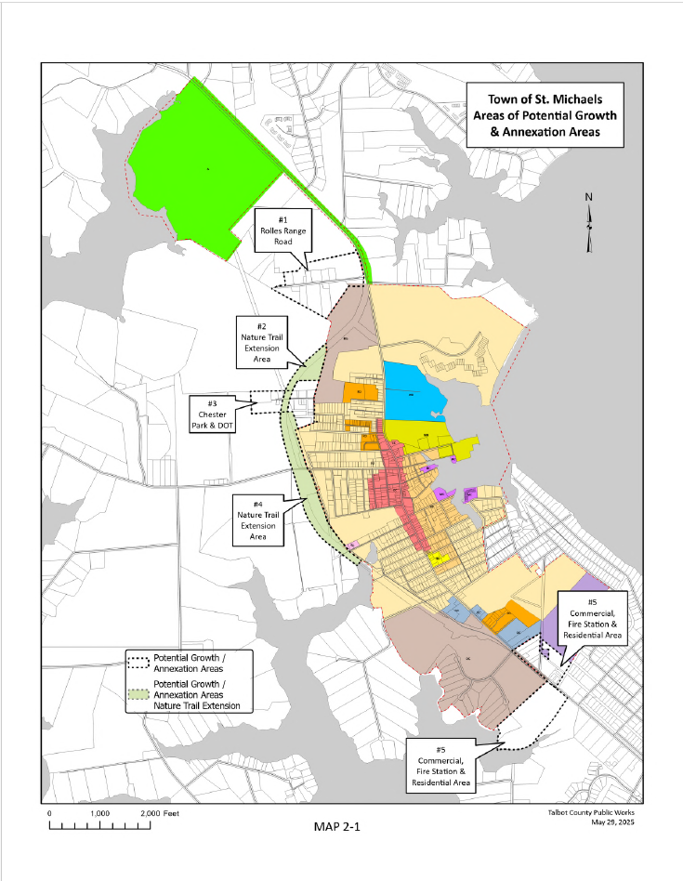
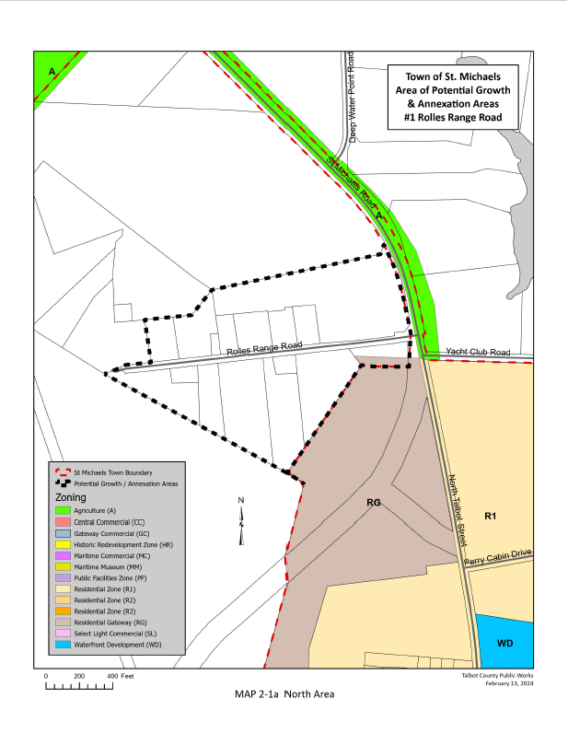
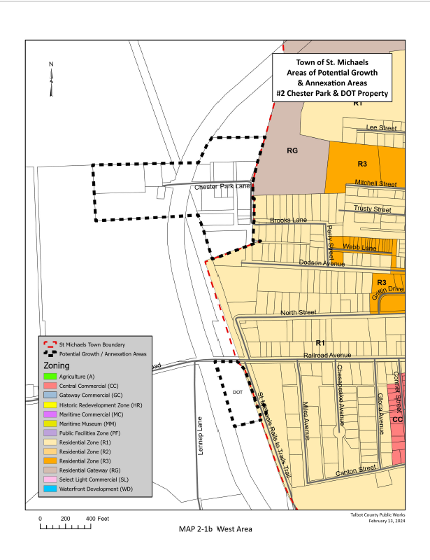
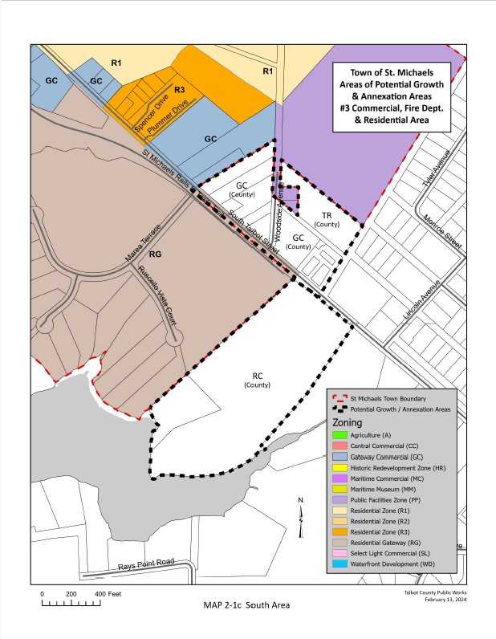
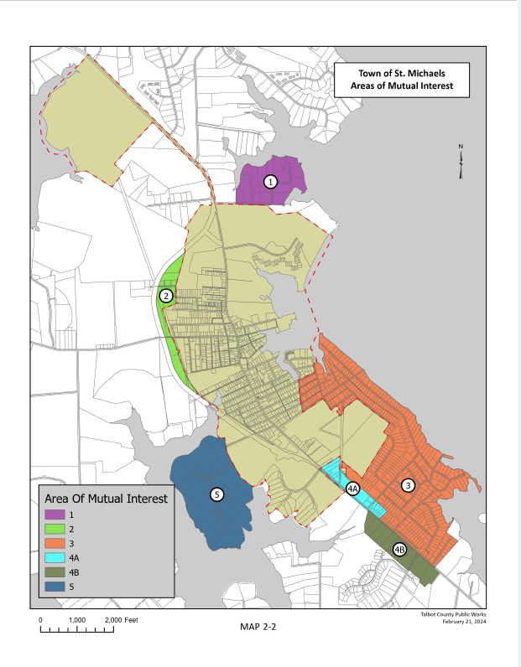
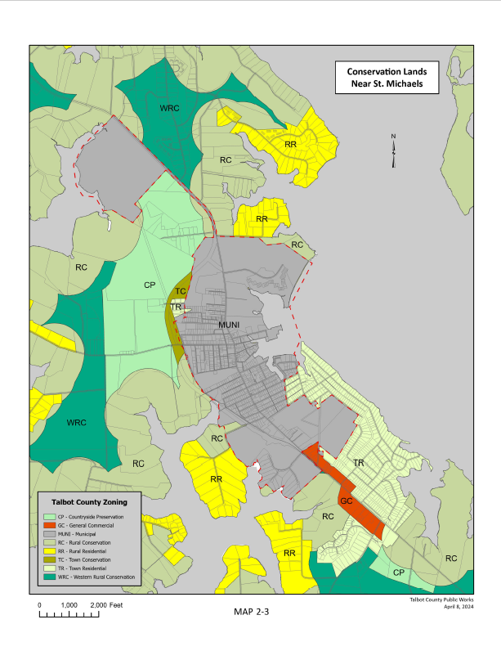

Chapter 3:

Environmental Resources and Sensitive Areas Protection

INTRODUCTION

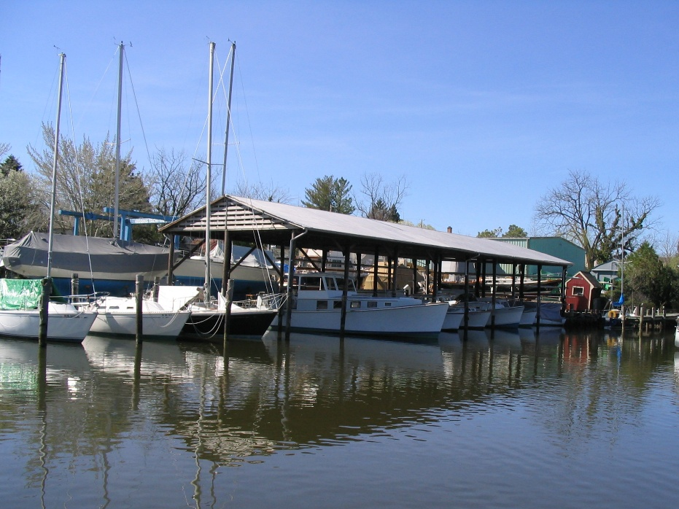
The Town of St. Michaels cherishes its environmental setting. Key components of that environmental setting include a natural harbor opening onto the Miles River and access to the Choptank River via San Domingo Creek on the southwest side of Town. This unique interface “where land and water meet” has made St. Michaels a settlement location since the seventeenth century. The Town’s waterfront orientation has served as the basis of an ever-changing economy that reflects St. Michaels’ connection to these waterfront resources, from an historic economy rooted in boatbuilding, seafood and agriculture, to our economy today which is largely driven by recreational boating and tourism. The economic benefits versus costs from natural resources derived industry is an area of interest for future analysis.

This chapter of the Comprehensive Plan recognizes that the unique waterfront location and landform are among the many environmental resources that serve as the most important defining characteristics of the Town. At the same time, the Town acknowledges that these resources are sensitive to land disturbances prompted by development and by our day-to-day activities. The Town environment’s sensitivity to disturbances underscores the need for stewardship of our environmental setting and natural resources. It is imperative to maintain policies that ensure the life and health of the Town’s water resources. The preservation of our unique environmental resources should be one of the guiding principles in all decisions regarding Town development.

The natural attributes of the landscape continue to influence how and where St. Michaels will grow, despite advances in technology and the capability for altering many site limitations. To great extent topography, drainage, soil characteristics, and other natural features define areas suitable for development. A brief review of relevant characteristics will serve to highlight those features which exert an influence on our growth patterns and identify potential problem areas.

Disturbing sensitive areas can increase the speed and volume of surface runoff from fields and streets, which can lead to land erosion, sedimentation, and siltation. Pollution of the water column and a reduction in the amount of light reaching submerged aquatic plants choke important parts of the aquatic food chain. Ultimately, spawning grounds and benthic habitats are destroyed. In addition, soil particles carry chemicals such as fertilizers, pesticides, and herbicides that have bonded to the soil or leached from farmland and yards into the tributaries of the Bay. Additional pollution is carried by runoff from rooftops, streets and parking lots. Sensitive areas are depicted on Map 3-1 (Sensitive Areas Map). Sensitive natural features that need to be protected include:

- Streams and Stream Buffers.
- Wetlands.
- Woodlands and native vegetation.
- Threatened and endangered wildlife habitats.
- Surface and ground water systems.
- Floodplains.
- Steep slopes
- Protected agricultural lands.
- Open space; and
- Highly erodible and permeable soils (including shorelines)

Topography, Drainage and Steep Slopes

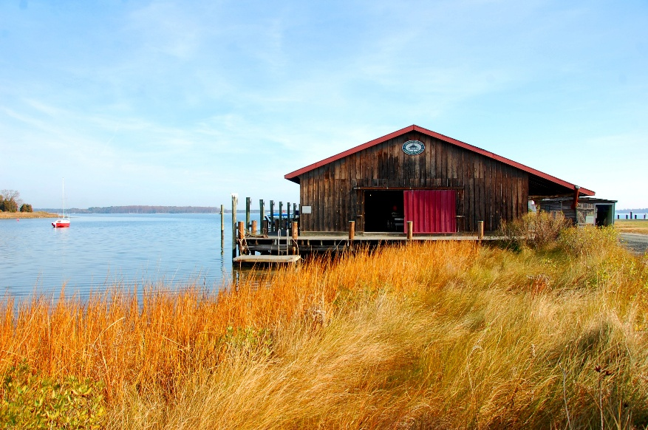
St. Michaels lies wholly within the Atlantic Coastal Plain region and averages elevations ten feet or less above sea level. The land in the immediate vicinity of Town features poorly defined streams and a close proximity to tidal water. Consequently, St. Michaels has characteristically poor surface drainage and a very high water table. The low-lying topography, high seasonal water tables, poor drainage, and high runoff characteristics of the soil combine to create a high flooding potential. When heavy rainfall and a high river discharge combined with storm tides, low-lying areas adjacent to rivers and estuaries become inundated with brackish water.

The underlying unconsolidated sediments slope gently toward the southeast at between approximately 10 to 95 vertical feet per horizontal mile. Beneath the coastal plain sediments lie older Paleozoic crystalline rocks at an average depth of 3,000 feet. Abundant groundwater is available throughout the St. Michaels area with the depth of the water table generally less than 25 feet and within three or four feet of the surface in many places. The maximum elevation in Town is approximately twelve feet along a ridge west of Talbot Street.

There are two drainage areas in St. Michaels with the drainage divide running approximately parallel with, and west of, Talbot Street. The eastern portion of Town drains into the Miles River, and the western portion drains into San Domingo Creek, which is in the Choptank River drainage area.

The irregular shoreline is a result of drowned river valleys formed by the gradually sinking land mass leading to a change in the overall drainage pattern. Extensive estuaries and tidal basins have resulted, producing a myriad of waterways.

Some soil erosion occurs on the shoreline running northeast from the harbor. Soils maps do not indicate the possible existence of steep slopes in Town.

Soil Characteristics

The majority of soils in the western portion of Talbot County, and particularly in the vicinity of St. Michaels, have limiting development characteristics. According to the USDA's Soil Survey - Talbot County, Maryland, the soils in the St. Michaels area are subject to a high water table, creating problems with regard to drainage, erosion, and load bearing capacity. Ten soils predominate in the area; Elkton, Othello, and Barclay Silt Loams are the most common. Approximately 30 percent of the soil in the area falls into the category of Keyport Silt Loam, which is slightly more suitable for development than the previous three and is found primarily near the waterfront and within the corporate limits of the Town.

Ground Water

Talbot County lies in the Atlantic Coastal Plain which is underlain by a mass of sediments resting upon a sloping surface of hard crystalline rock. It has been estimated that not less than 100 million gallons of water a day are available from the layered aquifers. Water is pumped from ten aquifers or bodies of sediments capable of yielding water that range in depth from the surface to more than 1,400 feet. Three of these aquifers are used extensively down to depths of 600 feet.

The St. Michaels municipal water supply derives from wells drilled into the Aquia aquifer formation. The wells yield a good grade of water for domestic use. The water is moderately hard, has bicarbonate qualities, is low in iron, and has safe levels of chloride, fluoride and dissolved solids. See Chapter 4, Water Resources.

Vegetation

The woodlands in the area surrounding St. Michaels are deciduous forest, evergreen forest, or mixed deciduous and evergreen forest. The deciduous areas are generally represented by oaks, hickory, tulip poplar, elm, and maple. The evergreen forests are usually represented by white pine, loblolly pine, and red pine. Some of the wooded lands surrounding St. Michaels have areas of excessive ponding which exceeds the typical high-water table.

Other Features

The Town recognizes that other environmental features should be considered for protection, including but not limited to threatened and endangered wildlife habitats, protected agricultural lands, open space and highly erodible, permeable and shoreline type soils. The Town also recognizes that our waterways are vital to our Town, both environmentally and economically, and will make any effort possible to preserve our working waterways.

Wildlife and Habitat

A variety of natural areas support the biodiversity that is characteristic of Maryland's Eastern shore. Important habitats include uplands, lowlands, deep woods, narrow tree lines, wet meadows, stream banks, woodland edges, and tidal marshes. In St. Michaels, two major habitat features are readily apparent: 1) the Miles River and San Domingo shore areas, and 2) the wooded areas which remain in patches around Town and in the planning area.

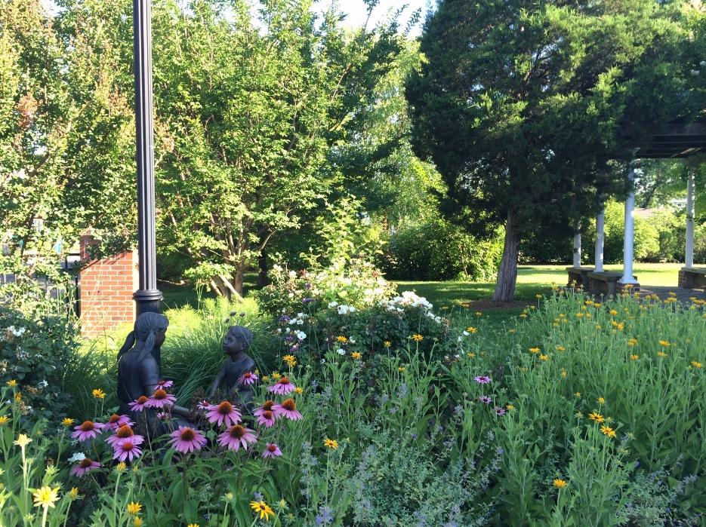
Vegetation, whether cultivated crops, pasture, or the natural vegetation of forests, swamps, and marshes, determines what kinds of wildlife live in a specific area. Cultivated legumes and grasses valuable for wildlife habitat, food, and cover include lespedeza, alfalfa, clover, tall fescue, bromegrass and bluegrass. Valuable native plants include switch grass and other prairie grasses, partridgepeas, desmodium, and various native lespedezas. Trees and shrubs include sumac, dogwoods, persimmon, pines, sassafras, hazelnut, shrub lespedezas, multiflora rose, autumn olive, oaks, hickory, blackhaw, sweetgum, holly, Norway spruce, and various fruit trees. Wetland plants are particularly valuable for food and cover waterfowl and fur-bearing animals. These include smartweed, wild rice, barnyard grass, three-square, bulrush, spikerush, widgeongrass, rice cutgrass, pondweed, duckweed, sedge, cordgrass, cattail, arrow arum, pickerelweed, buttonbush, waterwillow, and spatterdock.

The extensive field-woodland edges north and south of Town provide a home for many species, especially birds. The edge is a critical place for nesting, breeding, hiding, and feeding. Where wildlife corridors are not isolated islands but are linked into continuous bands, woodlands support more species, and contiguous areas become large enough to support predators and larger animals.

Animals characteristic of St. Michaels' habitats includes the following:

1. Open land wildlife such as rabbits and quail,
2. Woodland wildlife includes deer, squirrel, and raccoon,
3. Wetland wildlife including muskrat and various types of waterfowl,
4. Fish and aquatic animals residing in the Miles River and San Domingo Creek basins.

100-year Floodplains

The 100-year floodplain is based on the Flood Insurance Rate Map (FIRM) prepared by the Federal Emergency Management Agency (FEMA). Many sections of Town are located within the 100 and 500-year tidal floodplains, as delineated by FEMA. Lands within the 100-year floodplain are defined as "special flood hazard areas inundated by types of 100-year shallow flooding where depths are between one and three feet.” The 100-year flood is a flood condition that has a 1 percent chance of occurring in any given year and would be caused by exceptionally high tide/storm surges. All of the 100-year floodplain areas in the Planning Area are designated as Zone A." This zone is described in more detail on the FIRM maps for the St. Michaels area.

The Town actively monitors the potential impacts associated with global climate change, the rise of tidal water levels and the severity of storms. The purpose of such monitoring is to ensure that changes to the Town Code can be made as necessary to protect residents and their properties. The Climate Change and Sea Level Rise Commission has a variety of projects that they are currently working on to mitigate sea level rise and flooding (See Chapter 13, Climate Resilience, for details).

Non-tidal Wetlands

Non-tidal Wetlands include important environmental features that support plant and animal habitats important to our rural landscape. These wetland areas also support important groundwater recharge functions. Because federal regulations govern non-tidal wetlands, and wetlands have implications for limiting growth, the Town has identified locations of non-tidal wetlands mapped on the National Wetlands Inventory.

Chesapeake Bay Critical Area Program

In accordance with the Critical Area Act, all affected jurisdictions were required to develop and implement a Critical Area Protection Program to control the use and development within their territorial limits. The 1,000-foot Critical Area boundary is defined as any land 1,000 feet from the mean high tide or landward edge of tidal marsh. The Town of St. Michaels adopted a Critical Area Program along with a series of implementing provisions contained in the Town’s Zoning, Subdivision and Site Plan Review Regulations. The Town of St. Michaels has areas of our developed core, predominately lands adjacent to the harbor and San Domingo Creek that are in a Buffer Management Area. The policies and goals included in the Critical Area Program were developed to accommodate future growth of the Town while addressing the associated environmental impacts. Pursuant to 2008 Maryland Laws 119, effective July 1, 2008, the Maryland General Assembly authorized the Critical Area Commission to promulgate certain regulations for the administration and enforcement of state and local critical area programs. These revised regulations promulgated by the Critical Area Commission, as set forth in Title 27 of the Code of Maryland Regulations, were incorporated into Chapter 340 (Zoning) of the Town Code. The Town periodically updates the Critical Area Code to reflect current conditions. In 2023, a new tree mitigation ordinance that regulates the Intensely Developed Areas (IDA) of the Town was adopted and approved by the Critical Area Commission.

The Chesapeake Bay Critical Area includes all 1000 feet of landward of mean high tide. The three principal land classifications are shown Map 3-2 (Town of St. Michaels Land Use: Critical Area Program) and identified as:

1. Resource Conservation Areas (RCA) in 20-acre minimum aggregates intended for forestry, farming, and resource conservation;
2. Limited Development Areas (LDA) allow housing at a density permitted by the underlying zoning district; and
3. Intensely Developed Areas (IDA) for high density residential, commercial, and industrial uses served by public water and sewer.

About 62 percent of the Town’s critical area lands are classified as IDA. About 30 percent are classified RCA. The remainder is LDA. Conversion of RCA and LDA areas to IDA is the appropriate mechanism for permitting development keeping with the existing character in the Town, while ensuring protection of Critical Area resources. The Town’s Critical Area Code is required to be updated every ten years, and the Town will need to update the code by 2030 to address the recent State enacted legislation related to climate resiliency and equity.

Development of sea level rise mitigation projects will require the Town to work closely with the Critical Area Commission and staff to ensure improvements such as bulkhead replacements and living shorelines are properly designed to comply with the State’s critical area laws.



VISION

St. Michaels is a place where natural resources and sensitive environmental features are protected and preserved.
OBJECTIVES AND IMPLEMENTATION STRATEGIES

3.1 Preserve and protect the important natural features of the Town including streams, wooded areas, wildlife habitats, and other sensitive natural areas.

3.1.1 Establish specific policies for reviewing all activities with respect to impact upon and protection of environmental features and sensitive areas and update these policies as needed.

3.1.2 Review and amend, if necessary, the Town’s implementation documents in order to maintain and enhance existing specific protection measures for the following sensitive areas: 1) stream and stream buffers, 2) 100-year floodplain, 3) endangered species habitats, 4) steep slopes, and 5) wetlands.

3.1.3 Implement the Town Tree Mitigation Ordinance which establishes requirements for reforestation and afforestation when appropriate for those areas which lie outside the Critical Area boundaries.

3.1.4 Augment street tree plantings as appropriate.

3.1.5 Continue to employ environmental protection measures as developed by the State and set forth in the Town’s Critical Area Program. Update the Critical Area Code for consistency with new State legislation.

3.1.6 Evaluate the use of the Town’s Critical Area tree mitigation fund to implement the stormwater management practices which should be utilized in the Town.

3.2 Protect water quality and minimize siltation in St. Michaels Harbor, San Domingo Creek and the Miles River.

3.2.1 Continue to require the use of Best Management Practices to reduce nutrient loadings to the Miles River, St. Michaels Harbor and San Domingo Creek.

3.2.2 Use low-impact development stormwater management measures in the design of any new development. (Chapter 281 Stormwater Management of the Code of the Town of St Michaels).

3.2.3 Review all development adjacent to wetlands to assure compliance with buffer requirements established by Federal, State and Town environmental regulations. (§340-27 of the Code of the Town of Saint Michaels)

3.2.4 Establish specific policies for reviewing all development activities with respect to impact upon and protection of environmental features and sensitive areas including natural drainage ways.

3.2.5 Require structural and nonstructural stormwater management improvements that benefit multiple properties.

- Require the platting of easements and procedures which clearly define ownership and maintenance responsibilities of drainage easements and retention facilities.
- Encourage property owners to adopt Best Management Practices for stormwater runoff and retention for existing homes.

3.2.6 Evaluate future development proposals in light of the site's physical suitability to accommodate development while protecting natural resources.

3.3 Streetscape – Environmental

3.3.1 Encourage residents and businesses to plant trees on their properties utilizing native species.

3.3.2 Develop a strategy for monitoring the success or failure of environmental policies as established by the Town.

3.3.3 Continue to monitor and encourage the use of environmentally enriching plants and features as scientific advances occur.

3.4 Citizen Involvement in Environmental Matters

3.4.1 Work with the Town’s administration to establish a “Friends of the Environment” site on the Town’s website where environmental information e.g. rain gardens, tree and planting guidance, use of appropriate lawn supplements, etc., could be made available to the residents of the Town.

POLICIES

It is the policy of the Town that environmental and natural resources be protected from land disturbances.

It is imperative to maintain policies that ensure the life and health of the Town’s water resources.

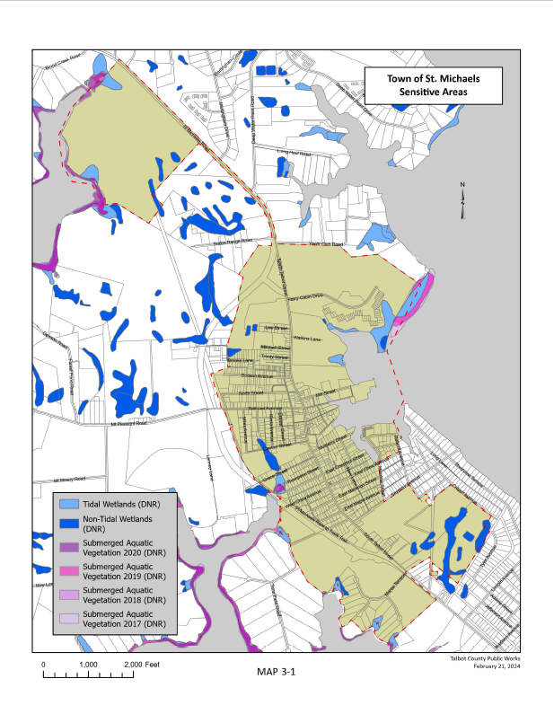
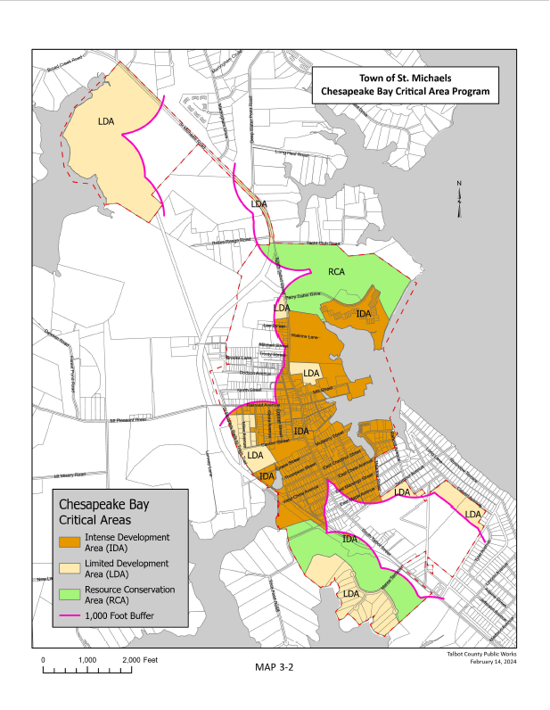
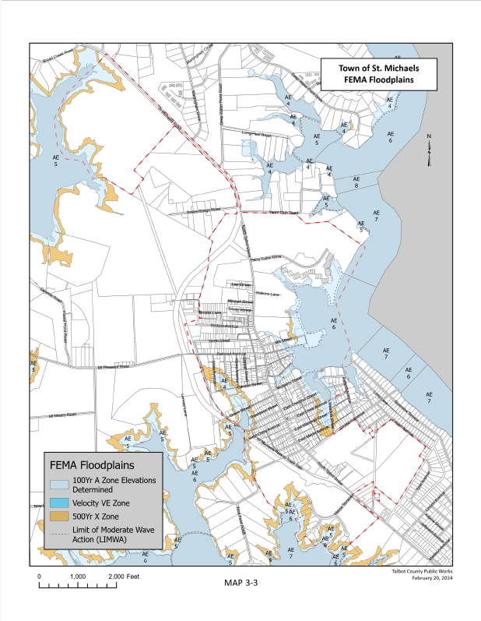

Chapter 4:

Water Resources

INTRODUCTION

The Town of St. Michaels recognizes our shared water resources with Talbot County are vital to overall water quality, especially as it relates to the Talbot County Region II Waste Water Treatment Plant (St. Michaels) and the Comprehensive Water and Sewer Plan. Specific flow data forecasted nutrient loads, equivalent dwelling units (EDU) allocation amounts, and full-service information are maintained by Talbot County, but should be evaluated by the Town as it relates to future developments, water resource upgrades and associated impacts in the region. The Town has limited growth planned but will evaluate growth annually as it relates to the State of Maryland Priority Funding Act and Smart Growth policies for water resources.

The purpose of this Water Resources Chapter is to ensure that any future development plans of the Town of St. Michaels take into account the opportunities and limitations of local water resources. This chapter evaluates both the wastewater generated and the available drinking water supply. This will serve to better protect both state water resources and public health while meeting state smart growth policies.

WATER RESOURCE GOALS

The goals of the water resource element are to:

- Maintain an adequate water supply for the Town of St. Michaels to serve not only the current water demands but future water needs resulting from population growth and development including both residential and commercial capacity.

- Protect and maintain water quality standards by reducing pollutant loadings, identifying potential pollution sources, and potential impacts of future land development to ensure public health and safety. Strategies to achieve this goal include upgrading all town water distribution lines to PVC pipe; ensuring arsenic removal systems on all Town wells result in compliance with Environmental Protection Agency (EPA) standards for arsenic levels; and updating the Town water distribution maps to reflect the most current data.

- Monitor nutrient or sediment total maximum daily loads (TMDL) derived from future development, wastewater and stormwater to determine the least impact on receiving waters.
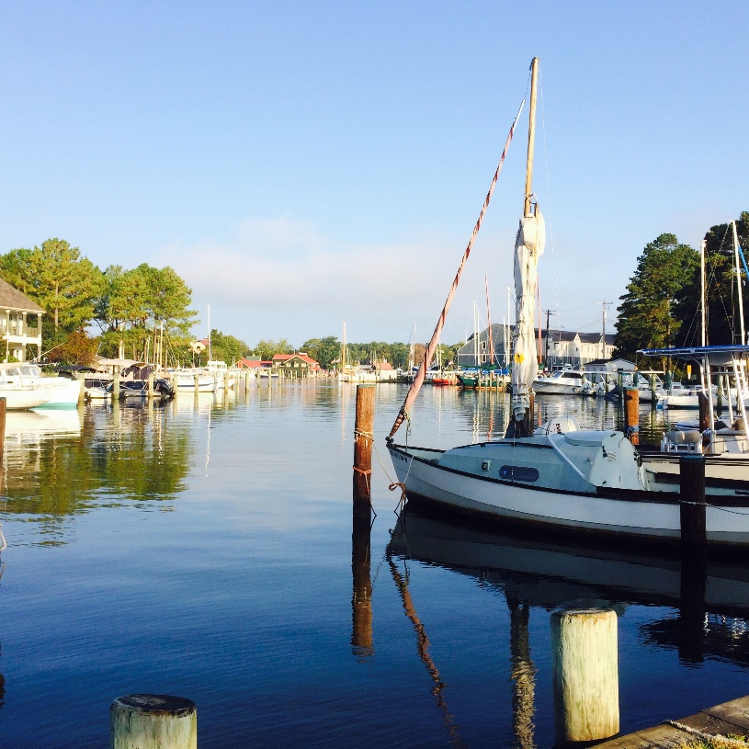
- Provide adequate wastewater and stormwater systems. Costs for new or expanded facilities should be allocated so that they are equitably and proportionally shared by all those who benefit. Technical review of development projects should be coordinated with the required County and/or Town departments to ensure that easements are provided.

- Install stormwater management best management practices (BMPs) to treat water flowing from the older parts of the Town that were built before such practices were required. When doing this work, care should be taken to improve, where possible, stormwater drainage from streets and private lots, but certainly not to make existing drainage problems worse or to create new drainage problems.

A policy has been established to incorporate in all government construction activity, where possible, added stormwater BMPs with the capacity to treat untreated water coming from surrounding parts of Town. Additional BMPs will be included in the nature trail extension project to treat stormwater flowing from the older parts of Town into waters that feed the Bay. Incentives should be developed for owners to install individual lot BMPs, such as roof-top disconnects, rain gardens, and French drains. Town support should be lent to construction of tidal marshes and other programs designed to remove pollutants that continue to enter nearby rivers and streams. Several sea level rise studies include incorporating new stormwater management practices such as building rain gardens and green spaces along the south Harbor area on E. Chew Avenue.

PUBLIC UTILITY SERVICES OF ST. MICHAELS

Water Supply System

The Town’s water system consists of two deep wells, 500,000 gallons of elevated storage, and about 11 miles of distribution mains. Water service is provided to approximately 2,300 people, both inside and outside of the Town. The Town of St. Michaels water system also serves the Rio Vista south of Town. Total water usage ranges from about 0.16 million gpd in the winter to 0.32 million gpd in the summer. Maximum demand for one day has been just over .35 million gallons. Only two of the three wells utilized in the past are currently in operation. Well No.2 is located at the Public Works facility on Glory Avenue, and well No. 3 is located on the east side of Marengo Street at New Lane.

Both wells are about 450 feet deep and draw from the Aquia Aquifer. Well No.2 is a ten-inch well drilled in 1965 with an operating capacity of 325 gallons per minute. Well No.3 is a 16 inch well completed in 1990 with an operating capacity of 350 gallons per minute. Both wells No.2 and No.3 are in good condition. However, in order to provide redundancy in the system in case of well failure an additional well and water storage tower will be needed. The Town is currently undergoing a capacity management network analysis to determine the proper need and location of a potential 3rd well. Although projected demand remains within permitted limits, having a third well will create the desired redundancy in the system in case of emergencies such as occurred in 2024 when a well house caught on fire and was off-line for a few weeks during repairs.

Maryland’s approval guidelines stipulate that community wells be capable of meeting the maximum daily water demand with all wells in service and be able to meet the average daily demand with the largest well out of service. The Town’s system meets these criteria, assuming the pumps run an average of 16 hours per day.

The 500,000 gallons of elevated storage are one 200,000-gallon tank and one 300,000-gallon tank. The 200,000-gallon tank, constructed in 1981, is in good structural condition, but requires periodic painting. The 300,000-gallon elevated storage tank, referred to as the North Tank, located next to Perry Cabin Park has been in operation since 1999. By locating the tanks at the opposite ends of the water system, head pressure losses in the distribution lines are minimized and flow rates have improved. The Town has installed a new Supervisory Control and Data Acquisition (SCADA) system that controls the on-off operation of the No.2 and No.3 well pumps, as well as monitors the North and South tank levels. This system enables the operations staff to closely monitor the Town’s water supply and make necessary adjustments. The Town installed new “Smart” Water Meters in 2023 in order to more precisely monitor individual site water consumption, detect leakages and improve customer service.

The natural arsenic level in the water in St. Michaels is 34 ppb. The Town has constructed arsenic removal plants at both wells, using various removal techniques with a media that attracts the arsenic to the media particles. Recent testing (2023) indicates this system has been successful. Also, the federal Environmental Protection Agency has recently mandated a lead pipe analysis and mitigation effort for all communities in Maryland and across the country. The Town is actively engaged in the first phase of inventory work to identify any existing lead pipe and will follow up with any remediation efforts that may be necessary. As of the date of this Comprehensive Plan, none has been identified.

The Maryland Department of the Environment (MDE) is the agency responsible for authorizing the use of all waters of the State. MDE issues the required Water Appropriation and Use Permit. The permit authorizes the Town of St. Michaels a water withdrawal limited to a daily average of 325,000 gallons on a yearly basis and a daily average of 450,000 gallons for the month of maximum use.

Growth Assessment

Based on the ten-year development potential analysis completed in Chapter 2, Municipal Growth Element, it is estimated there is land available in the Town of St. Michaels to add an additional 50 residences over the ten-year planning period 2025-2035. Applying the estimated average household size and the average water usage, these possible residences could use an additional 11,250 gallons of water per day.

To calculate the daily water usage for the Town, it was estimated that the average household size was 2.25 persons (2020 Census), and the average water usage level of service is 100 gallons per person per day. 2020 census data indicates that 38% of residents live alone, but the 2.25 multiplier is used to account for fluctuations in population with visitors. Based on the existing 719 accounts, each using an estimated 225 gallons per day, a total of 161,775 gallons of water is being used per day for planning purposes. Current records indicate that system-wide demand remains below the estimated level of service use. This can be for a variety of reasons such as seasonal housing and commercial tourism fluctuations. It is expected that summer use will increase consumption but remain within capacity levels. The new capacity management analysis should account for such fluctuations.

In addition, there are three possible annexation areas which are described further in Chapter 2, Municipal Growth Element. Some of these areas have sewer and water services. If these areas were annexed it would not have any significant impact on services as factored into the potential growth analysis.
TABLE 4.1
EXISTING AND POSSIBLE FUTURE WATER USAGE

Current Water Accounts | Estimated Demand Per Day  (gpd = Gallons Per Day)
Town Service: 719 | 161,775 gpd.
County Service: 437 | 98,325 gpd.
Existing Usage Total | 260,100 gpd.
Potential Growth Demand, 10 year*
Residential Units (50) ten year growth estimate | 11,250 gpd.
Residential Units (27) current townhouse project | 6,075 gpd.
Hotel Expansion Units (50) | 11,250 gpd.
Retail/Office (12 businesses) | 1,891 gpd.
Restaurants (6 new) | 10,500 gpd.
Additional Usage Total | 40,966 gpd.
Total Combined Projected Use | 301,066 gpd.
* Methodologies vary for business, restaurants

Based on the total water usage from existing residences and the residents of Rio Vista and Bentley Hay (437 du) who are already on the Town of St. Michaels water system, the Town of St. Michaels is within the limits of its Water Appropriation and Use Permit (325,000 gpd) from the Maryland Department of the Environment.

Nonresidential growth is projected to have 49,203 square feet of combined restaurant and retail/office uses. Water demand was calculated based on average available land and capacity of use per 1,000 square feet for retail/office use and an average of 70 gallons per seat for restaurant uses. It was assumed there would be about twice as much retail/office growth as restaurants. This resulted in a projected increased demand of approximately 23,641 gallons per day for non-residential use related growth along with 22,500 gallons per day for residential growth. The combined residential and commercial water demand to accommodate growth is projected to be 40,966 gallons per day (See Table 4.1). Total water demand to accommodate existing usage and growth is forecasted to be just over 300,000 gallons per day and within the overall water use permit restrictions.

If the Town of St. Michaels experiences modest growth as forecast and if the possible annexation areas were annexed and fully built out, the total water usage would still be within the limits of the Water Appropriation and Use Permit.

Sewer Service

Talbot County owns and operates a 1.0 million gallon per day sewage treatment plant serving the Town and surrounding area. The County sewer treatment allocated capacity assigned to the Town is 494,500 gpd. There are two other areas that are around the town and are serviced by the sewer plant. This includes the Rio Vista area, which is allocated 70,000 gpd and the Bentley Hay area which is assigned 29,800 gpd. There are three sewage pumping (or transfer) stations in the town: one on Green Street, on Mill Street and one on Grace Street. There are a few others, one outside of town in the Rio Vista area (Madison) and a grinder pump station located in the Perry Cabin development. Another grinder pump system is in place to service Brooks Lane and Chester Park areas.

2024 information available from Talbot County relating to wastewater treatment flow and capacity volume of the Talbot County region II Wastewater treatment Plant allocated for use within the municipal boundaries of St. Michaels indicates the following:

St. Michaels Town Only – Existing flows: 176,000 GPD*
Future Flows, Residential (10 years growth): 40,966 GPD**
Reserved Capacity for Infiltration & Inflow: 151,600 GPD*
Total Flows: 368,566 GPD

*(Talbot County Sewer & Water Plan, County web site, 2024)
** (From Table 4.1, p. 4)

Based on the potential growth as noted before in the next ten years in accordance with future land use in the Town of St. Michaels and taking into account the existing proposals enumerated above, an additional 50 units could be built in the existing Town limits. Assuming flow contributions of 200 gallons per unit, the Town could contribute an additional total of 10,000 gpd.

As the annexation analysis indicates, the potential demand for additional development due to annexation would be 50 units. Assuming that each would contribute 200 gallons per unit additional flows would be 10,000 gallons per day. It is clear that full build-out is not constrained by sewer capacity. The demand from the Town of St. Michaels for sewer service is well below the treatment capacity of the sewer plant. Development within the Town and in the County contribute to the sewer plant treatment demand so it is important to monitor the use and treatment capacity over time to stay within permitted limits.

Additional capacity may be gained by addressing infiltration and inflow (I&I). County policy makes it clear that the Town of St. Michaels does not gain 1 gallon of capacity for every gallon of I&I reduced. Nevertheless, any reductions achieved should be documented and the capacity gained incorporated into the flow allocation calculations.

Capacity Management Plan

Current State regulations require that a wastewater capacity management plan be established to manage new hookups when flow in any system reaches 80 percent of capacity. As the Region II Wastewater Treatment System is owned and operated by Talbot County, the preparation of any such capacity management plan would be the responsibility of the Talbot County Department of Public Works. The Town of St. Michaels would assist in any data and participation necessary for any required capacity management.

POINT AND NONPOINT SOURCE STORMWATER

According to Chapter 281 of the Code of the Town of St. Michaels (Town Code), the purpose of proper stormwater management is to minimize damage to public and private property, reduce the effects of development on land and on the quality of water in the Chesapeake Bay and its tributaries, control stream channel erosion, reduce local flooding, and maintain after development, as nearly as possible, the predevelopment runoff characteristics.

The objectives of stormwater management are to:

- Reduce or eliminate water pollution by reducing the amount and nature of impervious cover, increasing groundwater recharge, eliminating sources of contaminants, and removing pollutants from stormwater runoff.
- Design, construct, operate, and maintain stormwater management systems to control runoff from all land developed in accordance with Chapter 281 of the Town Code.
- Design stormwater management systems used for new development to the limit of technology and meet any pollutant removal goals established by the Town for a specific project.
- Ensure the use of decentralized nonstructural stormwater management practices to the maximum extent reasonably practical; and
- In conjunction with a proposed stormwater management system, establish controls and enforcement procedures applicable to the land area to be served by that proposed stormwater management system, to reduce the unnecessary use of pollutants on that land.

Stormwater management practices that control and manage stormwater runoff are to be applied to any land developed for residential, commercial, industrial, or institutional uses in accordance with an approved stormwater management plan. Stormwater management practices should be designed, constructed, and operated in accordance with the standards set forth in the Stormwater Site Design Manual of the Critical Area and Chapter 281 of the Town Code.

The Town has actively engaged in a variety of stormwater management improvements throughout the community. Sea level rise and nuisance flood mitigation efforts are currently in the planning stages. Recent efforts are outlined in more detail in Chapter 13, Climate Resilience.

A variance can be granted from any requirement of the Stormwater Management Criteria of Chapter 281 of the Town Code by the St. Michaels Board of Zoning Appeals if extenuating circumstances are met. More information on the special circumstances to be met can be found in Section 281-9 of the Town Code.

For any proposed development large enough to require a stormwater plan, the owner must submit a stormwater management plan or waiver application to the County for review and approval.

- Prior to granting approval, the Town shall review the plan to determine compliance with the requirements of the stormwater management code. The process for the review shall be the same as for applications for subdivisions and shall include a review by the Technical Advisory Committee.
- Major projects shall not be approved earlier than 45 days after a complete application is received by the enforcement authority.
- The approved stormwater management plan shall serve as the basis for all subsequent construction.

Notification of approval or reasons for disapproval or modification shall be given to the owner. If a decision is not made within 90 days, the owner shall be informed of the status of the review process and the anticipated completion date. The stormwater management plan shall not be considered approved without the inclusion on the plan of the dated signature of the Town.

There is not yet in place a Total Maximum Daily Load (TMDL) strategy which affects St. Michaels, but the Town is trying to do its part to reduce pollutant loadings by imposing the 10 percent pollutant reduction standard on those lands which lie within the mapped Chesapeake Bay Critical Area. It should be noted that approximately 75 percent of the Town lies within that area. In addition, the Town has adopted a no net loss policy for the removal of trees. Any tree removed must be replaced on an equal basis, utilizing the requirement that the tree be 2” in diameter at breast height and be of a native species.

The Town recognizes the impact of lawn-applied fertilizer on the water quality of our rivers. The State of Maryland is requiring home improvement and similar stores to begin selling non-phosphorous lawn fertilizer. This will hopefully help to reduce the negative water quality impact associated with lawn fertilization in the future.

VISION

The Town of St. Michaels seeks to protect its water resources and control development to allow for the conservation of these resources.

OBJECTIVES AND IMPLEMENTATION STRATEGIES

4.1 Ensure that the Town has an adequate safe and sanitary water supply.

4.1.1 Continue to coordinate water system master planning with the Town’s Comprehensive Plan and Tier Map.

4.1.2 Continue to construct the capital improvements as required to satisfy the Federal Government’s standards for arsenic levels.

4.1.3 Develop a monitoring and remediation process for analysis of lead pipe in the water system as required by the federal government.

4.1.4 Complete a water network capacity study and plan for a future 3rd well site if needed.

4.2 Provide adequate wastewater treatment service for the Town.

4.2.1 Encourage the County to continue their efforts to reduce infiltration and inflow in the sewer system to create additional capacity.

4.2.2 Continue to coordinate sewer planning with the Town’s Comprehensive Plan.

4.2.3 Continue to work with Talbot County to assure that any modifications to sewer allocations will not diminish the Town’s ability to grow in accordance with this plan.

4.3 Effectively treat stormwater runoff and reduce pollutant loadings entering St. Michaels’ waterways.

4.3.1 Incorporate the latest guidance and requirements as found in State design criteria.

4.3.2 Provide educational opportunities focusing on water quality improvement methods which can be implemented by individual property owners.

4.3.3 Consider incentives which may encourage the residents and businesses to pursue the best on-site management practices.

4.3.4 Review the effectiveness of the existing practice of installing silt fences at construction sites. Adopt policies that establish more effective run-off protection and/or ensure more careful monitoring by responsible inspection agencies.

4.3.5 Continue to work cooperatively with Talbot County to obtain grant funding for projects that address water quality in the Miles River and San Domingo Creek.

4.3.6 Continue to work with Talbot County and the State of Maryland to develop comprehensive projects and strategies to improve the water quality of stormwater runoff.

4.3.7 Consider converting open ditch systems to bioretention systems in an effort to address water quality associated with stormwater.

4.3.8 Program and seek funding sources for stormwater management mitigation projects relating to sea level rise and nuisance flooding.

POLICIES

The Town maintains a policy to continue joint efforts with Talbot County relating to future water resources. The Town will continue to collaborate with the County to ensure mutual services for water and sewer services are available to serve the Town and County mutual service areas.

It is the policy of St. Michaels that future development plans are evaluated on wastewater generated, available drinking water and stormwater mitigation to protect water resources and public health while meeting State smart growth laws.

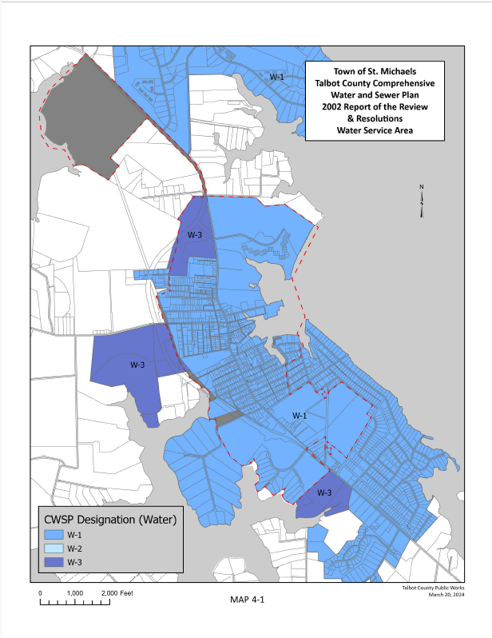
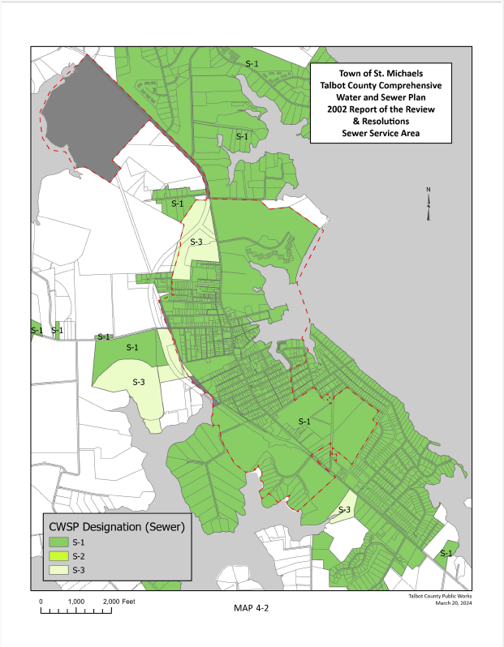

Chapter 5:

Community Facilities and Public Services

INTRODUCTION

Community Facilities (Map 5-1) and public services contribute to the overall quality of life for the residents and visitors to St. Michaels. The condition of our streets, the purity of our drinking water and the dependability of our emergency services and police department are important factors for the people who live in our Town. The goal of this chapter is to assure that the Town’s public facilities, infrastructure and emergency services meet the current and futures needs of St. Michaels citizens, visitors and businesses. Capital Improvement Plans (CIP) are reviewed on an annual basis as a part of the Town’s budget process. The objectives and strategies outlined in this plan should be a consideration for determining the infrastructure needs for the Town in the CIP planning process.
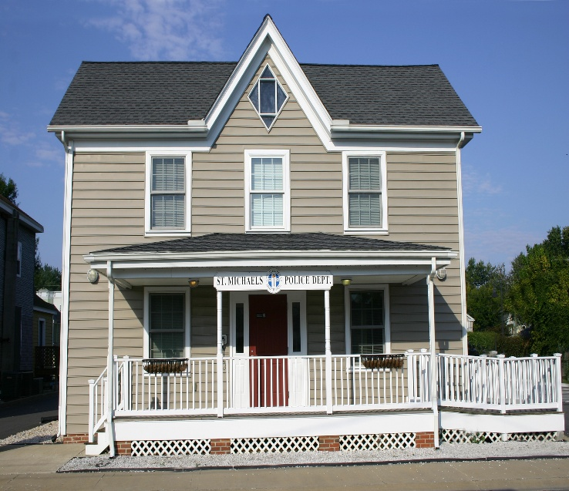
. 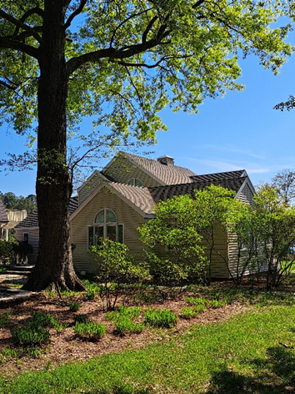

Town Administrative Office Police Department on Fremont St.
at San Domingo Creek Park

Town Administration

In 2023, the Town acquired 7.61 acres of land on San Domingo Creek (formerly a nursery site) and developed a master plan that includes a public park and the conversion of the existing business office building into administrative staff offices. The previous Town Hall was located at Hollis Park and the Town administrative offices were relocated to the new site in the summer of 2024. The Town is considering options for a permanent meeting space to hold community forums and public hearings. At the date of this Comprehensive Plan a variety of sites are being used including the public library, the Boy Scout Cabin at St. Mary’s Square and the Community Center.

The St. Michaels Department of Public Works is located on Glory Avenue in a building adjacent to well #3 and includes three maintenance bays and an adjacent storage yard. While building space is adequate at this time, the building is old and there is a need to have a greater yard and storage space. The location is surrounded by residential and commercial land uses in the middle of Town. Potential acquisition of surplus land held by the Department of Transportation may present an opportunity to relocate and redevelop this property for more appropriate uses and provide additional space for long-term needs.

Public Safety

The St. Michaels Police Department is located in the center of Town on Fremont Street in a stand-alone building. The police force consists of The Chief of Police, one administrative clerk and seven full time police officers who work on rotating shifts. The police jurisdiction ends at the Town limits. However, backup and special services are provided to the Talbot County Sheriffs Office and the Maryland State Police at their request.

Emergency Services
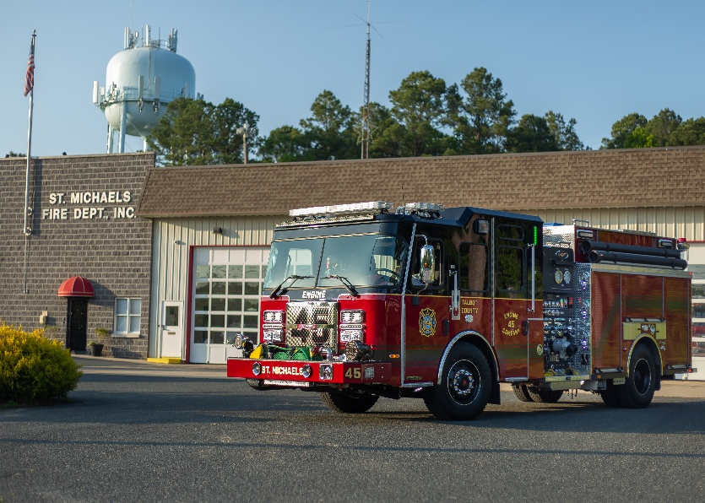
Fire, Rescue, and Emergency Medical services are provided by the St. Michaels Fire Department (SMFD) and Talbot County Department of Emergency Services (TCDES). Funding for SMFD is mainly a mix of County and Town funding, donations from residents and visitors, and department fundraisers like raffles, BBQs and flea markets. County Funding for TCDES is mainly derived from dedicated revenue provided by the Talbot County Council.

The St. Michaels Fire Department is made up entirely of volunteers, and membership ranges between 60-80 administrative members and trained responders. The department has approximately 5-20 responders available at any given time. The SMFD building is located on the south side of Rt. 33, and houses two 1000-gallon Engines, a 2500-gallon Tanker, a 105’ Ladder Truck, Brush Truck, Command Vehicle, Utility Vehicle, Rescue Boat, and Ambulance. The department also hosts the Talbot County ALS Ambulance, which is staffed 24/7 by two Talbot County employees.

The Department faces similar issues to all volunteer fire departments, including staffing, training, and funding shortages. A continual impediment in recruiting and member retention is the limited availability of work-force housing in the Town and surrounding areas.

Health Care

Residents of the Town have access to several hospitals, including the University of Maryland Shore Medical Centers in Easton and Cambridge. The Maryland State Police Aviation Command is available for incidents that require medivac and have access to major metropolitan emergency services in Baltimore and surrounding areas.

The University of Maryland Medical System is relocating its hospital in the Town of Easton to a new medical center to be located north of the airport in Easton. Construction began in 2024 and it is anticipated to be opened in the summer of 2028.

Choptank Community Health medical services are provided through a medical clinic located at the southern end of Town within a professional business complex. The clinic provides diagnostic and on-site treatment with more intensive medical services directed to the hospital or specialists. Should the expansion of the clinic be considered in the future, available space limitations due to the full occupancy of the business complex will become a major factor. The existing clinic provides services not only to the residents of the Town but also serves those communities located in the Bay Hundred area. It is therefore imperative that efforts be made to ensure the continuation and expansion of these medical services.

Hazard Mitigation

Hazard mitigation planning is the foundation for a long-term strategy to reduce disaster losses and break the cycle of disaster damage, reconstruction and repeated damage. As an incentive for State and local governments to develop plans, the Federal government requires mitigation planning as a condition of eligibility for hazard mitigation project funding.

The Town of St. Michaels in cooperation with Talbot County has adopted a Hazard Mitigation Plan. The purpose of the plan is to review assess and update areas vulnerable to natural hazards and prepare a long-term strategy to address them. The highest mitigation risks identified in the study were from winter storms, mass power outages, flash floods, tropical storms and shore erosion. The plan details and prioritizes projects that could be undertaken to mitigate all of the hazards identified. The County’s Hazard Mitigation Plan was last updated in 2022.

Education

Within the incorporated limits of St. Michaels lies the St. Michaels school complex. Talbot County operates three public schools serving St. Michaels and surrounding residential communities. The Tilghman Elementary School provides academic services to those students living in the Bay Hundred Area. The student population ranges from pre-school through and encompassing the 5th grade. Those students entering the 6th grade are transported to the St. Michaels Middle School and subsequently attend the St Michaels High School

The St. Michaels Elementary, Middle and High School lie on a 55-acre parcel of land south of the central business district. The Town's schools have the space to accommodate approximately 320 to 350 more students than are currently enrolled. The current capacity at St. Michaels combined middle and high schools are at 61 percent following major renovations. The school complex includes the Bay Hundred Community Pool which was opened in 2002. The Critchlow Adkins Childrens Center, which provides pre-school educational opportunities, is located within the St Michaels School Complex. The facility can accommodate 105 youth with a current attendance of 90.

Within the grounds of the St. Michaels School Complex is the home of the St. Michaels YMCA. This facility provides a joint benefit to the schools as the students have access to the facility without the need to leave the school property and the YMCA can utilize many of the school amenities such as their gymnasium and auditorium to augment their programs.

Library Services
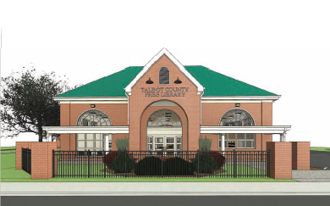
The St. Michaels Public Library is a branch of the Talbot County Library system and is located on Fremont Street offering approximately 10,000 volumes, including resource information, and a meeting room for community meetings and activities. The 8,668 square feet, handicapped-accessible library is open to the public 37 hours per week and has a yearly attendance of approximately 41,000 visitors. Based on the ever-increasing needs of the public, the library is nearing completion of a 3,000 square foot expansion of their facility to accommodate additional meeting and educational spaces. The branch participates in the County and State inter-library loan program. Talbot County libraries are funded 75 percent by Talbot County and 18 percent by the State of Maryland. Public funds are spent primarily on staff salaries, acquisitions, supplies and routine maintenance.

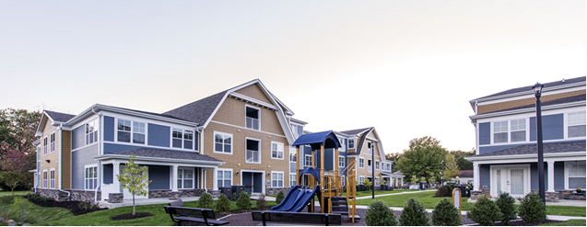
Housing

Providing affordable housing opportunities for middle and low-income families is important to the long-term economic and social vitality of the Town. The location of such housing, its proximity to jobs, childcare, stores, services and accessibility by car, public transportation or walking, have a significant impact on the cost of living and therefore affordability. This issue is discussed in greater detail in Chapter 10, Housing.

St. Michaels Farmers Market

Established in 1998 and registered as a public 501(c)3 charity since 2018, the St. Michaels Farmers market is a producer-only market promoting sustainable agriculture and family farming. The market brings fresh local food to the center of town on a weekly basis and implements programs to improve food access and equity for our Bay Hundred communities. A Community Tent is provided by the market at every session, giving other organizations the opportunity to interact with market customers. In addition to providing a venue for local musicians, the market contributes food to the Community Center and several local food pantries. It also participates in Maryland’s Supplemental Nutrition Assistance Program, a subsidy program to facilitate fresh food purchase by lower income residents. The market operates from April to November with typically 20-30 vendors, and several hundred customers attending each market session.

Public Streetscapes

The Town has about 50 acres of land devoted to streets, alleys, and public rights of way. Sidewalks line Talbot Street from Seymour Avenue to Dodson Avenue and are found throughout the Historic Area. Some street and sidewalk sections are in deteriorating condition. Many Town streets are lit by sodium vapor lights attached to utility poles; however, West Chestnut Street, St. Mary’s Square, and Water Street are lit by pedestrian-scale period lanterns which the Town maintains. The Town, in conjunction with the State Highway Administration, recently completed additional improvements to sidewalks on Talbot Street with the installation of decorative brick pavers and handicapped accessible crosswalk improvements. Additional analysis for accessibility to Town streets and buildings is needed to ensure the St. Michaels can accommodate the needs of all residents and visitors.

The Commissioners of St. Michaels have made it a priority to preserve the historic character of the Town while providing improvements to include road upgrades and maintenance, new public restrooms, improved street lighting and enhanced pedestrian walkways which contribute to the beautification of the Town. These improvements are linked to the Capital Improvement Plan.

Communications

Easton Utilities is in the process of extending internet and cable TV to St. Michaels and the rural community of Tilghman Island. A five-year franchise agreement was approved by the Town Commissioners to provide delivery of fiber optic cable throughout town after completing the improvements in rural service first. They have begun planning for installing underground internet infrastructure with the use of federal grant dollars. As a part of the agreement, municipal facilities will be connected at no charge to internet services. This will greatly improve the internet capability to download and upload data, which has been a problem in the past. It should also be of value to businesses, citizens and visitors and help boost economic development.
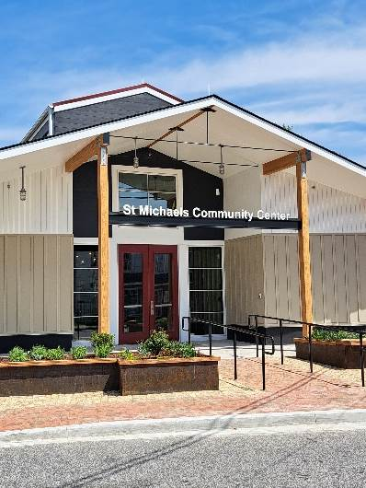
St. Michaels Community Center

The newly renovated St. Michaels Community Center is 5,700 square feet and offers programs that cater to all ages and interests including culinary and hospitality workforce development programs and STEM youth programs. It offers an array of wellness classes, promoting physical and mental well-being, cooking classes and access to computers. There is also a variety of activities for seniors. Additionally, it hosts local nonprofits, extending the reach and impact within the community for everyone to thrive, learn, and connect.

YMCA

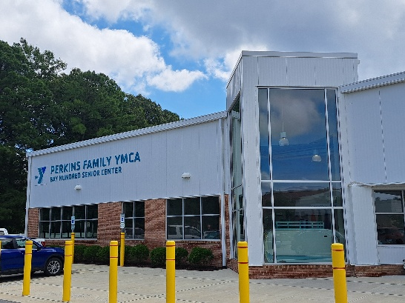
YMCA of the Chesapeake has 11 Eastern Shore area branches including The Perkins Family YMCA facility located on Seymore Avenue in St. Michaels. The YMCA is a nonprofit organization whose mission is to put Christian principles into practice through programs that build health, spirit, mind and body for all and is committed to strengthening community by empowering young people, improving the health and well-being of people of all ages and inspiring action in and across communities. The Y welcomes everyone and provides a wide range of programs, services and initiatives. The Bay Hundred Senior Center is co-located within the YMCA and provides access to a variety of senior services and programs.

Police Department’s SMYLE Programs

The St. Michaels Youth & Law Enforcement program has a goal of improving the quality of life for youth, seniors, and families of St. Michaels by sponsoring community service and educational programs. They work together to build a partnership between the community and the Police Department. Many educational opportunities exist throughout the year including a Youth Health Day to encourage physical activity and healthy eating habits.
In August of each year, the Police department hosts the annual National Night Out, a free community-wide event for all of the Town's citizens. The Police Department partners with the St. Michaels Community Center for an annual block party in August. Other events include the annual Back-to-School night. In October, the “Fall into St. Michaels” event is held with the St. Michaels Community Center and includes various Town Halloween activities. All of these activities help build community trust and partnerships between the citizens and the Police Department.
In December the highlighted event for local youth is the Shop with a Cop. This is also a community-wide fun festivity and decorated event for the Town’s citizens. In the winter, the department hosts the Jr. Police Academy. It is an after-school course to teach recruits – kids ages 9-12 – aspects of good character and instills team building, discipline application, physical training participation, and education on all aspects of policing.
VISION

St. Michaels is a town where public facilities and community services meet the needs of our residents, businesses and visitors.

OBJECTIVES AND IMPLEMENTATION STRATEGIES

5.1 Maintain Town streets and sidewalks as necessary.

5.1.1. Continue to evaluate the conditions and quality of the Town’s infrastructure and street system and develop a street system improvement program if needed as a component of the Town’s Capital Improvement Plan.

5.1.2 Prepare and annually update a Capital Improvement Plan that consists of a rolling five-year financial plan and budget to orchestrate and schedule improvements to Town streets, sidewalks, and other Town facilities.

- Maintain and improve streets as necessary.
- Consider the need for a permanent meeting space/building to hold public meetings of 50-100 people.
- All sidewalks in the business district should be bricked providing a visual indicator of commercial activity. Brick improvements to the sidewalks should be monitored for inclusion in the Town’s Capital Improvement Plan.

5.2 Provide Street lighting in all appropriate areas within the Town.

5.2.1 Continue to evaluate and upgrade streetlights.

5.2.2 Historic lighting options should be considered, whenever street and utility improvements are proposed.

5.2.3 Identify areas which are not adequately lit and develop a priority list of improvements.

5.2.4 Include top priorities for street lighting in the Capital Improvement Plan.

5.2.5 Coordinate with Choptank Electric Cooperative the installation of additional lighting along MD Rt. 33 to ensure street intersections are adequately lit.

5.3 Ensure publicly accessible internet and wi-fi connectivity service is available throughout Town.

5.3.1 In addition to providing service to Town properties, such service should be provided within the Town’s parks and harbor allowing for public internet access to residents and visitors within those areas.

5.3.2 Encourage the St. Michaels Business Association to identify advertising media for distribution.

5.3.3 Recognize the broadband requirements for medical, legal and other community support services and the need to assure that such capacity is available.

5.3.4 Work with Easton Utilities to extend broadband internet service in Town.

5.3.5 Utilize State Highway Administration general utility guidance documents when installing utilities along Hwy. MD33.

5.4 Establish and support community resources which serve the residents of St. Michaels and surrounding communities.

5.4.1 Continue to support the St. Michaels Community Center and the St. Michaels Farmers Market in their efforts to serve the community.

5.4.2 Encourage the utilization of the Housing Authority Administrative Building for community-based functions and continuing education opportunities.

5.4.3 Continue to support the YMCA in its efforts to provide health, fitness and community-based services.

5.4.4 Support the St. Michaels branch of the Talbot County Library and their various programs.

5.4.5 Consider relocating the Public Works facilities to a more appropriate site and redevelop the property for other uses.

5.5 Provide for increased demand for medical services within the Town and surrounding areas.

5.5.1 Evaluate the establishment of zoning use classifications which would permit the establishment of a larger community health facility, either free standing or as part of a professional building.

5.5.2 Support the continuation and expansion of medical facilities and services which will support residents and visitors to St. Michaels.

5.6 Support the needs of the St. Michaels Police Department.

5.6.1 Recognize problems with drug and alcohol related crimes and provide the tools necessary to curtail such activities in the Town.

5.6.2 The St. Michaels Police Department should continue to work with the State Police and local police departments including the Talbot County Drug Task Force.

5.6.3 Continue to support applications for grant money which will provide training or equipment.

5.6.4 Continue to support outreach programs targeted at the youth of the Town, with a focus on community responsibility, drug awareness and personal growth.

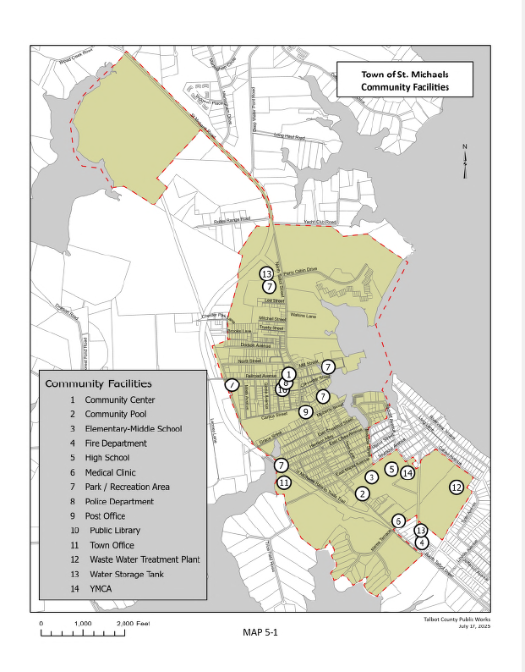

Chapter 6:

Transportation and Utilities

INTRODUCTION

The efficient and safe movement of people and goods and the provision of essential communications and other utilities are important to the quality of life and economic vitality of St. Michaels. As such the Town recognizes the direct relationship between land use policies and the availability of these services.

The infrastructure policies outlined in this Comprehensive Plan are intended to support local land use plans while ensuring adequate transportation facilities exist to serve the needs of residents, guests, businesses and utility needs. Since tourism brings many visitors to Town, the Town recognizes that alternative transportation methods beyond individual vehicles are necessary. Alternative transportation methods such as an “old fashioned” shuttle type service will reduce traffic congestion and parking needs in Town.

Public Transit

Weekday public bus service between various locations in St. Michaels and various locations in Easton is provided by Delmarva Community Transit. Partners in Care Mid Shore offers on-call ride sharing service. Otherwise, there is no public transit in St. Michaels. The closest public transit is in Easton and consists of a local bus network and a shuttle van between Easton Airport and transportation points in Baltimore (BWI airport, Amtrak and Greyhound). As a result, residents and visitors must arrive in St. Michaels by private vehicle or, to a much lesser extent, by watercraft. Providing public transit improvements in town would help provide safe traffic and pedestrian circulation. Considering this, it is desirable to develop a pilot program to improve public transit such as a loop bus route or trolley system.

Town Streets

As with many other early tidewater settlements, St. Michaels relied on water access and boat traffic to bring people and goods to the settlers in the Bay Hundred region. Today, St. Michaels attracts more visitors by car than by boat, with an attendant increase in vehicular congestion.

St. Michaels lies midway on State Route 33, a 23-mile sole artery connecting the town of Easton and Tilghman Island. The one-mile section that runs through the center of Town is named Talbot Street. According to surveys conducted by the Maryland Department of Transportation. over the past ten years from 2014 to 2023, there was a 10 percent increase in traffic on Talbot Street with current traffic from Easton area of 14,112 average daily trips; and 6,000 average daily trips from the north and west of Town.

Traffic in Town consists primarily of passenger and heavy commercial vehicles, often times, especially during the heart of the Town’s tourist season, competing with bicycle and foot traffic. Pedestrian safety is a major concern, and as such, nine designated crossing areas have been established throughout the Town. The Town’s posted speed limit is 25 miles per hour. In addition, during school openings, closing and large events, crossing guards are employed. Additional traffic safety awareness signs at the entrances to the Town would be a reminder of the need to yield to pedestrians. Controlling automobile speed on residential streets and alleys is also noted for future study and control.

St. Michaels has in recent years become a favorite destination for bicyclists with many of the hotels and marinas providing rental equipment for their guests. The end result is an increased conflict between vehicle and pedestrian traffic. However, the current planned extension of the Nature Trail by an additional 1.25 miles is underway and when completed it will allow bicyclists to safely bypass the commercial corridor of Town.

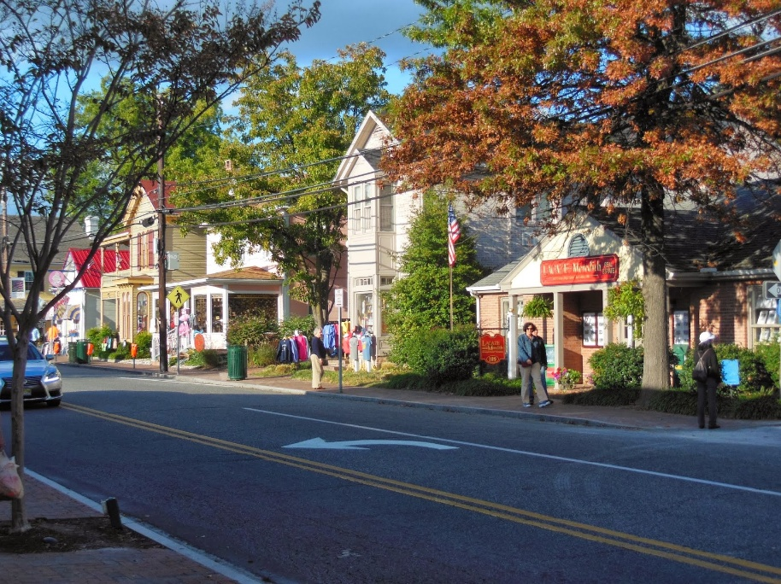
There are 20 streets which intersect with MD Rt. 33 in St. Michaels. Five of these streets serve not only Town residents but provide the sole access to Route 33 from outlying developments in Talbot County. Responsibilities for maintenance of the Town streets lie with the Town Department of Public Works staff and State Highway Administration. In 2024, the State Highway Administration extended brick pavers in Town and resurfaced Talbot Street.

Transportation priorities include a strong emphasis on managing existing resources. Talbot County has taken a strong stand on controlling the overdevelopment of the County’s Villages and rural areas, which should result in minimal impacts on MD Rt. 33 future flow numbers. By establishing Town and County land use and growth limitations, priorities toward managing existing resources can be established which will improve safety and traffic operations. An additional benefit will be the enhanced visual character of the Town and its entranceways.

St. Michaels continues to pursue park and ride services for the visitors to the Town during the peak tourism period of April through January. A parking lot has been established at the south entrance into Town and adjacent to the Nature Trail, but to date no mechanism for mass transit from there into the Town itself has come to fruition. The parking lot is a walkable distance to the downtown with other parking lots located nearer to the center of Town.

State Roadway System

Planning for Rt. 33 in St. Michaels is done by the Maryland Department of Transportation - State Highway Administration and is detailed in the Maryland Consolidated Transportation Program (CTP). CTP describes ongoing and new capital programs to be implemented over a six-year period. Talbot County works on a yearly transportation improvement plan in conjunction with the Maryland Department of Transportation. They develop a priority list which includes projects for the various communities in the County. For St. Michaels, this includes the extension of the Nature Trail and a new sidewalk of approximately 900 feet between the Inn at Perry Cabin to the main commercial area of Town. This can be constructed within the MD Rt. 33 right of way and will improve the safety of visitors to the Inn that desire to walk into the commercial district of Town.

School Access in Town

The majority of traffic related to schools comes from access off of Rte. 33 (Talbot Street) from population centers to the east and turning onto Seymour Avenue and into the school. There is an opportunity to create a new and better access system for the schools by improving the existing right of way through Woodside Avenue and into the southern area of the school. This new access could alleviate heavy traffic congestion and create safer pedestrian and automobile access to schools. A joint project between the County, the Town and School Board should be pursued.

Parking, Pedestrian Circulation & Bicycles

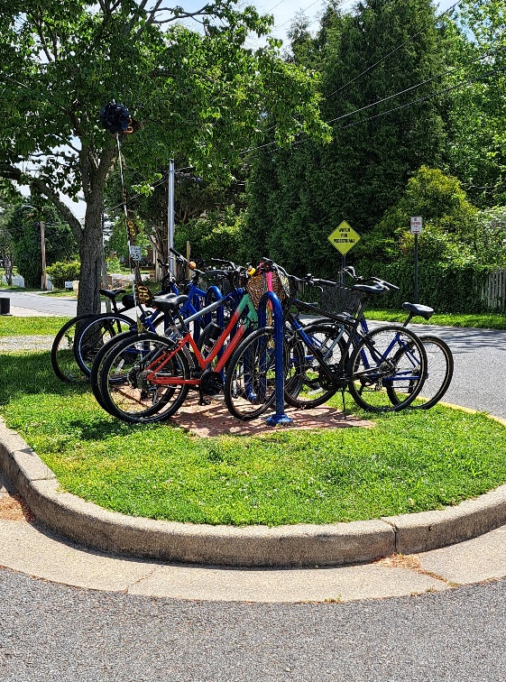
Parking and pedestrian circulation are growing concerns amongst the residents and visitors of St. Michaels with the popularity of tourism. In development of our Sustainable Communities Plan, pedestrian safety in crosswalks and crowded sidewalks were identified as areas in need of improvement. There is a need for better control of crosswalks through a combination of design improvements such as landscaping, curb cuts and bollards or by greater presence of police and crossing guards. A comprehensive pedestrian circulation, parking and wayfinding signage study is recommended to target specific improvements and more closely evaluate how pedestrians circulate through town.

The small size of the Town makes bicycling a good way to get around. Designated routes and bicycle amenities and services would be welcome. The completion of the Nature Trail extension will provide another way to circulate through town without the need to directly travel up and down the commercial corridor. Park and bike designated areas at the south and north entrances to the Nature Trail could help reduce automobiles downtown. Designating bicycle lanes on Talbot Street and other areas to better define and connect to the Nature Trail would be an improvement worth pursuing and add to the safety of cyclists.

Development of an American Disability Act (ADA) accessibility management study and implementation measures is needed to ensure handicapped and disabled citizens and visitors have appropriate access to buildings and public spaces throughout town. This should be included in future budgets. Recent repairs to sidewalks were given detailed design measures to ensure Talbot Street (the main commercial corridor) is designed accordingly. Additional analysis should include repairing damaged sidewalks in residential areas and feasibility of having more sidewalks.

Utilities

Apart from the Town municipal water system (discussed in the Water Resources Chapter), St. Michaels operates no other public utilities. Utility services are evolving from what had been established as long as a century ago. While the Town has access to internet services and cellular phone services, there is an increasing awareness of the need to provide broadband services capable of supporting the needs of computer-based companies, schools, medical facilities and hospitality-based entities.

Nearly all aspects of life in Talbot County and the villages which lie in the Bay Hundred area rely either directly or indirectly on access to the Internet at broadband speeds (currently defined as 25 Megabit per second (Mbps) download and 3 Mbps upload by the U.S. Federal Communications Commissions. Our residents connect to the Internet by two ways: first they connect via cable modems in their homes or offices, to hybrid fiber coaxial networks managed by internet service providers, who then connect to a fiber-optic “middle mile” backbone that is interconnected with Tier 1 Internet providers that are not located in close proximity to Talbot County; and second, they use wireless devices (smartphones, etc.) with cellular technology or wireless networks connected to a series of towers in the County and Town. From the towers, traffic routes along fiber-optic pathways out to the Internet.

Over time, the number of interconnected devices, the amount of data each process, and the speed at which they process that data has increased at exponential rates. Health care, public safety, education, commerce, entertainment and personal communication rely on this fiber-optic infrastructure.

In response to this need, Easton Utilities is in the process of extending internet and cable TV to St. Michaels and the rural community of Tilghman Island. A franchise agreement was approved by the Town Commissioners to provide delivery of fiber optic cable throughout town within a five-year period. As a part of the agreement, municipal facilities will be connected at no charge to internet services. This will greatly improve the internet capability to download and upload data, which has been a problem in the past. It should also be of value to both businesses, citizens and visitors and help boost economic development.

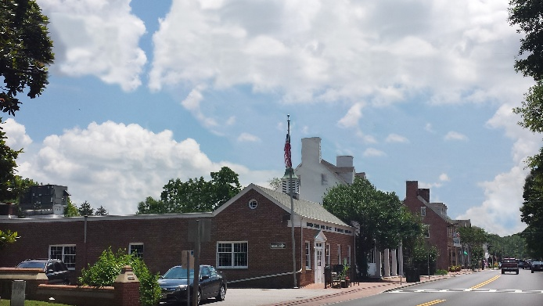
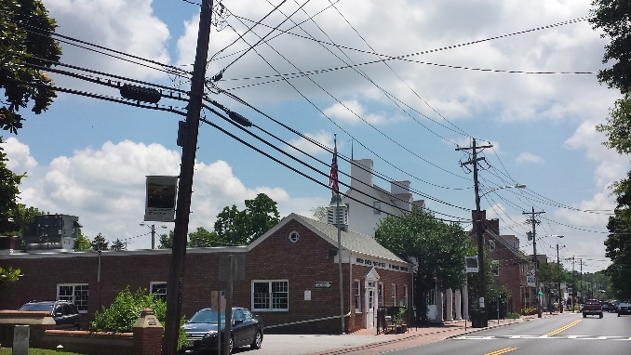
The photograph to left represents an artist’s interpretation of Talbot Street with utility lines removed or relocated. A feasibility study was conducted to determine the Town’s ability to bury and/or relocate the utility lines on Talbot Street. Successful completion of this project would result in less interruption of electrical and telephone service, beautification of Talbot Street which is the heart of the Town’s business district and pedestrian safety as the pole removal will allow for a wider pedestrian corridor. While this remains of great interest, financial and logistical concerns have prevented this from going forward. However, it is a long-term goal for the Town.

Additionally, Choptank Electric Cooperative, the main electric provider in St. Michaels, recently converted customers to a smart metering system and continually promotes “beat the peak” programs to reduce energy costs.
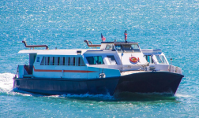
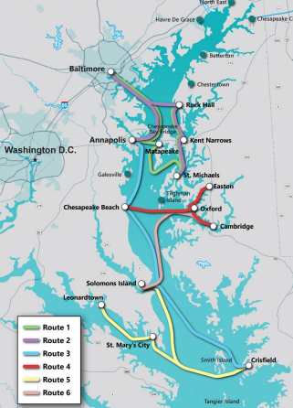
Example of a Ferry Service Ship

In 2024, a report titled “Chesapeake Bay Passenger Feasibility Study” was conducted by Cambridge Systematics and supported by various potential service counties in the Chesapeake Bay region with funding from the U.S. Department of Commerce and Economic Development. The purpose of the study was to evaluate potential passenger ferry services that could stimulate the economic growth of the host communities and improve access to the Bay, provide new water transportation connectivity options, and promote enhanced tourism throughout the region.
Chesapeake Bay Passenger Ferry Service
Potential Passenger Ferry Service Routes

Twenty-one host communities were identified as possible route links. Route 2 includes the Town of St. Michaels, with a potential estimated annual ridership of up to 155,881. Potential station sites will be required to support the ferries and passenger service including pier infrastructure, a terminal building, restrooms, parking and walkway connections to Town. According to the report, various management options such as public/private partnerships and funding options need additional study along with a phased development of the system over time.

The process is just beginning, and St. Michaels should consider participating in future discussions and participate in readiness assessment as well as consideration of benefits and costs of such a transportation system for the Town.

VISION

St. Michaels will provide safe and efficient provision for transportation and utility services.

OBJECTIVES AND IMPLEMENTATION STRATEGIES

Transportation

6.1 Explore options to alleviate traffic congestion and facilitate safe pedestrian movement on Talbot Street.

6.1.1 Coordinate planning efforts with SHA in regard to traffic management and safe pedestrian accessibility, including installation of bike lanes.

6.1.2 Continue to explore the opportunity for a land-based transportation systems to connect parking locations at the south end of Town to parking facilities at the north end of Town and connecting to commercial and harbor areas. If planned, the Town might:

- Pursue alternative transportation funding.

- Apply for local transit services assistance from MTA.

- Coordinate regional travel with Delmarva Community Transit.

- Create a Park and Ride area at the north entrance to the Town.

- Encourage walkability on Talbot Street.

6.1.4 Designate areas for short term bus parking to facilitate unloading and loading of passengers in the downtown area.

6.1.5 Continue to monitor the transportation routes and parking of buses on Town streets with an eye to limiting such street access and parking in the event hazardous pedestrian and vehicular conditions are identified.

6.1.6 Study and control vehicle speed on residential streets and alleys.

6.1.7 Conduct a transit related “pilot program” for improved traffic and pedestrian safety.

6.2 Ensure that vehicle and alternative transportation needs are an integral part of land use planning.

6.2.1 Require new development to design and construct streets, sidewalks, pathways and trails which provide opportunities for connectivity to the town for all modes of transportation.

6.2.2 Improve circulation by ensuring that new streets, ways, alleys, sidewalks and paths create safe and logical extensions of the existing grid pattern.

6.2.3 Explore Commuter Choice Maryland’s Travel Demand Management Program for
commuter transportation services.

6.3 Continue to promote safe and aesthetically pleasing walkways around town, in parks, adjacent to waterfronts and along recreational trails and pathways for public access.

6.3.1 Review and evaluate the current Town requirements regarding the cost of new sidewalks. Consider a new ordinance that will require the Town to cover the cost of sidewalks in existing residential areas when the Town mandates that new sidewalks be built.

6.3.2 Re-evaluate the feasibility of providing sidewalks on Railroad Avenue and
Boundary Lane.

6.3.3 Establish pedestrian paths where practical and appropriate as an alternative to creating new sidewalks.

6.3.4 Evaluate the location and number of existing crosswalks and develop appropriate signing to help ensure the safety of pedestrians.

6.3.5 Increase the policing of pedestrian crosswalks and street intersections during periods of heavy traffic.

6.3.6 Create, maintain and enhance pedestrian walkways that provide access to parks and waterfront destinations.

- Maintain brick sidewalks throughout the Business District.

- Improve pedestrian/bicycle connection between Mill Street and the entrance to the Maritime Museum.

- Pursue appropriate federal, state and private funding sources for necessary improvements.

- The Inn at Perry Cabin. Complete a new sidewalk from its entrance to the Town commercial area.

6.3.7 Coordinate with SHA regarding pedestrian and bicyclist safety on Talbot Street.

6.3.8 Continue to pursue with the State Highway Administration for the creation of a pedestrian crossing in the area of Perry Cabin Ball Fields on MD 33 and for safe access to the new nature trail extension.

6.4.8.1 Consider Maryland DOT’s Complete Street Initiative for a range of options for multimodal transportation improvements (biking, walking).

6.3.9 The Town and County should coordinate planning for transportation improvements in or near the Town or within the designated Areas of Mutual Interest.

6.3.10 Coordinate with State Highway Administration and Talbot County to develop an emergency evacuation plan, for use in the event of severe weather or a catastrophic event.

6.3.11 Work with Talbot County Government and the Board of Education to create a new secondary school access from Woodside Avenue to the St. Michaels school complex to improve traffic circulation and pedestrian safety and ease congestion.

6.4 Improve the ease and safety of bicycle travel in, around and through Town.

6.4.1 Develop plans for establishing and marking bicycle routes.

  - Approach State Highway Administration, Maryland Department of Transportation or Department of Housing and Community Development for appropriate grant assistance programs.

6.4.2 Consider the mapping and placement of bicycle parking racks in areas which will not conflict with pedestrian traffic patterns.

6.4.3 Coordinate with the County to integrate Town bikeways with those of the County.

6.4.4 Provide safe travel and parking accommodation for bicyclists when considering future developments.

6.5 Complete the extension of the Nature Trail from Railroad Avenue to the Perry Cabin Ball Fields.

6.5.1 Employ best trail building practices to reduce erosion on the St. Michaels Nature Trail extension project.

6.6 Assess the current and future vehicle and bicycle parking needs of the Town.

6.6.1 Commission a thorough study of the parking facilities in town through the employment of a qualified professional.

  - Evaluate the acceptable fee the Town should charge for parking.
  - Include signage, way-finding and urban design improvements in the study.
  - Include supply and demand data for parking.
  - Include comprehensive pedestrian circulation, parking and wayfinding signage study, target specific improvements and more closely evaluate how pedestrians circulate through town.

6.6.2 The study should address both commercial and residential parking requirements including a review of the “in-lieu” parking regulations as related to restaurants.

6.6.3 If more parking spaces are required, incorporate acquisition or development into the capital plan.

6.6.4 Determine how to optimize existing parking spaces and areas.

6.6.5 Continue to explore alternative methods of transportation which would provide visitors with an alternative transportation source into town, minimizing the need for utilizing their private vehicles.

6.6.6 Continue to explore and update the onsite parking requirements, shared use parking areas and business improvement funds for commercial development.

6.6.7 Investigate Sustainable Communities plan and State agency funding opportunities for implementation of transportation improvements.

6.6.8 Review areas in the public realm for ADA accessibility to ensure people with disabilities have appropriate access to buildings and public spaces. Examine all sidewalks in town for ADA accessibility improvements.

  - Recognize the significance of the Town being located along the Chesapeake Country Scenic Byway and Stories of the Chesapeake Heritage Area.

  - Adopt the 2023 Talbot County Highway Location references for guidance on roadway
identity.

6.8 Adopt the 2023 Talbot County Highway Location references for guidance on roadway identity.

6.9 Continue work with Easton Utilities to provide adequate broadband fiber optic cable width to support health care, public safety, education, commerce, entertainment and personal communication.

6.9.1 Encourage any project which requires access to a public right-of-way, either above ground or below, to evaluate the opportunity to install fiber-optic cable that is interconnected with existing networks, or at a minimum install conduit sufficient to provide for fiber-optic cable in the future.

6.9.2 Encourage multiple parcels to connect to fiber optic and other upgraded utilities to reduce associated infrastructure costs.

6.10 Encourage alternative energy where feasible and appropriate, taking into consideration the historic character of St. Michaels.

6.11 Continue to evaluate the feasibility of burying and/or relocating utility lines.

6.11.1 Consider the placement of underground conduit whenever new Town streets or major upgrades are proposed.

6.12 Participate in efforts to study and plan for passenger ferry services throughout Chesapeake Bay.

6.12.1 Establish communication with the Passenger Ferry Consortium and participate in discussions regarding establishment of a ferry service that includes St. Michaels.

6.12.2 Perform a readiness assessment in relation to future ferry services.

6.12.3 Develop benefit and cost analysis for a ferry service to St. Michaels.

6.12.4 Explore partnerships with waterfront property owners to determine the best landing for any potential ferry and the need for additional public infrastructure.

6.12.5 Work with the State Highway Administration (SHA) to identify potential ferry station sites and infrastructure needs.

POLICIES

The Town of St. Michaels commits to providing quality transportation and utility systems to support the citizens and visitors of the Town and exploring ways to improve these systems over the life of the Comprehensive Plan.

Chapter 7:

Economic Development

INTRODUCTION

The twentieth century brought many changes to St. Michaels. The harvesting of shellfish and canning and food processing businesses that once were the economic backbone of the area have given way to pleasure boats, tourists, restaurants, boutiques and real estate offices. As tourism increased, the business district was transformed from a community supported shopping area to a tourist-oriented downtown. This situation has been accompanied by a substantial increase in real estate values resulting in service-oriented businesses relocating to cheaper rent areas outside of town. Talbot Street is the historic business core of our community. Its buildings embody the community’s past and its visual identity, offering a unique shopping experience to the residents and visitors.

Tourism has much to offer the Town’s citizens and businesses. Some residents are concerned that there may be a “tipping point” where the impacts of tourism exceed the benefits. Additional data and analysis are needed regarding the impacts of tourism and its effect on maintaining a sustainable and diversified economy and small-town community that makes St. Michaels attractive to visitors.

This Comprehensive Plan supports the development of an economic impact study that looks closely at the benefits and costs to the Town from tourism, partnering with those in the tourism based economy and the means to maintain the quality of life that comes from a balance of economic development from tourism and community values and public service costs and impacts. Data collection could document revenues the Town receives directly or indirectly from tourism in comparison to public service associated costs and neighborhood impacts. Consideration of quality of life issues can help set parameters for festivals and special events to ensure a proper balance. The recently appointed Tourism Advisory Board can assist in collecting data and analysis.
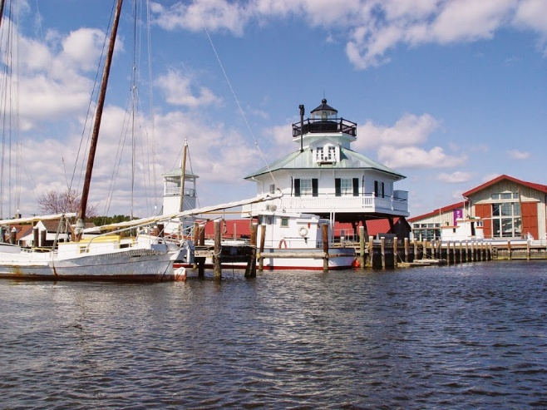
The Chesapeake Bay Maritime Museum, together with the quaint, historic nature of our town and businesses, attracts tens of thousands of visitors on an annual basis and has made St. Michaels a unique tourist destination. There are over 30 various festivals held throughout town every year by various non-profit organizations. The museum recently completed a new visitor’s Welcome Center to showcase its work and programs.

Chesapeake Bay Maritime Museum

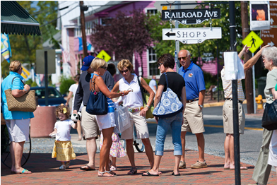
The commercial district offers convenience as it is within walking distance of residential areas and provides easy access to the community without relying on automobiles. Rehabilitation of buildings along Talbot Street and the construction of a business/office park at the southern entrance to the Town has provided a controlled environment for new businesses while providing site amenities which contribute to the beautification of the Town. Although there are many attractive stores on Talbot Street many of the Town’s full-time residents feel their personal shopping needs can not be fulfilled within St. Michaels.

In 2024, the Town decided it was important to further control franchise or formula type of businesses in order to help preserve the strong sense of community, pride and identity. The new regulations are designed to ensure these type of businesses enhance the community experience and not diminish or distract from it; and do not create a community that has the appearance or feel that you could be in almost any town, anywhere, and therefore may diminish the unique quality of life that is known to be St. Michaels.

There has long been interest expressed in pursuing revitalization efforts in the Fremont Street area. The location of the public library and police station on Fremont Street has acted as a catalyst for such revitalization. The newly expanded Community Center serves as an anchor to the north end of Fremont Street.
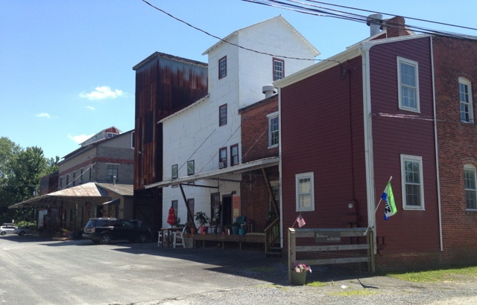
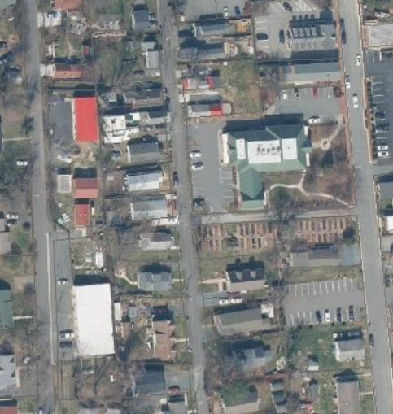

Old Mill District Public Works Properties

Just west of Fremont Street is Glory Avenue which has 36,000 square feet of land and 350 linear feet of frontage used for the Public Works site. This is an area that could be redeveloped for mixed use development and enhance the neighborhood and possibly provide more housing. The Public Works site is not well suited to be in a residential area and needs to be relocated at sometime in the future. The Town should consider opportunities to relocate the The Old Mill District facilities and partner with a developer to develop a new master plan for Fremont Street and include this property as well. The sale of this site could offset much of the cost of relocating the facilities. Redevelopment of the property would have economic and aesthetic benefits for the Town.

The Mill Complex, which houses the Historic Mill, Sewing Factory, adjacent properties and buildings has, in recent years seen a resurgence of development with many small start-up businesses making this area their home. The Mill Complex located between Marengo and East Chew Avenue is the home to a brewery, distillery, winery and various craft and retail outlets.

Directly across Marengo Street from the Mill complex is the “Classic Car Museum” which offers residents and visitors an opportunity to observe vintage vehicles, and the history associated with these vehicles. Development of the museum included the relocation and restoration of the Historic Pinkett House. The Classic Car Museum and the Mill Complex establish a solid commercial presence within the Town.

In 2025, the owner of a former historic train station relocated the structure to property in the Mill District and renovated it to bring it back to its former design as another visitor attraction in this historic redevelopment area.

As the Town changes over time, it must consider additional economic resources aside from tourism, such as small computer-based businesses, enhanced medical facilities and home-based industries. As the national economy increasingly relies on information-based services, robust data infrastructure has become critical to local success in business, education and workforce solicitation and retention. As described in Chapter 6, Transportation and Utilities, Easton Utilities has initiated the extension of broadband fiber optic communication services to rural areas in Talbot County. The Town Commissioners have developed a franchise agreement to bring this service, along with additional revenues, to the town in the near future. The Town is interested in expanding business opportunities in the technology sector and will look for grant funding opportunities for such in the future.

In 1988, the Maryland Scenic Highway Program was established as part of Highway Administration America’s Byways. The Town of St. Michaels is included as part of the program to promote tourism in and around St. Michaels, to enhance the quality of life for residents, promote the area to visitors and encourage responsible management and preservation of our historic roads and surrounding resources. Maryland Rt. 33, which runs through the heart of St. Michaels, has been designated as part of the Chesapeake Country Scenic Byway program, as part of the Michener’s Chesapeake area. Because of national, state and local byway marketing and product development initiatives, destinations along these byways receive more exposure from heritage tourists who value the travel experience as much as visitor attractions.

While retail and hospitality-based businesses continue to account for most of the economic activity in the Town, the Town has identified an increased interest in heritage and nature-based tourism (eco-tourism) opportunities. The rich history of the Town, its waterfront setting, the Michener’s Chesapeake Country Byway designation and the proximity to an abundance of varied wildlife and other natural features makes St. Michaels a target area for this type of business.

The Town Commissioners recognize the need to foster continued interest in the Town by promoting tourism and stimulating economic growth in the Town, while balancing the needs of residents and businesses. In relation to this, there is interest in looking at various options to balance revenues and expenses. A comprehensive approach that examines various options and opportunities for generating revenues for long-term improvements and public services could help ensure financial and economic health for the future.

The Town Commissioners adopted Ordinance 559 in 2024 which established the St. Michaels Tourism Advisory Board. The purpose of the Board is to assist the Town in its efforts to encourage businesses to locate or remain in Town while preserving the Town’s historic, maritime and small-town character; and to advise the Town on matters relating to the business environment. The Board will establish data on marketing and tourism and develop a Promotion Plan. The Board began meeting in 2025.

VISION

St. Michaels attracts and retains businesses that support the Town, its residents and visitors while protecting its historic and environmental assets.

OBJECTIVES AND IMPLEMENTATION STRATEGIES

7.1 Promote a healthy business district that provides needed goods and services to residents as well as an inviting and attractive atmosphere to all who visit St. Michaels.

7.1.1 Establish a Business District Improvement Committee composed of the St. Michaels Business Association, business owners/operators and town officials.

- Create an improvement priority list for better lighting, benches, brick sidewalks and landscaping in the commercial areas.

- Integrate the recommendations into the Town’s Capital Improvement Program, as appropriate.

    - Authorize an updated study of the parking requirements for the Town that accommodates both the residents and visitors.

    - Develop with the involvement of the private sector a plan for redevelopment
of Fremont Street. The goal of this plan will be a better mix of civic, residential, commercial and business uses to enhance the downtown’s role as an activity center while protecting the quaintness of the Town.

- Research federal and state grants that may be applicable.

- Create a revitalization zone and study other possible revitalization measures that can be taken.

- Research the advantages and disadvantages of having a business in Town versus surrounding areas and formulate ways to encourage the retention and establishment of businesses in Town.

- Provide data on statistics of visitors per season and income generated via different sources, such as room tax generated.

7.1.4 Coordinate economic development goals and activities with those undertaken by Talbot County and Maryland State government.

7.1.5 Evaluate current standards and requirements for permanent signs and consider broadening the range and type of signs that can be utilized by businesses to identify their location. Signs should provide direction and contribute to the image and identify of the downtown.

7.2 Define and promote sustainable tourism to ensure it is aligned with the values of the community and maintain quality of life for residents.

7.2.1 Identify and utilize incentives to encourage investment and development in the commercial zones.

7.2.2 Evaluate the potential for consolidation of properties or subdivision and development of those properties which extend from Talbot Street to Fremont Street recognizing that access and parking issues would need to be concurrently considered.

7.2.3 Support and accommodate the development of (non-franchise/formula business) tourism-related businesses, including historic and natural sites, water access, museums, outdoor recreation, hospitality, cultural/ arts facilities and performing arts ventures.

7.2.4 Encourage cooperation among public and private organizations that publicize and promote tourism.

7.2.5 The Town recognizes the value of being situated along the Michener’s Chesapeake Country by-way and encourages sensitivity in decision making concerning the visual quality surrounding this important resource.

7.2.6 Recognize and encourages continued use associated with an active harbor.

7.3 Conduct various studies and develop reports and recommendations regarding long-term fiscal and economic benefits and costs and include input from Town constituents.

7.3.1 Hire experts to conduct a benefits and costs analysis to the Town to balance economic development from tourism and community values with public service costs and impacts.

7.3.2 Develop a new master plan for Fremont St. that considers recent public improvements to the Library and Community Center and considers the possible sale/lease and redevelopment of the Public Works properties on Glory Avenue and pedestrian linkages of it and other sites with Fremont Street.

7.3.3 Establish “Baseline” data on economic development to measure changes in the economy over time.

7.3.4 Encourage the private sector to pursue a Maryland Main Street program designation to provide additional resources for promoting downtown.

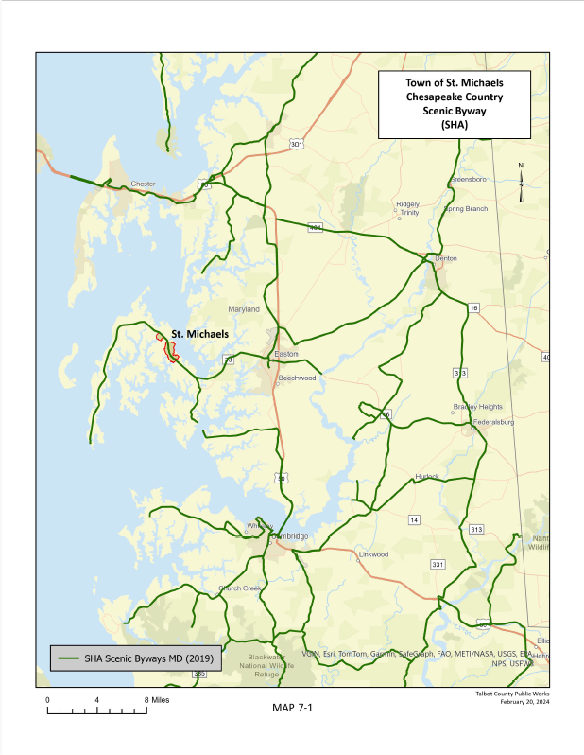

Chapter 8:

Historic and Cultural Resource Protection

INTRODUCTION

It is possible to see the history of St. Michaels in its historic buildings and events which date back over three centuries. Physical reminders of early history give depth and richness to the Town, to past events and to people’s lives. Historic and cultural preservation allows the legacy of the past to be protected and remembered. It allows for the past to be integrated with the present and reminds us that the old have a useful place alongside the new. The preservation of historic buildings and structures includes consideration of the integrity of the location, neighborhood, design, setting, materials and workmanship.

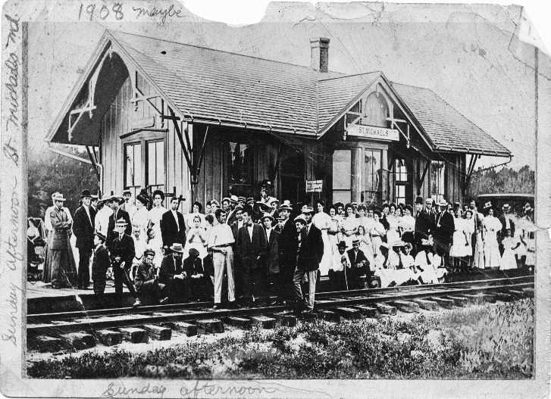
Access to St. Michaels originated by boat and evolved by ferry, train and eventually automobile. Train service to the region developed in the early 1900s with travel from the ferry across the Chesapeake Bay at Claiborne with train access on to Easton and Ocean City, passing through St Michaels. In 2024 the owner of an old train station from the area developed a plan to relocate and renovate the station building. It now sits restored at a prominent location on Talbot Street in the Old Mill District and is a public attraction.

With its roots as a planned town of the late eighteenth century, with lots arranged around a central public square, St. Michaels exhibits the scale of a small tidewater town nestled against and dependent upon its waterfront. While a handful of structures in town date from the late eighteenth and early nineteenth century, much of the built environment reflects the building boom of the second half of the nineteenth century, when St. Michaels prospered on the abundant oyster harvests. Of the several tidewater Chesapeake Bay towns that grew in the nineteenth century, St. Michaels particularly stands out as a well-preserved and intact example.

ARCHITECTURAL HISTORY

St. Michaels has a substantial and well-documented stock of historic structures, streetscapes, sites, and settings. Over 250 historic structures have been surveyed and documented, forming a largely intact historic district, in which houses, churches and commercial structures from the late nineteenth century are particularly well represented. A number of these sites can be viewed in the areas shown on Map 8-1, St. Michaels Historic Areas.

National Register Historic District

The National Register of Historic Places, an inventory of historic resources, is maintained by the National Park Service. Listing in the National Register provides recognition to sites, buildings, structures, objects, and districts that are significant to American history, architecture, archaeology, engineering, or culture. The St. Michaels National Register Historic District was surveyed, nominated, and approved in 1986. In addition to providing recognition of significance, listing in the National Register mandates consideration in the planning of any federally or federally assisted project and provides eligibility for federal and state tax credits for historic preservation projects.

St. Michaels Historic District
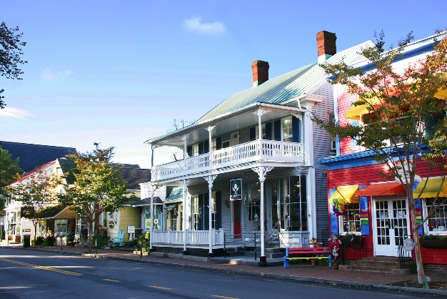
The St. Michaels Historic District (formerly named the St. Michaels Historic Area) was created in 1972 and has been expanded and modified several times since. The five-member Historic District Commission is composed of volunteer citizens with interest or specific expertise in historic preservation and appointed to three-year terms by the Town Commissioners. The Commission reviews proposed exterior changes to any structure or appurtenance in the defined district, based on an approved and published set of guidelines. This review process provides the best tool for protecting and enhancing the historic character of St. Michaels. In addition to the review of proposed projects, inclusion in the Historic District also provides eligibility for a state historic preservation tax credit to home property owners who undertake historic preservation projects. The Historic District Commission is currently working on designing, purchasing and placing signs at several locations of the perimeter of the district to better define the district and notify citizens and visitors that they are entering the historic area of town.

Currently, the St. Michaels National Register Historic District includes several neighborhoods in the Town that are not included in the locally zoned St. Michaels Historic District. Historic resources located outside of the locally zoned Historic District may be threatened by demolition or character changing alterations or additions. Measures to consider expanding the Town Historic District boundaries to coincide with the National Register Historic District and educating residents about the value of these properties to neighborhood character could help address these threats. Another threat to historic properties is demolition by neglect, which has been addressed by expanding the “demolition by neglect” provision in the zoning code from addressing only income-producing properties to cover all properties except owner-occupied residences. Another measure that could help to address this problem is a property maintenance code.

The Town allowed for smaller and older historic homes to be converted to vacation cottages in the past. This had provided renovation of these structures to preserve their historic value. All of the eligible structures have been protected, and so this program was successful. Below is a historic home on Locust Street which recently underwent major repair work for such purpose.
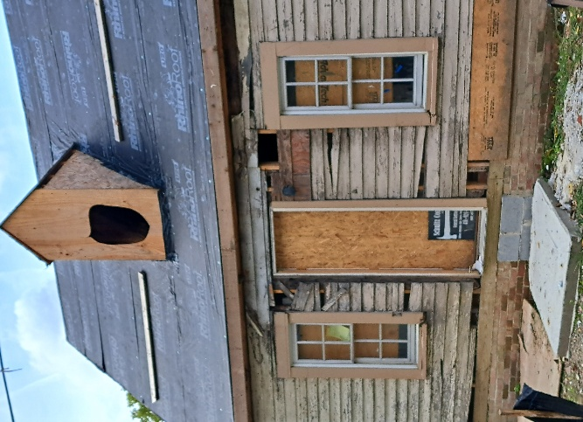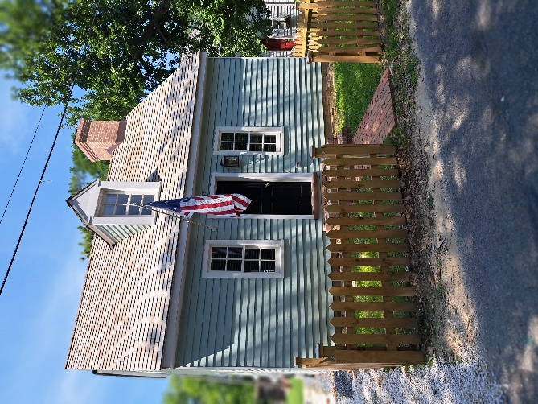
Locust Street House Renovation
While great progress has been made repairing and renovating historic structures in Town, there are still various opportunities to save sites from further deterioration. One of these is Sardis Chapel, which is in the center of the original historic St. Mary’s Square. The chapel is of the Greek Revival style and dates back as a Methodist Church to 1839. It has had various uses over the years and is commonly referred to as Granite Lodge. It is.
currently owned by Masonic Lodge. It is in need of interior and exterior improvements to bring it back to its former glory. Developing a partnership and searching for funding to save this old building would be worth the effort.

In addition to historic homes, there are several historic churches in Town that add to the charm and history of the community. The largest among them is Christ Episcopal Church. The present structure on Talbot Street dates back to 1878. St. Lukes United Methodist Church, also on Talbot Street is of the same era (1871). There are also several historic cemeteries in town including a cemetery on Brooks Lane that contains Buffalo Soldiers from African American military regiments.

New commercial and residential development and rehabilitation projects have been designed to complement historic buildings, rather than clash with them. The Town, our business community and residents have invested in preservation, restoration and improved access to many previously endangered or neglected historical buildings and sites. A heritage tourism industry has developed in the region and St. Michaels is a key destination taking full advantage of such opportunities.
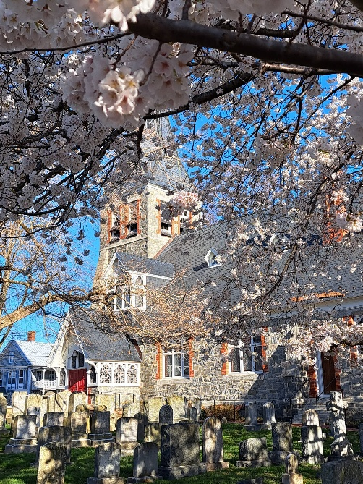

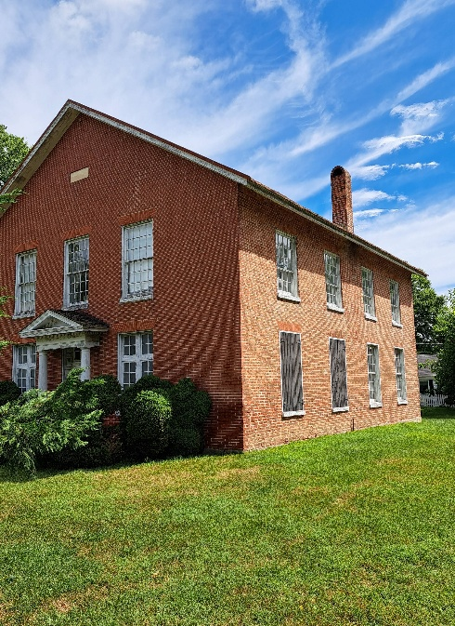

Sardis Chapel Christ Episcopal Church

CULTURAL HISTORY

Preservation and rehabilitation of historic structures and streetscapes enhances the historic character of the Town, stabilizes neighborhoods, protects property values, and attracts visitors to St. Michaels who support the business community by eating, lodging, and shopping. The Town of St. Michaels recognizes the importance of its historic resources and encourages preservation and rehabilitation efforts by private owners and local government. Private houses and public buildings are often carefully restored. New uses are found for historic buildings which no longer serve their original functions.

Continued historic and cultural preservation will provide St. Michaels with a number of aesthetic and economic benefits, including:

- Promotion of a strong sense of community identity, pride and tradition.

- Managing change over time to promote quality of life in the community by ensuring neighborhood stability and a sustained cultural heritage.

- Revitalization through the preservation, restoration and adaptive reuse of structures contribute to the historic character of the Town.

- Increased property values and tax revenues as a result of sensitive rehabilitation and restoration.

- Increased revenues from tourism activities generated by an interest in historic cultural tourism and historic buildings and sites.

The Stories of the Chesapeake Heritage Area encompasses heritage sites and places in Talbot and adjacent Counties which were designated a certified heritage area by the Maryland Heritage Area Authority in 2005. This program recognizes St. Michaels as offering a number of heritage resources of importance to the region. Based on the afore noted, The Stories of the Chesapeake Heritage Area Management Plan dated April 20, 2005, and as may be amended from time to time in the future, is hereby incorporated, by reference, in the Town of St. Michaels’ Comprehensive Plan.

The St. Michaels Museum at St. Mary’s Square

The Town has two historic and cultural resources related museums: the St. Michaels Museum at Saint Mary’s Square and the Chesapeake Bay Maritime Museum. The St. Michaels Museum’s Mission is “To celebrate the unique history of St. Michaels and the surrounding area through preservation and education.” St. Michaels Museum, founded in 1964 has three nineteenth century buildings. All three were built in St. Michaels and saved from demolition and restored. There is the waterman Jeremiah Sewell’s home saved in 1964, the Teetotum, a commercial duplex used for business, government and at one time a library and third, a rare surviving two bay 1851 Chaney House, home of three free African American brothers and their formerly enslaved father. The museum provides both guided and self-guided historic building tours as well as exhibits on St. Michaels’ history and nearby countryside.
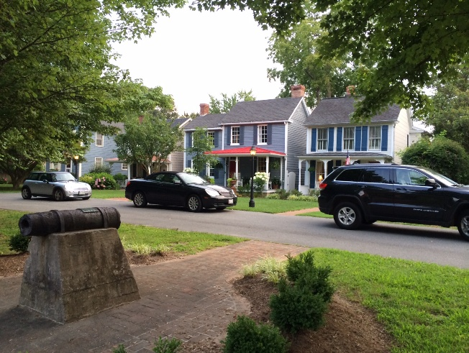
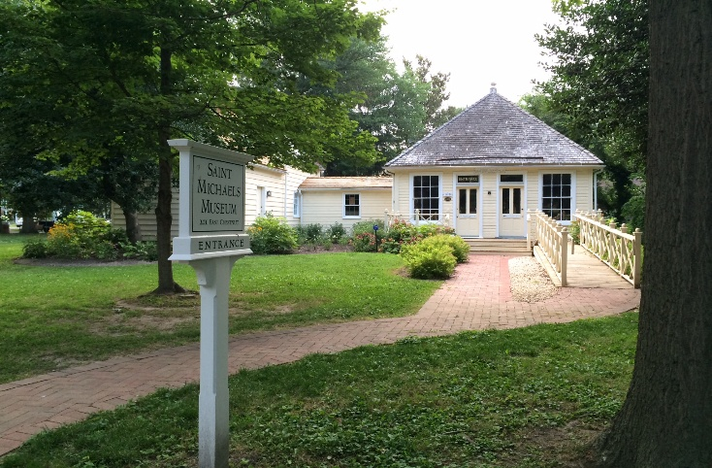
The St. Michaels Museum St. Mary’s Square

The Boy Scouts log cabin in St. Michaels is a historic building that has been home to the Town's Scout troops since 1938. The cabin is located in St. Mary's Square (adjacent to the museum) along with other important symbols of St. Michaels' past. The well-known carpenter of the day Josiah Fairbank was among those who built the Scout House. It was renovated in 2019 to make it a modern facility and is used by the Boy Scouts and also by the Town for a variety of meetings. One of its most remarkable features is a massive fireplace and chimney made of granite that stonemasons George Todd and Albert Wales created when the clubhouse was built. Carved in the keystone of the interior part of the fireplace is “147,” the number of the troop when the building was built. A 128-foot lighted walkway welcomes pedestrians to the front door. There also is a fire pit outside for the traditional Scout flag disposal ceremony.

The Chesapeake Bay Maritime Museum

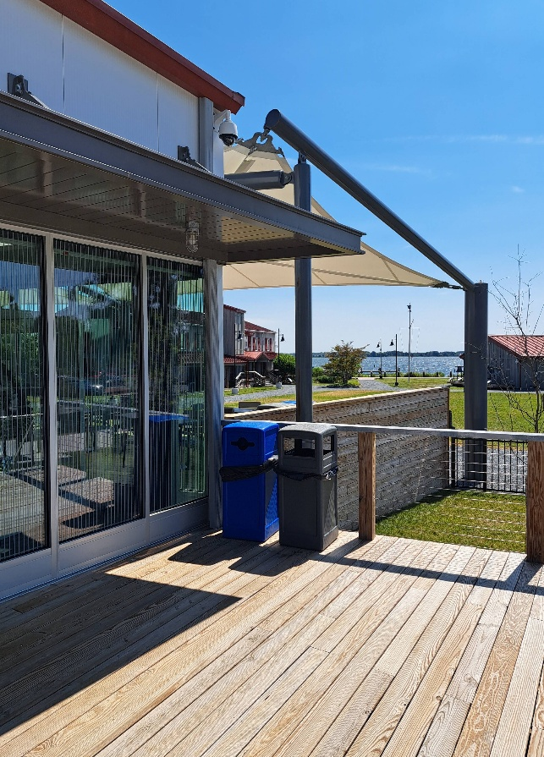
The Chesapeake Bay Maritime Museum’s mission is to “Explore and preserve the history, environment and culture of the entire Chesapeake Bay region and make this resource accessible to all.”

According to the Chesapeake Bay Maritime Museum, “The Chesapeake Bay’s racing log canoes are descended from workboats used by oyster tongers in the 19th century. Inevitably, competition among the watermen led to racing and organized races, and larger masts and sails were added in the pursuit of speed. On summer weekends today log canoes continue to compete in races on the nearby Miles River.” Canoes on the National Register are docked in St. Michaels. The Chesapeake Bay Maritime Museum hosts a variety of boats and wooden ship structures from the early maritime years in St. Michaels. Additionally, St. Michaels has long been known as a working waterfront town, including ship building and other activities related to Watermen’s heritage. With the State of Maryland declaring Watermen an endangered culture, the preservation of local Watermen’s culture is important to the Town.
CBMM Welcome Center
The Classic Motor Museum of St. Michaels

The Town’s most recent museum is the Classic Motor Museum of St. Michaels. The Classic Motor Museum is dedicated to appreciating, preserving and showcasing America’s heritage of automotive innovation and adaption while at the same time exposing future generations of Talbot County and Eastern Shore young adults to that heritage and its contributions. It has over 20 mint condition classic cars in a beautiful Amish-built Exhibit Barn. Current activities include future construction of a new facility on Talbot Street and apprentice training program. This includes the renovation of an old garage with antique gas station pumps and lighting as an entry feature to the south end of Town.

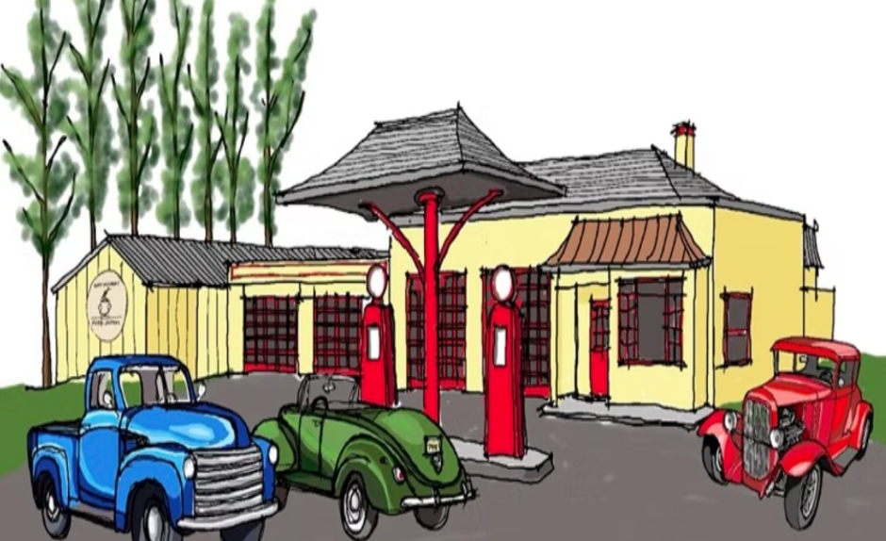


Rendering of the site for the Moror Museum’s expansion and apprentice training program

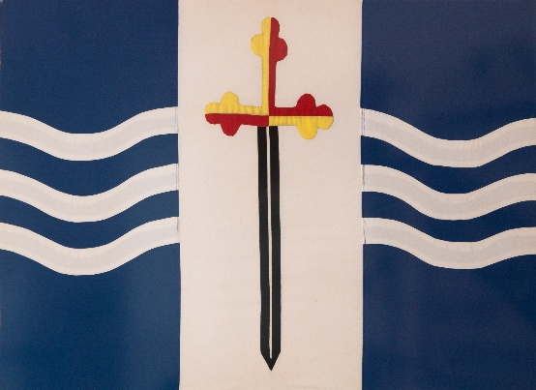

The St. Michaels flag was adopted by the Town Commissioners of St. Michaels as the town’s flag in 1970. The sword represents the Archangel Michael in the colors of Maryland with a background of white waves of water which refer to the narrow spit of land the town sits on between the Miles River and San Domingo Creek. The blue is to recall the sailors’ wish for “fair wind and blue water”.

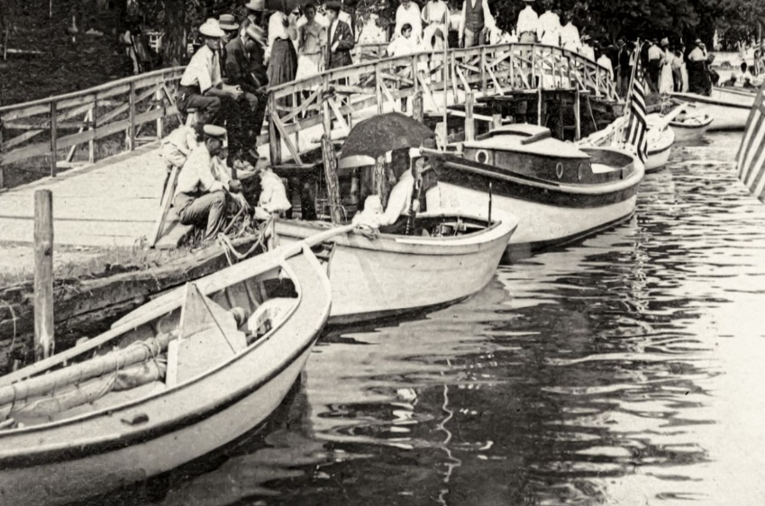
Honeymoon Bridge (pictured at left) was once used in a movie scene. Future plans are to replicate, raise and replace this bridge which connects Cherry Street to town properties on the St. Michaels Harbor and the Chesapeake Bay Maritime Museum. This will help mitigate sea level rise and improve pedestrian access.

ART IN PUBLIC SPACES

The St. Michaels Parks & Recreation Board has expressed interest in developing an Art in Public Space program. Public art is defined as art that is created intentionally for a place and space in the public realm, regardless of whether it is situated on public or private property, located indoors or outdoors Public art is free and accessible to everyone. Public art can include expressions of community values or enhancements to an environment and can raise awareness of an unseen narrative. A public survey was developed which resulted in widespread support for such an effort. The initial effort will focus on historic themes celebrating history and independence and will begin with a sculpture to be located at the St. Michaels Museum in St. Mary’s Square.

Goals of the program include:

- To enhance the beauty and active participation of the public in the parks and outdoor spaces of St. Michaels.
- To educate residents, children and visitors to the unknown heritage of early St. Michaels history, in particular to demonstrate the racial, ethnic and cultural diversity of the community.
- To demonstrate that the traits of early residents – independence, cooperation and determination – still exist today.
- To develop plans to create public are in parks and outdoor spaces.

AFRICAN AMERICAN HISTORY

Perhaps the most famous person associated with St. Michaels is Frederick Douglass – born a slave and became an abolitionist, orator, newspaper owner and writer and later in life counseled President Lincoln during the Civil War. He was a U.S. Marshall of Washington D.C. and Consul General to Haiti. His master, Thomas Auld, lived in St. Michaels and Douglass resided here as a boy in 1833, living separately in a small building on Cherry Street, and then was hired out for several years as a farm hand.

In 1877 Douglass returned to St. Michaels as a freeman and visited the Auld family home on Cherry Street and Locust Street. He met briefly with Auld on his death bed. Douglass said: “We had both been flung, by powers that did not ask our consent, upon a mighty current of life, which we could neither resist nor control.”
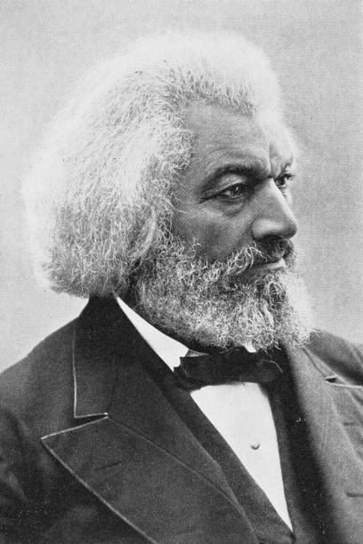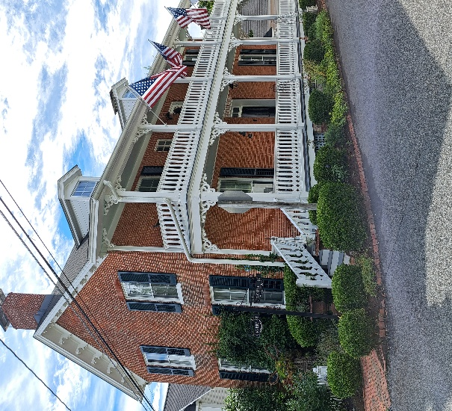

Frederick Douglass Dodson House (Cherry & Locust St.)

The Chaney House located on the St. Michaels Museum campus was built by the free African American brothers in 1851: George Jr., Charles and Samuel Chaney. Their father was enslaved, their mother free. The brothers were able to buy their father’s freedom, and he moved in with them when freed as did a sister and her family when they gained their freedom. Over the years, the original two room home was expanded to accommodate the extended family. The Chaney House affords a view of how free African Americans might have lived in St. Michaels prior to, during and after the Civil War.

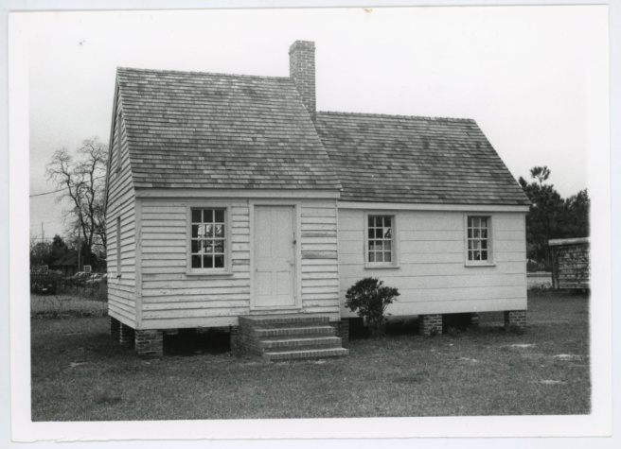
One of the important contributions that freed blacks would provide would be the establishment of Freedom Lodges. The Shealtiel Lodge was established in Saint Michaels and later changed its name to Freedom’s Friend Lodge No. 1024. Though not the first to be founded, the Lodge is the oldest standing Odd Fellows lodge in Maryland as well as one of the oldest in the country. The lodge is listed as a historic property in Maryland in part because of the antiquity of its architecture. Once the home of Eliza Bailey Mitchell, abolitionist Frederick Douglass’ closest sibling, the Mitchell house is a structure built between 1815 and 1850. It has been restored to resemble the original and typical parlor-and-hall style home. In 1972, James E. Thomas, the great-grandson of Peter and Eliza Mitchell, became the first Black Commissioner of the Town of St. Michaels and, a few years later, its first elected president. He was instrumental in saving the Mitchell house from demolition. It was moved to the Fogg’s Landing area of the Chesapeake Bay Maritime Museum in 1981 and was restored to interpret the lives of enslaved and free Black laborers.

The Mitchell House
VISION

St. Michaels is a place where historic and cultural resources have been valued and preserved.

GOALS AND IMPLEMENTATION STRATEGIES

8.1 Further the goal of restoration, adaptive rehabilitation and preservation of historic structures, sites, streetscapes, and settings.

8.1.1 Consider expansion of the St. Michaels Historic District to include areas of the National Register Historic District and other neighborhoods that may be determined to be historically significant should such requests be made by the affected property owners.

8.1.2 Periodically revise the St. Michaels Historic Area Guidelines to address more specific materials, techniques, and other aspects of historic structure rehabilitation while conforming to the Secretary of the Interior’s Guidelines for Rehabilitation of Historic Structures.

8.1.3 Continue to evaluate the feasibility of burying or relocating utility lines.

8.1.4 Continue a program of planting and replacing street trees to improve streetscapes throughout the Historic District.

8.1.5 Consider updates to guides and assessments of the Historic District as it relates to evaluation of contributing structures.

8.1.6 Support public art projects to publicize the historic and aesthetic character of the Town in public spaces.

8.2 Support the St. Michaels Historic District Commission and zoning regulations applicable to the Historic District.

8.2.1 Pursue Certified Local Government status with the Maryland Historical Trust to provide eligibility for continuing education grants for staff and members of the Historic District Commission.

8.2.2 Evaluate the zoning ordinance to allow consideration for historic character in reviewing variances for front lot line setbacks and to allow consideration for historic character on side and rear lot line setbacks for accessory structures.

8.3 Educate residents, realtors and property owners about the benefits, boundaries and requirements of the Historic District, review process and design standards and about the availability of state and federal tax credits for historic preservation projects.

8.3.1 Encourage distribution of a brochure to area realtors to be given to potential buyers setting forth the Town’s Historic District boundary and the benefits and responsibilities of being in such a district.

8.3.2 Encourage property owners to seek the expertise of the Historic District Commission when considering improvements to their property through informal discussions with the Commission.

8.3.3 Post signs to mark the boundaries of the historic district and encourage the marking of individual historic structures with date plaques.

8.3.4 Facilitate workshops to educate local property owners on financial incentives for preservation and rehabilitation.

8.3.5 Generate and distribute a list of accepted alternative materials and conditions under which they are accepted in either rehabilitation projects or additions and new construction. Generate and distribute a list of suppliers of approved alternative materials.

8.4 Encourage sponsorship of Town events that celebrate the historic and cultural resources in St. Michaels.

8.5 Recognize the heritage associated with log canoes and other historic boats on the National Register that are docked in our waterways.

8.6 Continue to explore opportunities to preserve the working watermen’s heritage associated with St. Michaels.

8.7 Protect historic and culture sites from climate and weather-related events.

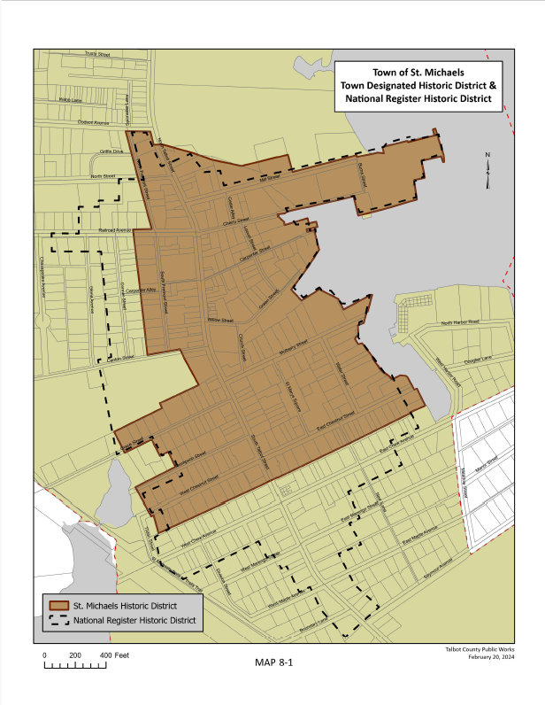

Chapter 9:

Parks, Recreation and Open Space

INTRODUCTION

Outdoor recreation contributes to the physical fitness and mental well-being of Town residents and visitors. The quality of St. Michaels’ parks serves as a clear indicator of the Town’s pride in its fundamental character, historic beginnings, and waterfront community image. A quality park system serves not only area residents but also diversifies the Town’s offerings to the visitor population upon which much of its economy depends.

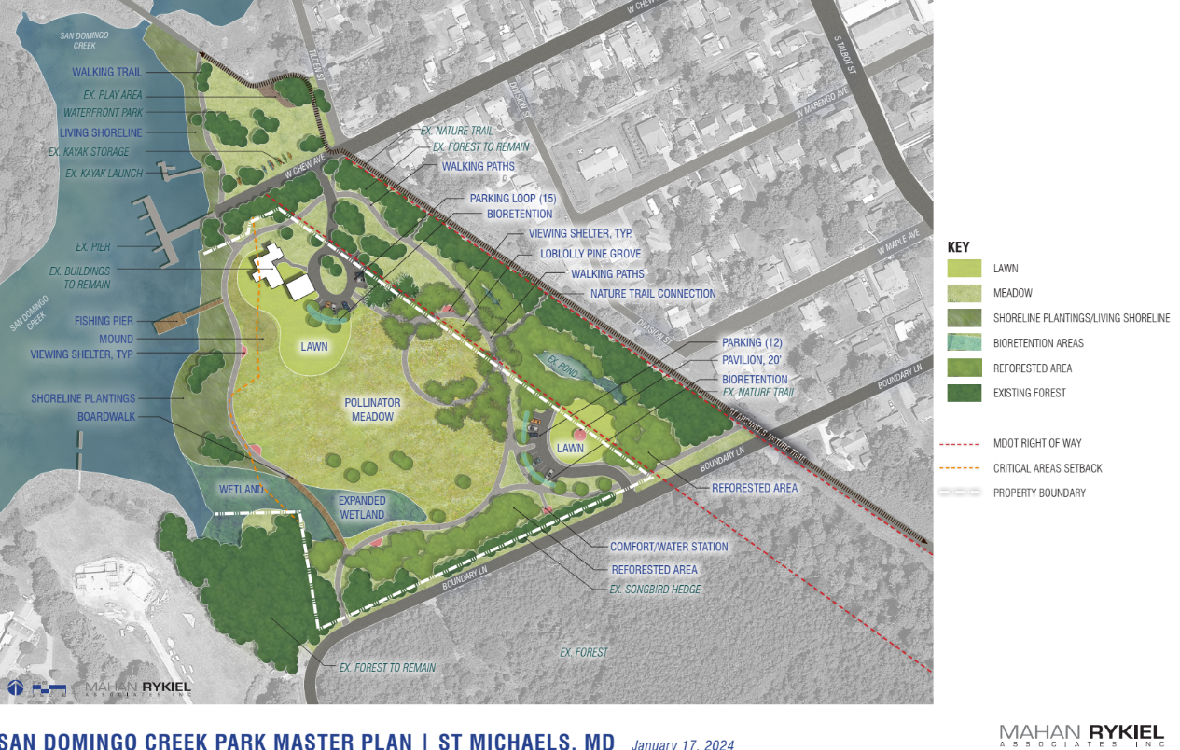

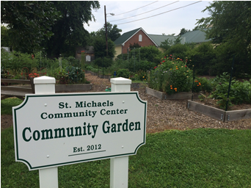
This Chapter of the Comprehensive Plan proposes that parks and recreation offerings be viewed in a context in the future as a tool to accomplish a number of related community development objectives, such as:

- Achieve environmental resource protection or management objectives.
- Provide a diverse range of recreational opportunities to provide creative play for children and active and passive recreation of all segments of the population.
- Educate and provide opportunities to observe natural landscapes and wildlife.
- Integrate arts, culture, and community events within traditional park areas.
- Appreciate the historic contribution of Talbot County watermen to the character and development of the Town of St. Michaels and their continued efforts to preserve a lifestyle indigenous to the Chesapeake Bay.

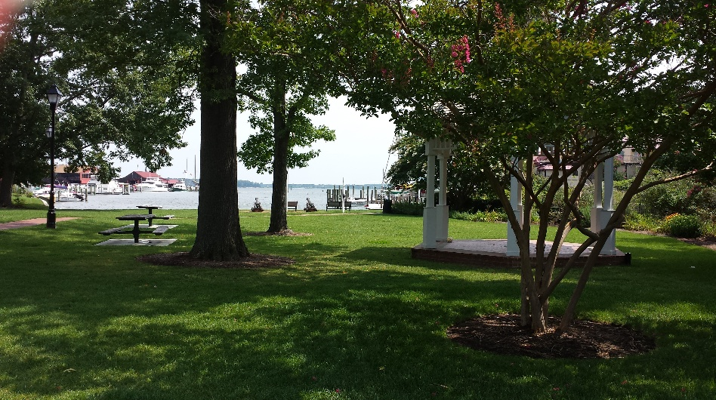

In planning for recreation and open space in St. Michaels, an important distinction must be kept in mind: recreation areas, such as community parks and boat landings, are used actively, while open space areas are primarily passive in nature and managed for natural resources protection. These two uses, while not attempting to achieve the same objectives, are not always incompatible. Combined with creative land planning and management programs, they can be mutually supportive toward achieving their respective objectives.

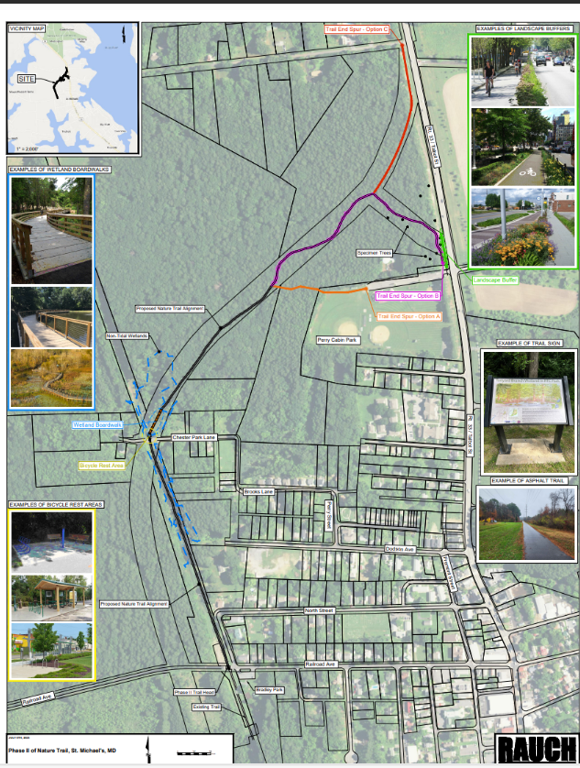
There is currently a 1.3-mile walking trail constituting Phase I of the St. Michaels Nature Trail, which extends from Bradley Park off Railroad Avenue to the southern edge of Town across from the Fire Department. The residents and visitors to the Town have expressed overwhelming support for the extension of the nature trail from Bradley Park to the Perry Cabin Ball Field (Talbot County Recreation Area). This extension would allow for a continuous route from the southern boundary of the Town to its northern boundary providing an alternative for pedestrians and cyclists traveling on MD Rt. 33. There is also consideration being given to the creation of a spur from the nature trail across the Marea Subdivision property, at the south end of Town, to an area overlooking San Domingo Creek.

In late 2024, the Town received additional funding from MDOT to complete the construction of the trail extension. The trail will wind through dense forest, include a wetland bridge crossing, a pavilion where the original St. Michaels Train Station was located and a new restroom. The project construction is anticipated to be started by the publication date of this updated Comprehensive Plan and open to the public in 2027.

In Chapter 6, Transportation, reference is made to the establishment of a pedestrian walkway from The Inn at Perry Cabin to the entrance of the Chesapeake Bay Maritime Museum. Should this goal be achieved, an additional opportunity will be established for both the residents and visitors to St. Michaels. It is anticipated that Perry Cabin Resort will complete a significant portion of this in
Trail Extension Map the future
St. Michaels provides varying park or recreational options, ranging in scale from smaller than an acre in size that permit access to St. Michaels Harbor or San Domingo Creek, to two larger County park facilities, over ten acres in size, located at each end of Town (See Map 9-1). Some of these locations support a wide range of athletic and recreational activities, while others, like Muskrat Park or Hollis Park provide for enjoyment of St. Michaels Harbor.

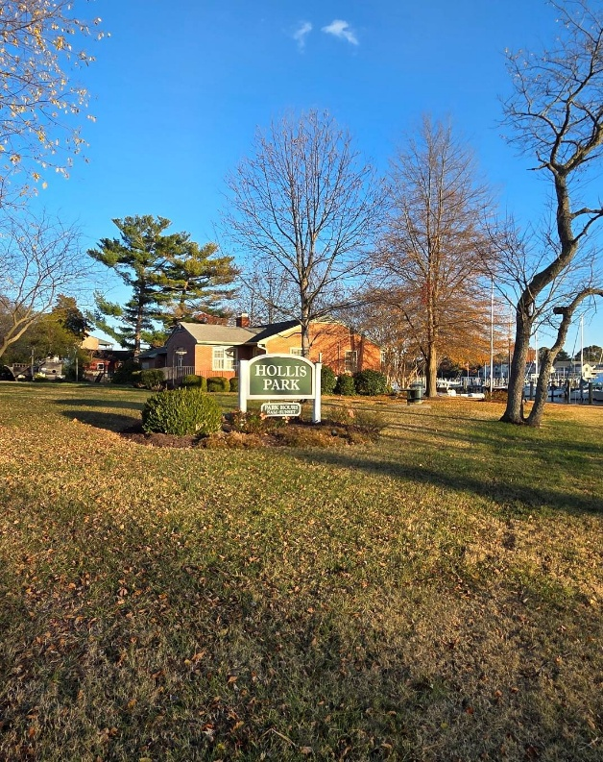
Hollis Park previously housed the Town’s administrative offices. In 2024 the offices were relocated to a new site at San Domingo Creek Park. This provides a unique opportunity for creative re-use of the park and the currently vacant building.
The site is located on the northern end of St. Michaels Harbor and adjacent to the Chesapeake Bay Maritime Museum property. The town also owns approximately 1 acre adjacent to the site that is used for parking at this time. This site is currently being examined for feasibility of a dog park.

The property was purchased, in part, with State Program Open Space funding and any re-purposing of the building would need to retain a recreation component. Previous concepts include use of the site for sea level rise mitigation, a music pavilion, and relocating the Town’s farmers market to this site. A comprehensive assessment is recognized as an important future project for the community.
Hollis Park

The Town in past years has been focusing on the acquisition and improvement of smaller parks to serve the needs of residents. However, in 2024 the Town set a new direction with the acquisition of 7.6 acres which was subsequently designated as San Domingo Creek Park. The community participated in a 9-month public outreach process that led to the final design and adoption of the future plan for what will be the largest park site within the Town.

The St. Michaels school complex, which falls under the jurisdiction of the Talbot County Board of Education, allows use of the school site for public recreation. Three of the facilities identified on the map, and in the inventory provided in Table 9-1, are privately owned and access to these facilities is on a fee basis.

The St. Michaels YMCA (Perkins Family YMCA) opened in 2017. It also includes the Bay Hundred Senior Center and is a part of the YMCA of the Chesapeake organization. It includes full service senior center and a variety of health and exercise facilities: a pool, exercise studios, wellness center, a gym, locker rooms, supervised play, pickleball, basketball and a variety of programs and classes. It is conveniently located next to the school complex on Seymour Avenue.

Table 9-1 provides an inventory and overview of the size and characteristics of the Park and recreation and/or museum facilities located in and adjacent to the Town.

Table 9-1
Approximate Size and Characteristics of Town Park Facilities
(public and private)
Site | Size | Park Features
1. Canton Farm Nature Area (T) | 40 acres | Nature Preserve and Wildlife Observation area located in the County adjacent to Town but owned by the Town and partially under conservation easement.
2. Perry Cabin Field (C ) | 20 acres | General recreation facility with baseball/softball fields (lighted), basketball court, playground areas, picnic shelter, picnic areas, walking trail, soccer fields, public restrooms, and open space.
3. Chesapeake Bay Maritime* Museum (P) | 20 acres | Welcome Center, a working shipyard, exhibit buildings, lighthouse, children’s outdoor exhibits and play areas, boardwalk, piers, picnic tables, bench seating, and views of the Miles River and Foggs Cove.
4. St. Michaels School Complex(C) | 15 acres | Running track, tennis courts, basketball courts and playgrounds.
5. Clint S. Bradley Park (T) | 2 acres | Play equipment, gazebo, picnic tables, and restroom.
6. Bay Hundred Community Pool* (C ) | 1 acre | Outdoor pool facilities, showers, lockers and pool building.
7. Dog Park (T) | 1 acre | A former skate park, currently a parking lot and planned for a future dog park.
8. Hollis Park (T) | 1.9 acres | Park facility providing playground, picnic tables, bench seating and views of St. Michaels Harbor and improved sea level rise mitigation bulkheads, trails and pedestrian promenade along the waterfront.
9. Muskrat Park (T) | .5 acres | Features gazebo, picnic tables, benches and Adirondack chairs, environmental education signage, parking area and views of St. Michaels Harbor and the Miles River. Also features historic replica cannons.
10. St. Mary’s Square * (T) | 1 acre | A park-like setting featuring three circa 1860 buildings with artifacts significant to the history and culture of the area. Including St. Michaels Museum, Boy Scout Cabin, Granite Lodge (Sardis Chapel), The Women’s Club at St. Mary’s Square.
11. Back Creek Park ** (T) | .3 acres | Recreation area with pier, kayak launch ramps and storage racks**, picnic tables, bench seating, play equipment and views of San Domingo Creek.
12. George W. Wilson Reading Garden (T) | .25 acres | Reading garden located adjacent to the library with bench seating, patio area and rain garden.
13. St. Michaels Community Center Community Garden * (T) | .50 acres | 40 beds for vegetables, herbs and flowers, with benches, mulch and compost area.
14. Frederick Douglass Park (T) | .1 acre | Downtown seating area and information kiosk. Restrooms located in adjoining parking area.
15. St. Michaels Nature Trail (T) | 2.5 miles | Eight and ten-foot-wide walking and biking trail – handicap accessible, with benches, doggie bag stations.
16. Park at Radcliffe Avenue (P) | .05 acre | Small historic park with great water views located in the adjoining community of Bentley Hay
17. San Domingo Creek Park & Town Administrative Offices (T) | 7.6 acres | Passive recreation and environmental restoration project with Town Administrative Offices on site. Waterfront trails and pier.
18. E. Chew Avenue Pocket Park (T) | 0.25 acre | A future planned site to serve as a small viewing area along the Harbor and to help mitigate stormwater flooding from sea level rise.
19. Perkins Family YMCA* (P) | 1 acre | A full-service YMCA exercise and wellness facility and also houses the Bay Hundred Senior Center and associated services.
P= Privately Owned, T= Town Owned, C = County Owned
* Denotes a fee required for admittance or use
** Denotes a fee required for storage

The Town owns 60 boat slips that are rented to people whose boats are registered in the State of Maryland. Two of these slips are made available to the Maryland Department of Natural Resources. One additional slip is used by St. Michaels Fire and Rescue Services.

Table 9-2
Public Boat Ramps, Landings and Temporary Docking Facilities in St. Michaels

Site | Dock Features
1.Back Creek Park | Town-owned pier with docking privileges for watermen and residents, kayak launch ramp, and kayak racks for registered users only, landing
2. Honeymoon Bridge at Hollis Park | Town-owned boat slips and temporary docking
3. North Harbor Drive | Town-owned boat slips, two boat ramps and limited temporary parking for trailers
4. Mulberry Street | Small bulkhead area for temporary docking

There is public waterfront access from several of the parks. With the acquisition of San Domingo Creek Park, the Town dramatically increased waterfront parkland in the community. A small fishing pier is anticipated in the future along with waterfront viewing areas, boardwalks over wetland and walking and biking trails that link to the adjacent St. Michaels Nature Trail.

In 2024, the Maryland Department of Housing and Community Development approved the Town’s updated plan to continue as a designated Sustainable Community. To qualify for such a designation, the Town had to evaluate its strengths and weaknesses in areas, including housing, transportation, utilities and recreation. The Town recognized the intrinsic value of our parks to both residents and visitors and supported the continued efforts necessary to maintain the conditions of these facilities while expanding the recreational, cultural and artistic opportunities offered. The adoption of the updated Sustainable Communities Plan as well as the Town’s Priority Funding Area (PFA) Map to include all of San Domingo Creek Park enables the community to qualify for grant funding that would not otherwise be available from the State of Maryland.

The Town is part of the Stories of the Chesapeake Heritage Area. This program focuses attention on the preservation and enhancement of historic, cultural, natural, scenic and recreational resources. Recognition and participation in this program allows access to potential funding for improvements to our parks and open spaces.

Another park and recreational interest under consideration is development of a dog park somewhere in or near St. Michaels. The Town is known for its friendly attitude towards dogs and such a facility is viewed favorably by the community. There are various possibilities and the feasibility and impacts for such needs careful review. The use was vetted as a part of the San Domingo Creek Master Plan and ultimately rejected from that site. There are a few alternative sites that are being considered in or near St. Michaels and it is anticipated that a dog park will become a part of the parks and recreation inventory in the future.

VISION

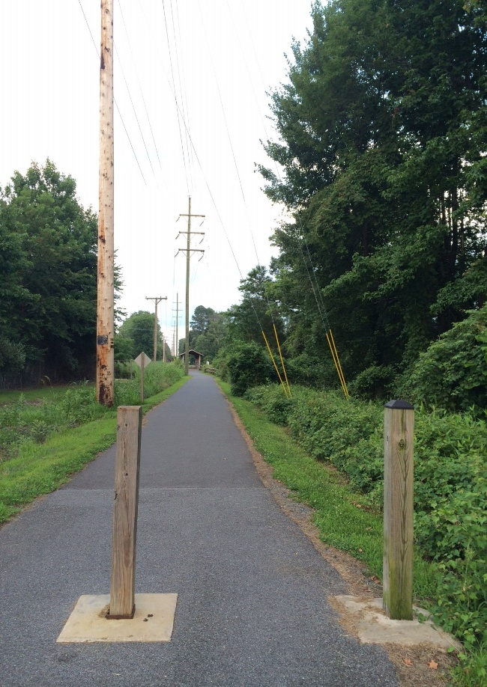
St. Michaels is a town with a diverse park system that serves multiple uses, preserves open space, provides access to the waterfront and maintains the historic character of the Town for residents and visitors.

OBJECTIVES AND IMPLEMENTATION STRATEGIES

9.1 Recognize that the primary function of the Town parks is to provide a serene setting where residents and visitors can enjoy passive recreational endeavors.

9.2 Provide opportunities to meet recreational needs and offer environmental observation and enjoyment. Encourage temporary or permanent art in the parks and open spaces.

9.2.1 Continue to maintain an accurate inventory of Town recreational facilities and improvements.

9.2.2 Maintain adequate public waterfront access points.

9.2.3 Enhance and retain the natural qualities of all parks in St. Michaels, in addition to expanding the nature trail and interpretation elements.

9.2.4 Enhance the existing Town Park facilities through the use of amenities such as restrooms, drinking fountains, benches and Adirondack chairs, picnic tables and bike racks, recycling, water refill areas, dog waste bags, renewable energy.

9.2.5 Ensure public safety of public recreational facilities through the use of adequate lighting, policing and maintenance.

9.2.6 Encourage volunteerism in the acquisition, construction, operation, and maintenance of parks, trails and recreation facilities.

9.2.7 Promote opportunities for public participation in planning parks, trails, and recreational facilities.

9.2.8 Assess the best location and funding options for a future dog park.

9.2.9 Develop a master park plan for the re-use of Hollis Park. Utilize a community input process to assess alternatives and costs for consideration by the Town Commissioners.

9.2.10 Task the Parks and Recreation Advisory Board to maintain the implementation strategies of these objectives.

9.3 Develop and extend the Town’s trail system for shared use by pedestrians and bicyclists.

9.3.1 Work with Talbot County Parks and Recreation Department to provide a pedestrian and bicycle trail system from Easton to the County ball field at the north end of St. Michaels. Include a future trail connection from the south terminus of the Nature Trail to grocery stores and restaurants located near the Town but located in Talbot County.

9.3.2 Coordinate safe biking trails within the Town’s bicycle route system with other existing and planned bicycle facilities.

9.3.3 Work with the owners of the Inn at Perry Cabin and the St. Michaels Maritime Museum to construct an ADA compliant sidewalk tying into the existing Town sidewalk system.

9.3.4 Complete the 1.25-mile extension of the Nature Trail from Railroad Avenue to Perry Cabin Park.

9.3.5 Develop a comprehensive bicycle and pedestrian plan that includes existing and
proposed bicycle and pedestrian facilities to better understand how and where new linkages would be built.

9.4 Parks and Recreation Advisory Board.

9.4.1 Continue open dialogue and budgeting with Commissioners pertaining to park improvements.

9.4.2 Provide oversight to improve and maintain landscaping in parks.

9.4.3 Assign a level of maintenance to parks and recreation facilities appropriate to sustain attractive and useful facilities. Before acquisition or construction, a funding plan for long-term operation and maintenance shall be established.

9.4.4 Assure park facilities provide access for all age groups and conform its park facilities to the Americans with Disabilities Act (ADA) requirements.

9.4.5 Allow for appropriate educational and entertainment activities in Town parks.

9.5 Use recreation facilities to promote environmental and historic awareness.

9.5.1 Implement historic markers and art.

9.5.2 Provide better signage for parks. Signage may include interpretive and historical information.

9.5.3 Identification and celebration of historic activities that have occurred in St. Michaels.

9.5.4 Support historical, environmental and cultural education through the preservation of historical sites and the support of festivals and events reflecting the heritage of the Town.

9.5.5 Continue to evaluate and enforce the rules and guidelines for public parks in the Town.

9.6 Develop San Domingo Creek Park in accordance with the approved Master Plan

9.6.1 Continue work on grant applications for demolition, design and construction of the park.

9.6.2 Work with citizen groups to form support networks to promote and fund park development.

9.6.3 Explore opportunities to better utilize the remaining (2nd) building on the park site adjacent to the Town Administration Building.

POLICIES

The Town maintains a policy to provide availability for a variety of parks and recreation related activities for citizens and visitors on both public and private property.
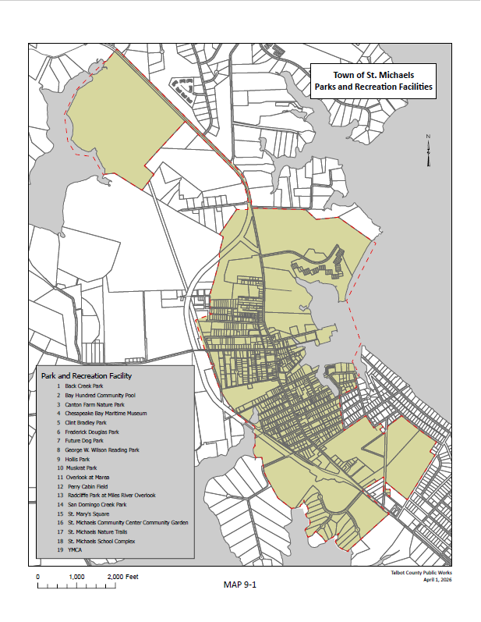
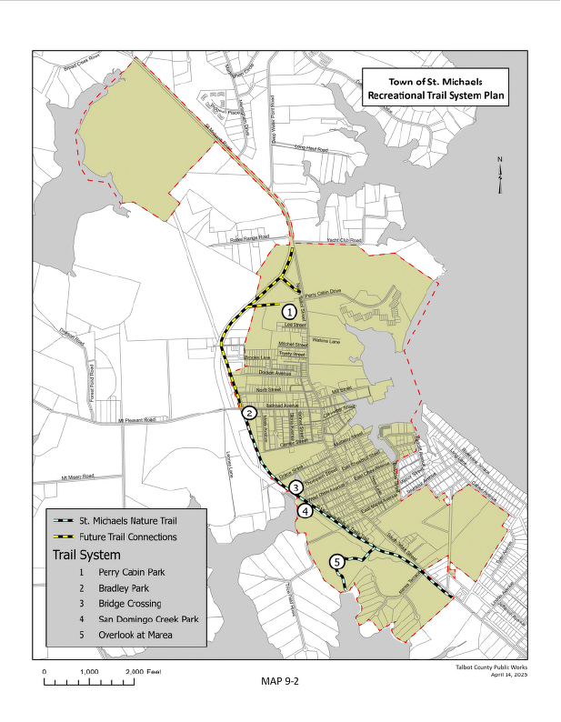

Chapter 10:

Housing

INTRODUCTION

Housing in the Town of St. Michaels consists primarily of single-family residences, typically on lots of 7,200 square feet or less, and for the most part contained in three areas zoned for residential use. According to the 2020 census data there are around 725 housing units (including single and multi-family) in the Town and just under 20,000 county-wide. Around 19% (135) housing units are used as seasonal, recreational or for occasional use only. There are additional housing units adjacent to the Town but are technically outside of the Town boundary. A local housing survey would be of value to measure more specific trends over time. The seasonal nature of the community’s economy should be of consideration in planning and project development.

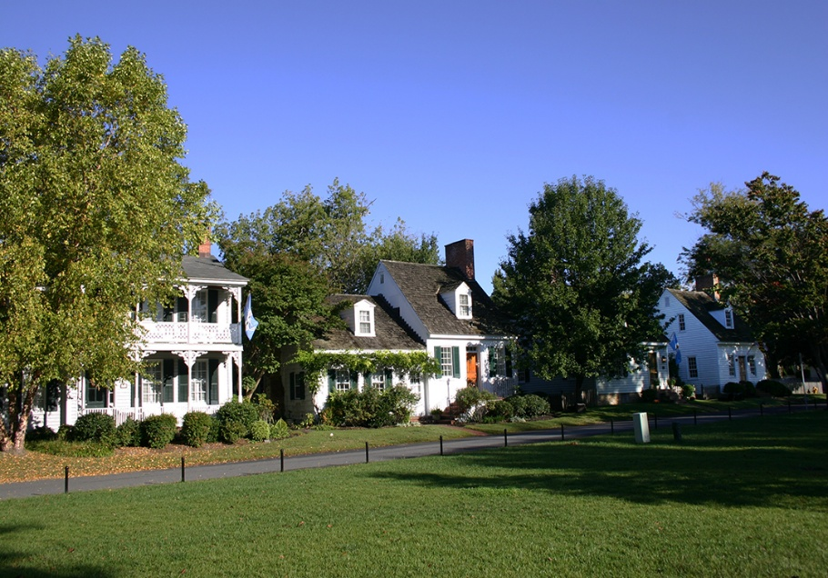
Census data indicates that there are 357 housing units built before 1939, many constructed much earlier in the nineteenth century and considered a vital part of the historic appeal of the Town. The average household size is 2.25 persons per household.

The housing issues in St. Michaels can be generally categorized as one of three problems: housing cost, housing quality, and housing availability. To some extent these problems are interrelated.

The residential rental market in the Town of St. Michaels is also limited. Many rentals are designed for low to moderate income families but there are limited housing units within condominiums and apartments above commercial establishments. However, considering the small size of the community there are approximately 145 housing units that are subsidized and available for low to moderate income families. These include: Riverwoods Apartments, Hamilton Village, Griffin Apartments, Willieville Apartments and 8 homes for Habitat of Humanity. Habitat for Humanity is also considering another project in Town. The Housing Commission of Talbot County includes St. Michaels and Easton Housing Authorities and oversees federal housing programs for public assistance in Town. The Housing Commission is planning the demolition and disposition of the Griffin Apartments over the next 5 years. Current activities include preparing a Request for Qualification (RFQ) to select a development partner for the project. Density, unit type and funding still needs to be determined but will be based on existing zoning standards, community acceptance of design and the public approval process.

The Town is also experiencing the deterioration of a small portion of our housing stock through home abandonment or neglect. While the Town has adopted the International Building Code as general livability standards, citations related to blight have proven cumbersome and of limited success in producing the renovations necessary to bring these dwellings back into code compliance.

A few small cottages, formerly watermen’s homes, have been restored and placed on the market as vacation rentals. These historic cottages had fallen into disrepair and were permitted to be restored and used for short term rental, thereby saving them from blight and demolition.

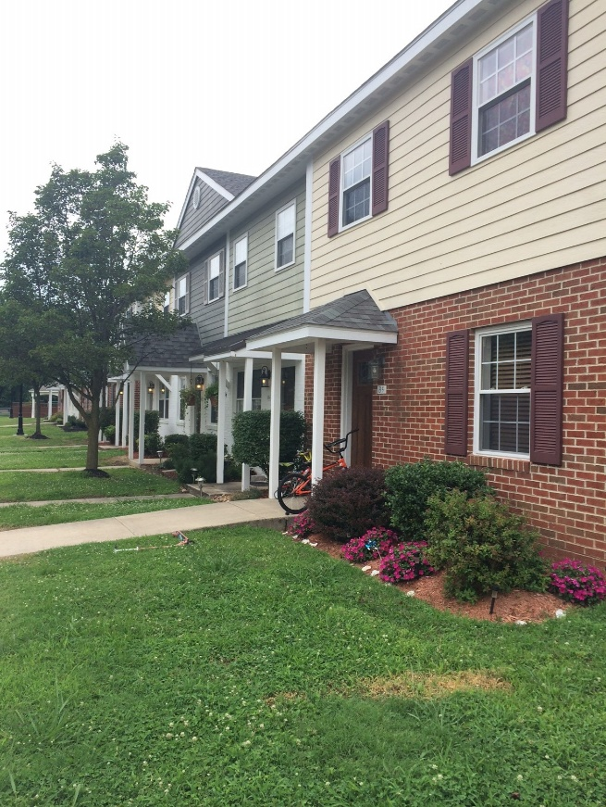
While zoning changes have been enacted to allow apartments above commercial establishments, fire and safety issues often make this conversion not financially feasible. The Town continues to support mixed-use structures in the business area as they provide greater security during off-hours and broaden the range of housing options in proximity to shops and services. Market conditions and high commercial rental rates make doing business in St. Michaels expensive; therefore, the addition of residential rental income should be an attraction for business investment. There is also some limited employee sponsored housing offered from major employers and exploring more of this would be of value to help keep employees of local businesses living in the Town.

As a result of successful historic preservation efforts and our unique geographic location, home prices are generally higher than comparable houses in many other Eastern Shore towns.

The Town of St. Michaels is essentially fixed within its present boundaries with the exception of those areas as noted in Chapter 1 as infill developments which includes about 25 vacant lots throughout town and a few larger tracts of residential land. Chapter 2 includes a potential build-out scenario of approximately 116 additional units which would likely be a mix of unit types and occur at buildout, most of which during the next 10-year planning cycle.

According to the 2020 census data, 52 percent of the Town’s population is over 50 years in age. It is a well-documented fact that as people age, they prefer to remain in their homes. However, living independently is not always possible and there is often a need for assistance in everyday living. This need has been met in other jurisdictions, where space permits, by conversion of part of a residence to live-in accommodations. Alternately, where space is available in homes occupied by pre-retirement people, older relatives can be accommodated in attached suites or within accessory structures converted to accommodate such a use. However, such accommodations should not affect the historic architectural appearance of the Town’s homes.
Opportunities for revitalization exist in several areas of the Town including commercial and residential properties. Many of these areas as noted in the Town’s adopted Sustainable Community Plan (see Map 10-1) The Sustainable Communities Program is a place-based designation offering a comprehensive package of resources from the State of Maryland that support holistic strategies for community development, revitalization and sustainability. It requires geographically targeted resources for historic preservation, housing and economic development under a single designation. The designation places special emphasis on infrastructure improvements, multimodal transportation and development that strengthens existing communities.

Affordable and sustainable housing within a defined geographic area with an existing built environment is best achieved through revitalization or additional state investment to strengthen the local market and targeted sites. The Town renewed its Sustainable Communities Program area in 2023 which requires updating every five years. This includes several residential neighborhoods which may be able to take part in such programs.

LOW INCOME, WORKFORCE AND FAIR HOUSING

St. Michaels is a small community with limited housing opportunities with only about 2% available for sale and about 3% are available as rental. Median residential home sales price in 2022 was $539,495. The County area median income is documented at $106,500 per the Maryland Department of Planning (see table below). With interest rates and a meager deposit, housing ownership would likely require at least $3,000 and above monthly mortgage payments and above and would exclude the average median income or workforce citizen from the housing market. Rental market rates in 2025 are estimated to be over $2,000 per month, limiting affordability in the rental market for families with average or below average income. The Town continues to explore ways to provide additional affordable housing by promoting employer based housing programs, accessory dwelling units, and workforce based housing projects where opportunities exist. However, considering the limited opportunities for new housing and the size of the Town, we look towards working with Talbot County, Easton and the Housing Commission in support of workforce housing that would benefit both the Town of St. Michaels and the entire county.

We are committed to actions to assist in housing wherever possible including:

- Promote projects for affordable housing – workforce and low income
- Support to affirmatively further fair housing - inclusion and diversity of housing, reduce disparities and comply with civil rights and fair housing laws.
- Work with the Maryland Department of Housing and Community Development activities and programs.
- Continue to support work with St Michaels Housing Authority (Housing Commission of Talbot County) with subsidized housing programs.
- A policy of non-discrimination and proactive advancement of housing equity.

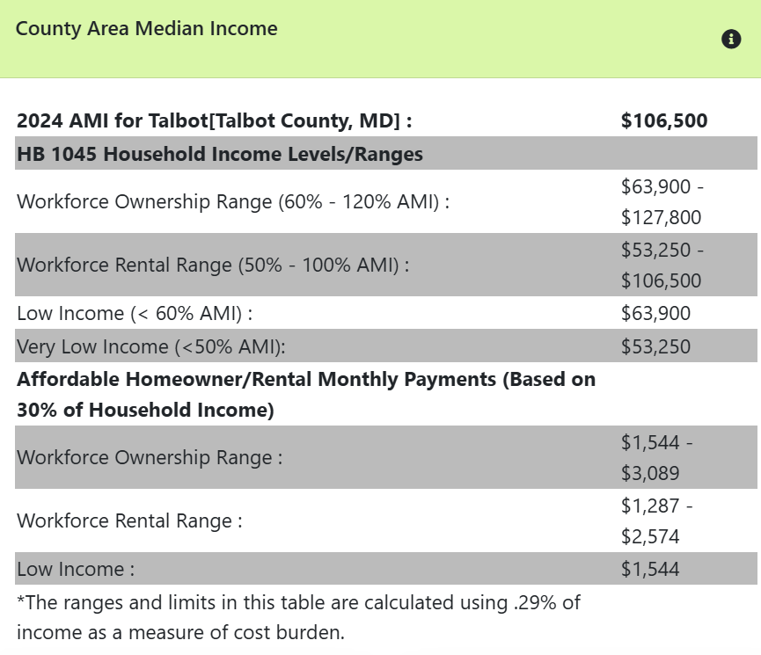
Source: Maryland Department of Planning

Revitalization efforts should be concentrated on improvements which do not change the character of a neighborhood, but offer opportunities for home and business structural improvements, landscaping, street and sidewalk improvements and a potential for new rental or home ownership opportunities. Additionally, attention needs to be directed toward ensuring that infill and restorative projects do not create architectural anomalies in their respective neighborhoods.

There is constant pressure to convert homes for short-term rentals or vacation housing due to the attractive qualities of the Town and economic opportunities. Only a few specific older and historic homes can be used as short-term rentals as well as second floors above commercial spaces. This is intended to protect existing residential neighborhoods by limiting that use from spreading throughout the Town and reserving long term residential homes for permanent residents.

Accessory Dwelling Units are becoming a popular option to be used for family visitors. The Zoning Ordinance allows for these to be used as long-term rentals, and this is a way to provide for more affordable housing without changing the appearance and overall use of residential neighborhoods.

VISION

The Town of St. Michaels will retain its historic, small-town character, while providing for the preservation of the Town’s historic structures. The Town will enact rules and regulations necessary to address the housing needs of residents regardless of income and age.

OBJECTIVES AND IMPLEMENTATION STRATEGIES

10.1 Maintain and restore the integrity and appearance of residential neighborhoods and commercial properties.

10.1.1 Enforce Town Code Chapter 96, Blight, which is intended to prevent and prohibit blighted structures within the Town of St. Michaels.

10.1.2 Closely monitor the construction and development of any new project for compliance with applicable zoning and site plan requirements.

10.1.3 Consider the drafting of an Ordinance that addresses the requirement that new structures and renovations be in keeping with the general appearance of the neighborhood in which they are located.

10.1.4 Explore with Talbot County the possibility of tax relief for families who are active members of the St. Michaels Volunteer Fire Department.

10.2 Support housing revitalization and housing affordability efforts.

10.2.1 Seek federal, state and other funds specific to revitalization and rent-to-own opportunities.

10.2.2 Continue to coordinate with the Housing Commission of Talbot County to improve site conditions through structural upgrades, sustainability landscaping and security measures.

10.2.3 Work with Habitat for Humanity to build additional affordable single family houses in St. Michaels.

10.2.4 Utilize the Town’s approved Sustainable Communities work program strategies in conjunction with the Comprehensive Plan to support housing revitalization when appropriate.

10.2.5 Support affirmatively furthering fair housing - inclusion and diversity of housing, reduce disparities and comply with civil rights and fair housing laws.

10.2.6 Support a “Point in Time” survey to identify total number of people experiencing homelessness in St. Michaels.

10.2.7 Complete a more detailed housing survey than census data to determine full-time and part-time housing residents and amount of vacation housing to help evaluate impacts on the community and neighborhoods.

10.3 Increase alternatives to single residential units within Town in areas where appropriate.

10.3.1 Continue to encourage the mixed-use in commercial buildings to include rental units on the upper floors of commercial buildings.

10.3.2 Continue to explore public-private partnerships to help provide
opportunities for moderate income and working families including employer sponsored housing programs and review potential zoning code changes to provide for such.

10.3.2 Explore the use of extended family accommodation through in-home modification or Accessory Dwelling Units in appropriate zones.

- Establish specific criteria to ensure Accessory Dwelling Units contribute to the neighborhood in which they are located.

- Modify Chapter 340 of the Town Code to permit live/work configurations in future redevelopment or infill projects.

- Encourage long-term rentals and possible routine inspections to ensure compliance.

10.3.3 Encourage and support grant requests or tax credits for rehabilitation and/or construction for housing for low to moderate income or elderly residents.

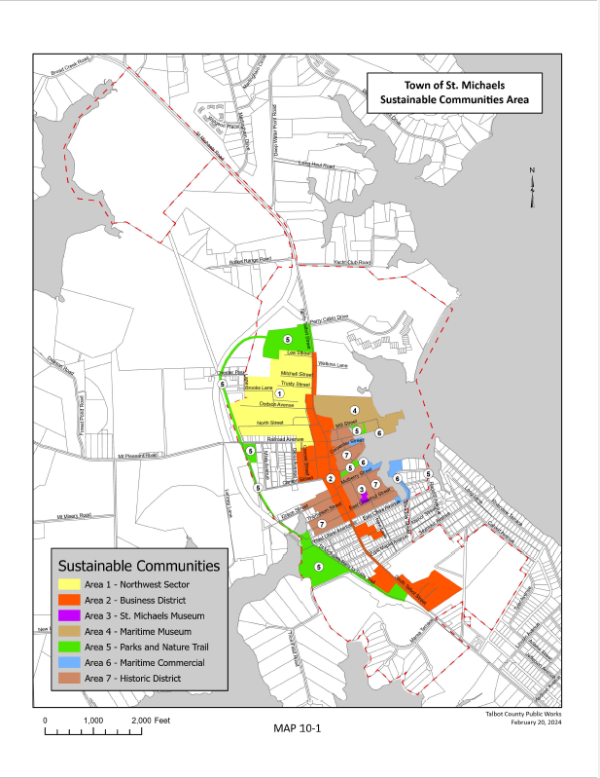

Chapter 11:

Governance and Communications

INTRODUCTION


St. Michaels is governed by five Town Commissioners elected at large by the voters of the Town for staggered four-year terms. The Commissioners elect a President and a Vice-President. Administrative functions are carried out by Town Office staff under the direction of the Town Manager, appointed by the Town Commissioners. In addition to the Manager, the Town employs a Clerk, Zoning Officer, Code Compliance Officer, Planning and Zoning Clerk, Finance Clerk, General Services Clerk and Administrative Assistant.

Many important functions of the Town Government are carried out by Town Boards and Commissions appointed by the Town Commissioners.

Board of Zoning Appeals. This board decides appeals where it is alleged there is an error by the Zoning Inspector or the Planning Commission in the enforcement of the zoning code, interprets the intent of the zoning code, decides special exceptions and authorizes on appeal in specific cases a variance from the terms of a Town ordinance.

Climate Change/Sea Level Rise Commission. This commission studies the recommendations contained in the St. Michaels Harbor and Stormwater Infrastructure Study and the Comprehensive Plan, recommends projects, and pursues grants designed to help mitigate and prepare the Town for sea level rise anticipated by 2050. It coordinates planning of sea level rise solutions for waterfront businesses and residences adjacent to the Town's harbor and is a clearing house for information related to sea level rise initiatives within the Town.

Ethics Commission. This commission provides published advisory opinions to persons subject of the Town’s Ethics Code and makes determinations as to complaints filed by any person alleging violations of the Ethics Code.

Historic District Commission. This commission develops guidelines for the preservation, restoration and rehabilitation of existing structures and for the design of new structures in the Town’s Historic District that are consistent with those of the Maryland Historical Trust. It acts upon requests for a certificate of approval required in the Historic District by the zoning code.

Parks and Recreation Advisory Board. This board advises the Town Commissioners with respect to the Town’s parks. It reports to the Commissioners any needs for maintenance and recommends policies and practices and the means of their implementation. It interacts with community agencies and others in making recommendations on the planning of facilities and programs in the parks. It coordinates activities by citizen volunteers and makes budget recommendations to the Town Commissioners.

Planning Commission. This commission prepares the Comprehensive Plan and submits it to the Town Commissioners for adoption, approves plans for major geographic sections or divisions of the Town and recommends the boundaries of the various districts so the Town may avail itself of zoning powers under Maryland law. When directed by the Town Commissioners, it makes recommendations relative to amendments to the Town's Comprehensive Plan. It advises the Town Commissioners and Board of Zoning Appeals on matters relating to zoning, annexations, applications for special exceptions and variances. It reviews site plans for compliance with the zoning code, approves proposed subdivision plats and makes recommendations to the Town Commissioners on applications for growth allocation.

Tourism Advisory Board. This board assists the Town in its efforts to manage, promote and stabilize the economic health of the Town's tourism economy while preserving the Town's historic, maritime, and small-town character, and provides advice on matters generally relating to the business environment.

Waterways Management Advisory Board. This board is an advisory and consultative body to the Commissioners of St. Michaels and the St. Michaels Planning Commission on policy and planning issues affecting the waters of the Town. It monitors the condition and operation of all Town-owned slips and launching facilities. It proposes new improvements to or expansion of existing piers, bulkheads or shoreline stabilization projects and reviews lateral lines or alternative methods for establishing riparian rights for projects proposed in Town waters.

Communications amongst the Town’s citizenry, its government bodies and business community should be supported by the most advanced technology. Technology carries a cost as does the need to keep an informed citizenry to support the Town government, attend its meetings, participate in its activities, and keep abreast in a timely manner of its decisions and regulations.

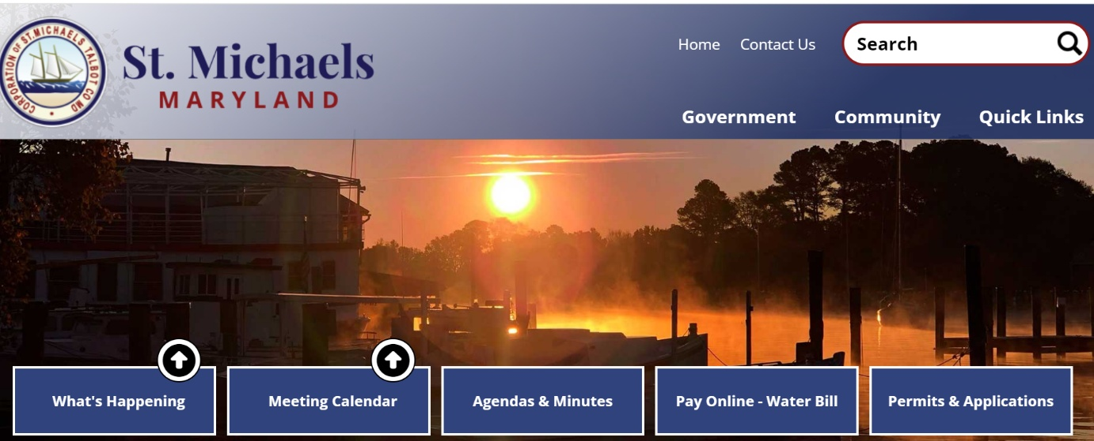

The Town recently updated its website www.stmichaelsmd.gov. This action reorganized information for easier access by citizens and visitors. In addition, schedules of meetings, agenda, minutes, legal notices, enforcement documents and applications are available and updated as legislative changes are promulgated. The site also includes links to local and state resources and local clubs and organizations. New online payment of water bills is provided. Work continues to add features such as on-line development applications and payment for processing. The Town uses social media to inform its citizens including “Constant Contact” messaging on special events, emergencies and public information. Anyone can sign up and be included in this notification system. The Quick Links tab on the website also takes you directly to a list of current activities in Town.

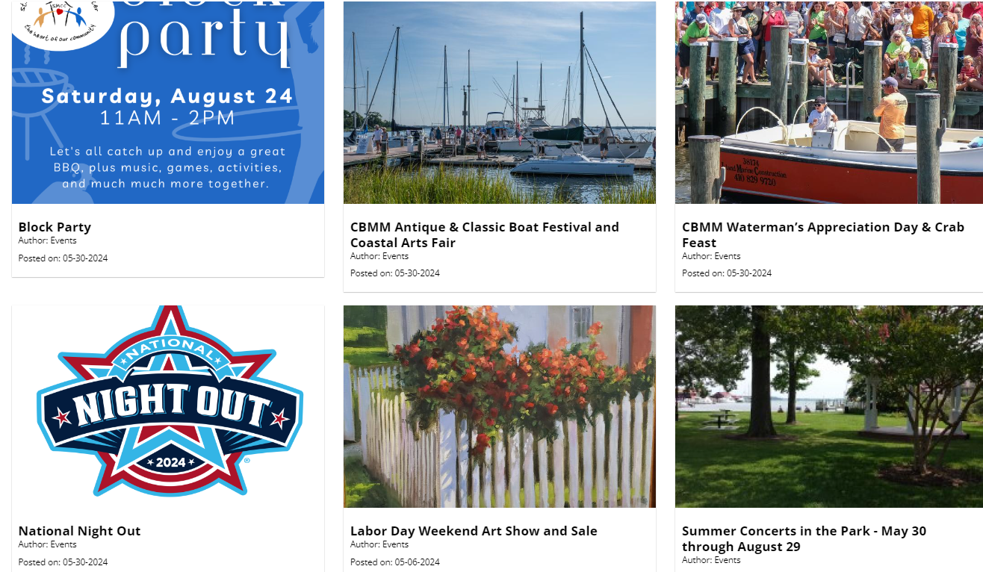

Quick Links Activities on the Town’s Web Page
As part of the Comprehensive Plan update, the community noted two areas of improvement in governance and communication that would be of value. First is to establish more direct relationships with Talbot County government. The County includes large areas of residential and commercial development that abut the Town, but not within the Town’s jurisdiction. Also, the County provides sewer services to the Town, while the Town provides water services to these adjacent areas.

The County and Town can share long-range planning studies for land use and infrastructure, and development reviews and solicit input to ensure compatibility. The Town’s Municipal Growth and Development Regulations (Chapter 2 of this plan) documents areas of mutual concern and more formal review and advisory processes would ensure both governments are aware of activities in these areas.

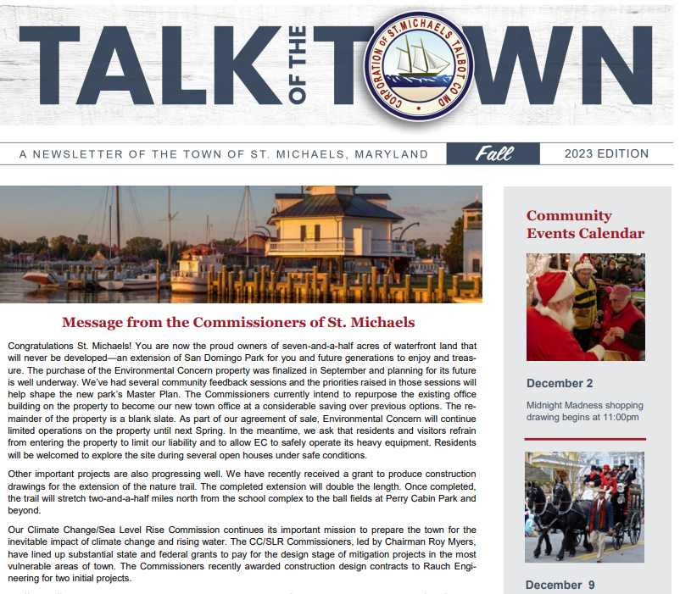
A second area of concern is to better share plans and goals between the Chesapeake Bay Maritime Museum and the Town leaders. There were 30 special events or festivals during 2023, several of which were within the Chesapeake Bay Maritime Museum property or with other non-profit organizations. Better communication and coordination between the Town and all festival providers would help reduce any areas of concern such as understanding when major events are planned and processing events permits in a timely manner, and economic issues and interests that are shared between the various groups.

The Town also publishes a seasonal newsletter to keep lines of communication open between the government and its citizens and provide another format to keep everyone apprised of activities, events and projects.

Town Newsletter

VISION

St. Michaels continues to employ modern communications technology as a governance tool to impart to its residents and its business community the Town’s notices, activities, plans, decisions, and regulations in as timely a manner as is available.

OBJECTIVES AND IMPLEMENTATION STRATEGIES

11.1 Continue to develop electronic communications between the Town and individual citizens and businesses.

11.1.1 Create an email contact list which encompasses all residents and businesses of the Town.

11.1.2 Develop a comprehensive community calendar with events of the community center, library, churches, art league, etc.

11.2 Continue to collect and analyze data related to tourism efforts and impacts on the Town.

11.2.1 Support sustainable tourism efforts by publicizing special events and programs utilizing print and electronic venues.

11.2.2 Support historic and cultural events relating to the history of the Town through print and electronic venues.

11.2.3 Work with the Tourism Advisory Board to diversify and target activities as appropriate.

11.3 Strengthen communication between the Town Commissioners and the various Town Boards and Commissions, Talbot County Government, the Chesapeake Bay Maritime Museum and all branches of government.

11.3.1 Continue to draw on the expertise of Town residents to provide support and assistance to the Town government.

11.3.2 Establish communication processes or protocols between the Town government, County government and non-profit organizations.

11.3.3 Outreach to State and Federal governments to strengthen communication and solicit resources.

11.4 Strengthen communication between the Town Commissioners and residents.

11.4.1 Continue the Commissioners’ efforts to provide transparency in government.

11.4.2 Consider altering the hours of the Commissioners’ public meeting times to afford greater participation by the residents.

11.4.3 Consider ways to allow part-time residents to be more actively involved in governmental decisions.

Chapter 12:

Climate Resilience

INTRODUCTION

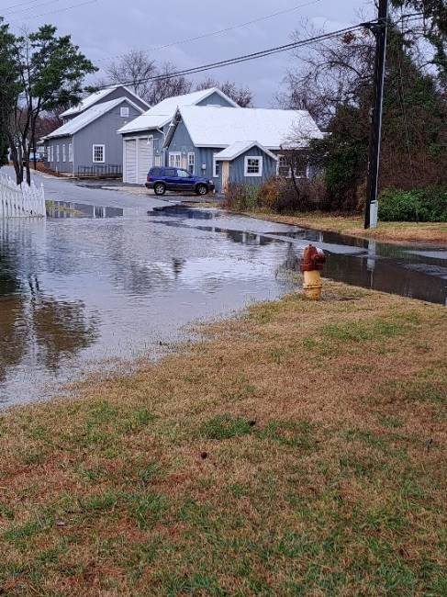
Tide records have revealed that Chesapeake Bay Sea levels have risen more than one foot over the last century, due to global sea level rise and land subsidence. Sea level rise in Maryland is accelerating and projected to rise over one foot more by 2050 (Boesch et al, 2023; Sea Level Rise Projections for Maryland, 2023; University of Maryland Center for Environmental Science, Cambridge, MD). As a consequence, many residents have taken measures to raise their homes or install alternative energy systems to be more climate resilient and sustainable. St. Michaels has also adopted Code requirements for construction in the floodplain, such as additional freeboard venting.

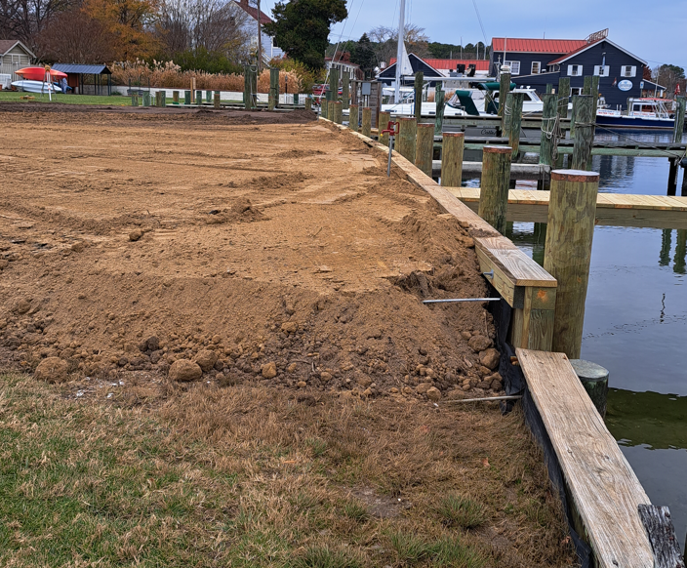
The Town has also partnered with Talbot County to adopt a Hazard Mitigation Plan and evacuation route for the Bay Hundred area. The Town of St. Michaels also created the Climate Change/Sea Level Rise Commission (CC/SLRC) in 2021 to begin a multi-year effort to upgrade the Town's harbors and stormwater infrastructure in order to prepare for the anticipated sea level rise and flooding expected by 2050 and beyond.

The Commissioners recognize the challenges associated with being a coastal community on the East Coast near the Chesapeake Bay including low lying infrastructure and high water tables, and hurricane risks, and that it is crucial for the Town to improve its resiliency measures. Flood mitigation efforts have focused both on more urgent needs to mitigate impacts to the year 2050 and longer-range efforts to the year 2075. The Climate Change/Sea Level Rise Commission consists of seven members appointed by the Town Commissioners of St. Michaels. Members include citizen volunteers, business representatives and professionals with expertise in climate change and sea level rise. Since its inception, their focus has been to actively plan for mitigating the impacts of sea level rise in the Town of St. Michaels in both the Miles River and the San Domingo Creek frontage and has been building the foundation for action over several years. They also work to partner with and inform property owners of ongoing efforts and opportunities to participate in the planning and design process.

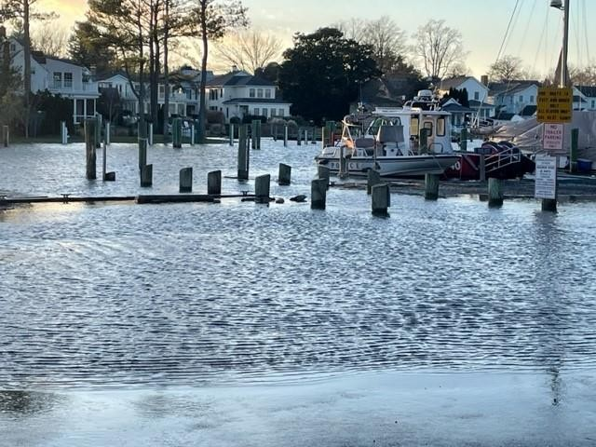
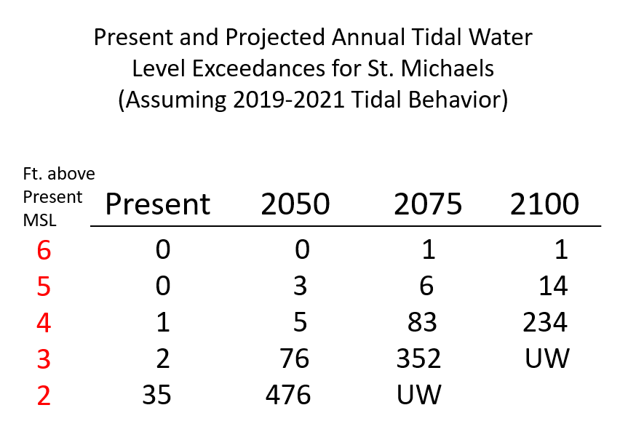
Among various studies that have been completed were the detailed sea level and storm surge projections developed by Dr. William Boicourt that considered flood events and through the year 2050 and 2100. This chart indicates that using a 5’ mean sea level elevation would likely mitigate all but hurricane flooding events up to the year 2075. Therefore, this was chosen as the preferred design criteria for new infrastructure improvements.

St. Michaels Harbor Area

A report called: Harbor and Stormwater Infrastructure Study (2021) completed by George, Miles & Buhr identified at-risk flooding areas with conceptual mitigation strategies around the main Harbor that could be implemented in the next 5-15 years. This study was completed with funding under the Maryland Department of Natural Resources - Community Resilience partnership with the Chesapeake and Coastal Services Division. It identified vulnerable areas of the Town in need of detailed analysis and mitigation efforts to protect them from the impacts of sea level rise and nuisance stormwater flooding. The analysis has resulted in looking closely at the most flood-prone areas which includes the east side of Town along the St. Michaels harbor which abuts the Miles River and in another study titled: San Domingo Creek & Westside Stormwater and Flood Mitigation Study for the west side of Town, completed in 2023, which includes the San Domingo Creek watershed. Both of these waterbodies connect and flow into the nearby Chesapeake Bay.

The study recommended using a 1 percent sea level rise projection of 2.4 feet plus the normal 1.02 feet tide or a 3.42-foot rise over mean sea level for mitigation projects. The study also depicted severe flooding by including a 5 percent chance of a sea level rise of 2.1 feet together with a 1.9-foot tide surge for a 4-foot flooding event. After further consideration of the above study and this report a later study on the San Domingo Creek area, the CC/SLRC recommended setting the objective for mitigation of sea level rise and stormwater flooding projects at 5 feet over mean sea level as there was a significant difference between protection at 4 feet vs. 5 feet by the year 2075.

For planning purposes, the harbor area has been divided into three parts or phases for study. First is the area defined by E. Chew Avenue and W. Harbor Road located along the southern portion of the Harbor area. The second area of study is the northern harbor which includes the Chesapeake Bay Maritime Museum (CBMM) – Burns Street/Mill Street, the Promenade waterfront walkway and Honeymoon Bridge which links Cherry Street to Hollis Park and the CBMM and the associated bulkhead along the water. The third area of study is the central harbor area including Muskrat Park, Church Street, Mulberry Street and the associated waterfront homes and businesses in that area. Several planning and design efforts are underway at the time of development of this Comprehensive Plan.

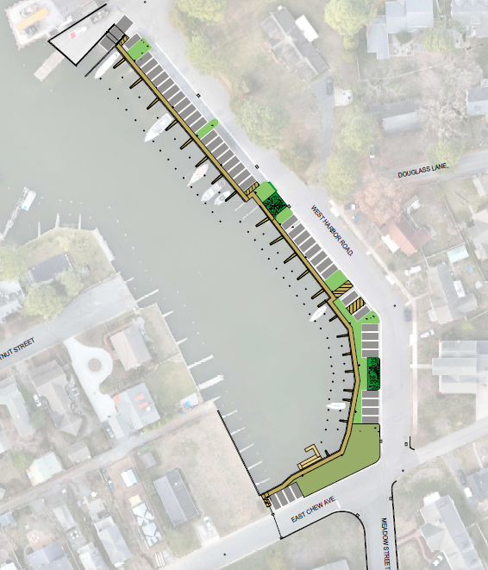
The East Chew Avenue/W. Harbor Road area in the south harbor area was the first conceptual mitigation plan developed for the harbor flood-prone area on the eastern part of Town. This analysis included a feasibility and conceptual design (shown here) which recommends raising the bulkhead, increasing green space and improving stormwater management through various collection designs and pumping systems for the area.

The next area of the harbor to be analyzed was the northern portion along the Mill Street Corridor. The Town was subsequently awarded an Advanced Assistance Grant for additional work in the middle and northern sections of the harbor. The project is funded by the Federal Emergency Management Agency (FEMA), through the Maryland Department of Emergency Management (MDEM). The Advanced Assistance Grant which funds mitigation work enabled the development of the overall concept plan and engineering and construction drawings to be used for future permitting and development. The goal is to have design and construction drawings that are permit viable and ready to be submitted for future construction grant requests sometime during the 10-year span of this Comprehensive Plan update.
W. Harbor Road (Small Boat Ramp) &.
E. Chew Avenue Concept Plan
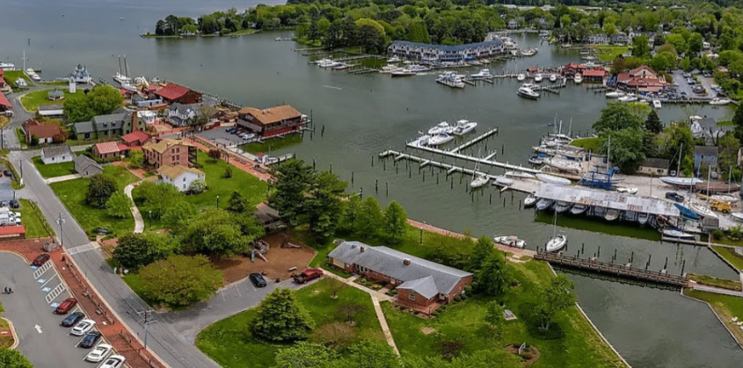
St. Michaels Harbor Area
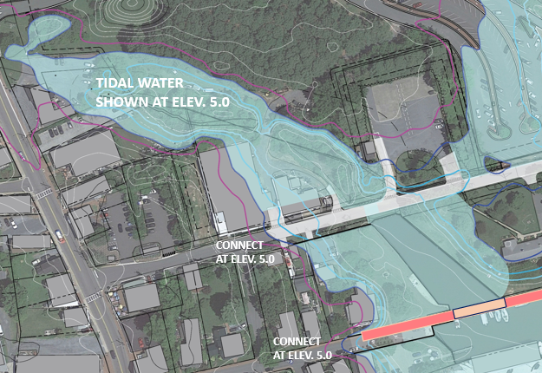
Projected 5’ Mean Sea Level Elevation Flood Area – Honeymoon Bridge and Mill St. Area
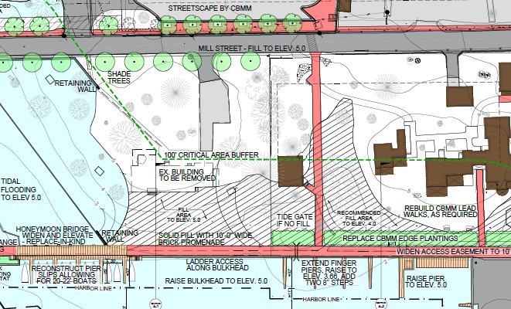

Advanced Assistance Grant: Phase I Conceptual Flood Mitigation Design Plan

Phase I conceptual design and construction plans addressed issues related to stormwater management and sea level rise along the Mill St./Burns St. area adjacent to the Chesapeake Bay Maritime Museum and Town owned Hollis Park site (See design above). It examined flood mitigation and resulted in new designs for raising these roads and building a new elevated bulkhead. It also includes raising, widening and rebuilding Honeymoon pedestrian bridge and some design improvements along Cherry St. The project includes final construction drawings, and the Town will be looking for opportunities to fund these improvements during this Comprehensive Plan’s 10-year cycle. The Town will continue to partner with the Chesapeake Bay Maritime Museum to find ways to implement the plans which will benefit both the town and the museum with the least impact to surrounding properties. The next phase of the grant funded activities, Phase II work, is to study Muskrat Park, Church St. and Mulberry St. and develop similar mitigation projects during 2025 with construction improvements to follow.

San Domingo Creek Watershed

Building on the main harbor efforts are studies and projects to consider specific issues and possible design improvements related to stormwater management infrastructure and localized and projected flooding for the Town's second harbor and waterfront on the San Domingo Creek, located on the west side of St. Michaels.

A report titled: St. Michaels San Domingo Creek and West Side Stormwater and Harbor Infrastructure and Flood Mitigation Study, was completed by BayLand Consultants December 6, 2023. The vulnerability analysis conducted in that study indicated that the Back Creek Park area is ranked high in vulnerability assessment prioritization for flood mitigation. The report recommends replacing a failing bulkhead with an expanded living shoreline in Back Creek Park. (See Living Shoreline design concept.) A grant was awarded from the Maryland Department of Natural Resources to complete this project and work has commenced.

In addition, a feasibility study was developed regarding the possible use of a tide gate at the narrow part of San Domingo Creek where a nature trail bridge crosses the creek. This study considered the effectiveness in protecting the upper watershed from tidal flooding.

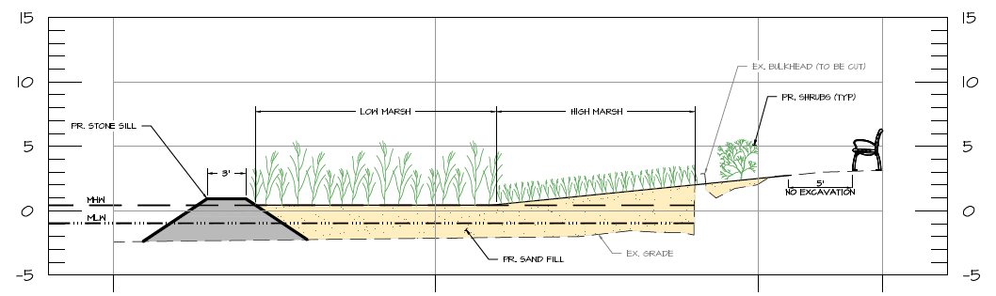
Conceptual Living Shoreline Design – Back Creek Park

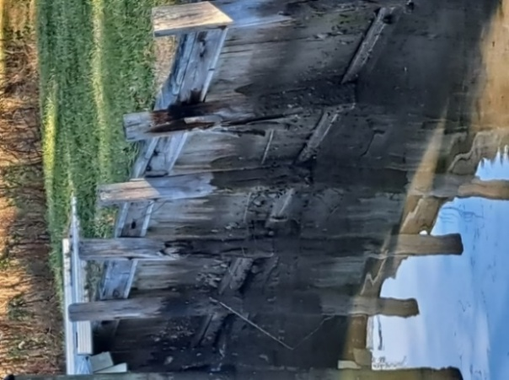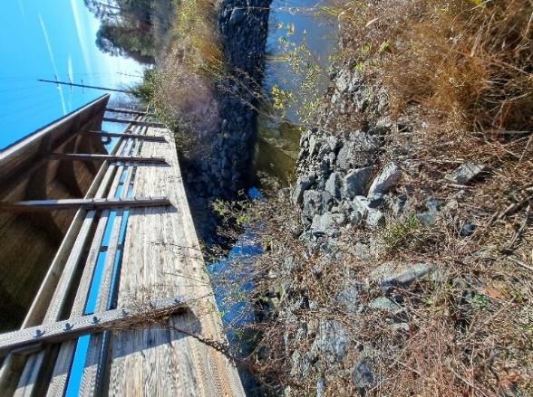
Bulkhead to be replaced Tide Gate study area at
with a Living Shoreline Nature Trail bridge

Another community driven effort to improve the Chester Park, North Street, Perry Street and Brooks Lane area is being worked on. This is both a drainage improvement project and a neighborhood enhancement effort. The drainage in this area was initially poorly designed many years ago and is in need of retrofitting improvements.

“Envision the Choptank” environmental partners began hosting community meetings in 2022. That was followed by some topographic surveys by the University of Maryland Sea Grant Extension. In 2023, BayLand consultants completed an assessment and hydraulic analysis of the area and recommended replacing culverts, inlets and installing redesigned swales to mitigate stormwater flooding. A “watershed” type of approach is being taken with phase I road and culvert replacements being planned and phase II additional residential scale best management practices to be developed.

The Center for Watershed Protection has assisted the community in helping coordinate efforts and research grant opportunities for further flood mitigation work needed in the future. Clean up efforts removed debris and contributed to improved drainage. Specific plans for improving the drainage systems on both public and private lands are being developed and will help reduce flooding common to the area. Grant funding to continue the work is being considered with the Maryland Department of the Environment.

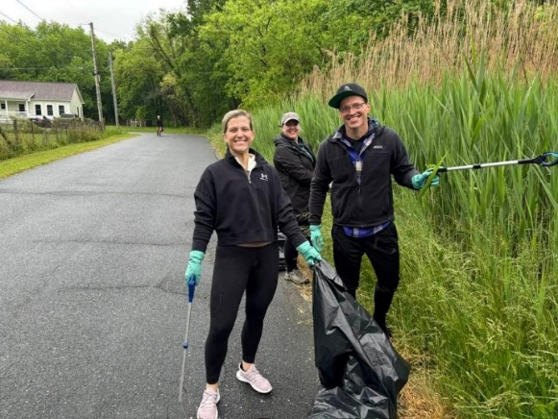
 Clean Up Day Workers

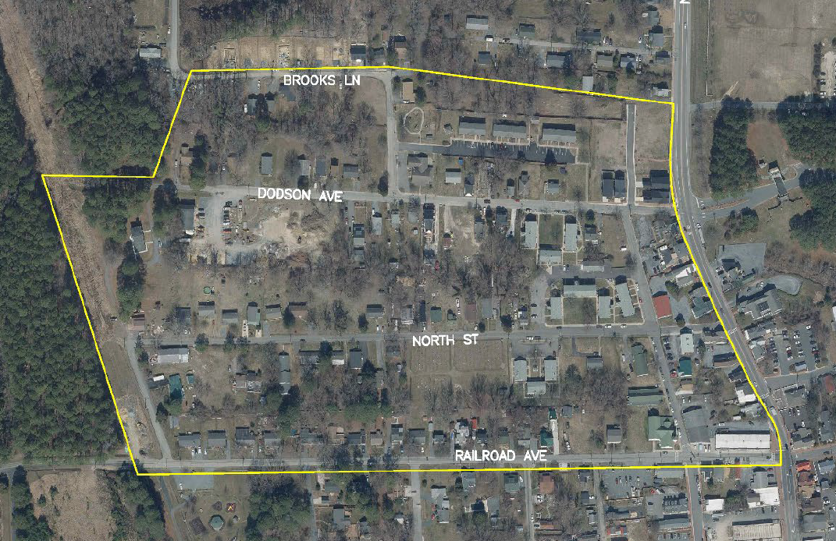
North Town Stormwater Mitigation Study Area

St. Michaels Floodwatch

Dr. Andrew Thaler, a member of the CC/SLRC, developed a tool to help the residents of St. Michaels better visualize and understand how sea level rise will affect the Town in the coming decades. This is an interactive web visualization of flooding projections, overlaid with photographs from recent flooding events.

Nuisance flooding (also called high tide or sunny-day flooding) is flooding that occurs predictably throughout the year in conjunction with large high tides. Unlike flooding associated with major weather events, nuisance flooding represents a chronic threat to the Town's infrastructure, but one for which we can plan and prepare. Storm surges, though rarer, occur infrequently in conjunction with weather events and extreme high tides. Photographs from commonly flooded areas can be posted on the web page for St. Michaels Floodwatch which uses a story maps framework.

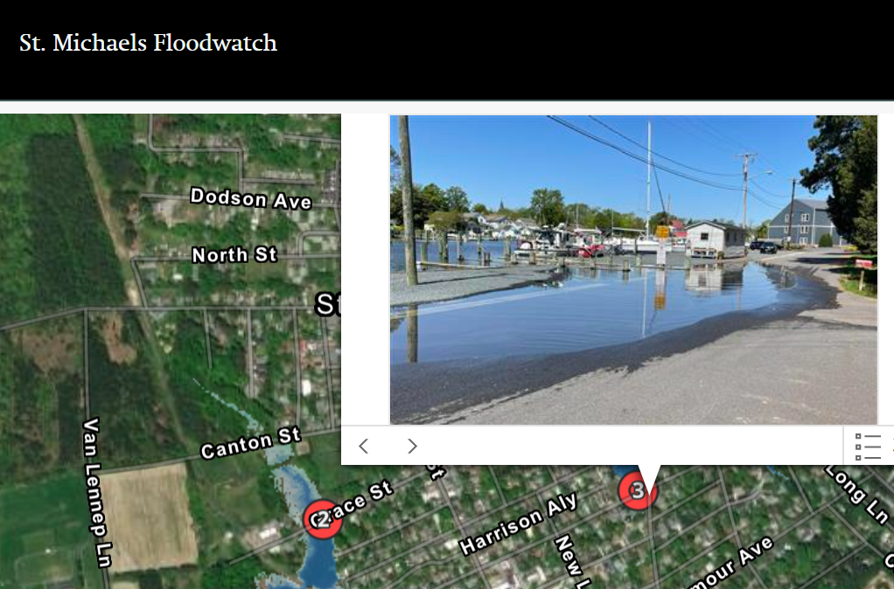

Climate Change

As the Earth continues to warm, it is incumbent on all of us to take measures to reduce our consumption of energy to limit our carbon footprints. Using renewable resources (solar, wind resources, electric vehicles, recycling) and energy efficient technologies in our homes and work are a starting point and something we all can do to help. The Town has focused efforts on sea level rise mitigation, and as we develop and implement those plans, expanding the focus to energy conservation and carbon reduction will be a priority in the future. It is anticipated that natural resources conservation efforts will increase in importance over time to enable a sustainable future. Climate change and resource conservation is of high importance and one of the major planning themes for this Comprehensive Plan.

The Challenge

The Town Commissioners and the Climate Change/Sea Level Rise Commission have followed a classic planning process where we first identified the problem, documented the problem, studied the problem, designed solutions and are implementing the solutions. Producing documentation as feedback on how effective the results will be is important to learn lessons and make adjustments as warranted for the future. Recognizing that sea level rise impacts both public and private properties will likely require partnerships between the Town and property owners to effectively mitigate the impacts.

As we move forward from concept designs to specific improvements, the costs become greater. Construction of mitigation infrastructure will require millions of dollars over time. Although grants are a tremendous help, they often require a match of 25 percent or more. For a small town like St. Michaels, providing funding for this work is a major challenge. Sometimes additional grants can be secured to cover matches, but often they too require a match contribution. Considering this, funding for more immediate life and safety projects will likely take priority over projects like these for which the ultimate impact is slow moving over many years. The Town will look for opportunities that fund most or all of the projects like that underway to construct a living shoreline at Back Creek Park.

Long-range planning and creative funding solutions will be necessary to build improvements to keep the Town resilient and viable as we face the uncertainties of climate change and sea level rise in a changing world. We will need to form partnerships with Talbot County citizens and governments on the regional, state and federal levels to tell our story, secure project funding assistance and to recognize our small town successes and serve as a potential model for other communities.

VISION

St. Michaels will evaluate vulnerabilities in the Town and look for opportunities to reduce risk associated with climate change, energy consumption and sea level rise.

OBJECTIVES AND IMPLEMENTATION STRATEGIES

12.1 With climate change and sea level rise continuing to increase, it is crucial that the Town improve its resilience measures. The ability of neighborhoods, buildings and infrastructure to withstand and recover quickly from weather-related events is imperative to the sustainability and economy of St. Michaels.

12.1.1 Look for partnerships in the Town and beyond to build public projects that reduce climate risks including those with Talbot County, state and federal agencies to work with and supplement our local efforts and funding.

12.1.2 Educate property owners on how to make their structures more resilient to flooding through elevating homes and critical equipment, raising bulkheads, the use of natural (green) infrastructure where feasible, purchasing flood insurance, the use of pervious paving and installing stormwater management systems and other improvements.

12.2 Continue to update our floodplain mapping, zoning and building codes that encourage reducing risk in flood prone and climate change areas.

12.2.1 Encourage residents to retrofit existing properties to reduce flood risk.

12.2.2 Inventory and protect historic properties susceptible to climate change.

12.2.3 Adopt flood-resistant construction methods that meet the needs of our Town.

12.2.4 Consider code revisions that encourage alternative energy use such as incentives
of various areas and bulk requirements when certain alternative energy methods are employed.

12.2.5 Prevent or mitigate future building projects in areas under sea level rise stress or subject to storm surge flooding, or which would further degrade stormwater management systems.

12.2.6 Develop and distribute information on home energy conservation measures and activities that citizens can participate in.

12.2.7 Consider State Highway Administration’s Climate Change Vulnerability Online map application for climate change impacts on State Transportation Infrastructure.

12.3 Continue to update our Hazard Mitigation Plan as Federal Emergency Management Agency (FEMA) requires.

12.3.1 Explore eligibility for FEMA hazard mitigation funding to execute projects that reduce the risk to public facilities and infrastructure.

12.4 Evaluate procedures that allow for proactive adaptations rather than reactive changes relating to storm and/or flood occurrences, such as raising buildings and infrastructure above flood elevations.

12.4.1 Repair and maintain strormwater infrastructure.

12.5 Update our Sustainable Communities Plan regularly as it relates to climate resilience.

12.6 Apply and maintain an inventory of flood mitigation related permits for the National Flood Insurance Program Community Rating System.

12.7 Regularly map projected sea level rise projections based on NOAA Climate Program Office data.

12.8 Provide funding for sea level rise and stormwater flooding mitigation projects.

12.8.1 Research and apply for State of Maryland and other potential federal grant funds.

12.8.2 Research and apply for grant opportunities to cover local match requirements.

12.8.3 Establish in the Town’s 5-year capital improvement plan (CIP) funding for local
match contributions for sea level rise and flood mitigation projects.

12.8.4 Explore and consider various funding mechanisms to provide CIP revenues for
sea level rise and stormwater mitigation projects such as yearly budget allocations for such, municipal bond issues, or funding from “Resilient Maryland Revolving Loan” program with the Maryland Department of Emergency Management or partnering with property owners.

12.8.5 Consider hiring a project manager – to coordinate these efforts.

Chapter 13:

Implementation Schedule and Priority Guide

The following implementation schedule is provided as a guide for carrying out the major plans, projects and programs within the ten-year planning period of this Comprehensive Plan. It is inclusive of currently active and ongoing planned activities and includes a priority guide for the future public and its elected representatives. The priorities are in keeping with the Town Commissioners expressed interest in making life and safety issues a priority for implementation (as outlined in the Introduction) and to facilitate a balanced perspective in decision making when allocating time, resources and public funds.

The time frames are estimated, and full implementation may be contingent upon external factors such as available funding, staffing and changing priorities of the administration. Because of that, some overlap, adjustments and flexibility may be needed. However, it provides a framework towards implementation of this Plan and tracking progress over time.

EXISTING, ACTIVE PROJECTS & PLANS

- Implementation of tree mitigation ordinance throughout Town.

- Continue work with utility companies to provide broadband fiber optic cable throughout Town. Ensure publicly accessible internet and wi-fi connectivity service is available throughout Town.

- Work with the Historic District Commission on designing, purchasing and placing signs at several locations on the perimeter of the district.

- Enhance the Old Mill District as a public attraction with projects like the historic train station.

- Use social media to inform the Town’s citizens including “Constant Contact” messaging on special events, emergencies and public information.

- Work with the public art project advocates to plan and install art in local parks and other spaces.

- Develop Phase I of San Domingo Creek Park in accordance with the approved Master Plan.

- Continue work on currently funded studies and design improvements related to sea level rise mitigation and stormwater management infrastructure and localized and projected flooding for the town.
- Work with the federal Environmental Protection Agency on a mandated lead pipe analysis and mitigation effort.

- Guide infill development which includes about 25 vacant lots throughout town.

- Work with county staff on improving code enforcement actions to maintain an attractive appearance in Talbot County approaching St. Michaels.

- Continue efforts to connect people with needed services and associated agencies.

PRIORITY 1 PROJECTS (1-4 Years):

Priority 1 projects are defined as a task, effort or capital allocation that will have an “immediate positive effect” to public life and safety with the consideration that it is readily achievable, having available immediate funds, is within Town jurisdiction to implement and can be expected to be achieved within 1-4 years.

- Develop a comprehensive pedestrian circulation and parking supply and demand study. Include wayfinding signage study as a way to target specific improvements for parking and more closely evaluate safety and how pedestrians circulate through town. Adjust the Town code based on study results.

- Complete a reduction of speed analysis within the secondary streets of Town.

- Develop plans and funding strategies to repair damaged sidewalks and implement ADA requirements on all Town sidewalks and review feasibility of having sidewalks on one side of all Town streets.

- Complete the extension of the Nature Trail from Railroad Avenue to the Perry Cabin Ball Fields Park as funded through State and Federal grants.

- Provide funding for the Town’s administration office new driveway access from W. Chew Ave., including parking and landscaping improvements in accordance with the approved San Domingo Creek Master Plan.

- Study and present options and cost estimates for a permanent meeting space to hold community forums and public hearings. Consider using the second public building on the San Domingo Creek Park site adjacent to the Town Administration Building, or leasing options at other locations.

- Work to add features to the Town’s web site such as online development applications and payment for processing.

- Resolve the dog park initiative.

- Provide funding to hire experts to conduct a benefits and cost analysis to the Town to balance economic development from tourism, festivals and community values with public service costs and quality of life impacts.

- Consider additional traffic safety awareness signs at the entrances to the Town to control automobile speed on residential streets.

- Establish improved communication processes or protocols between the Town government, and County government and non-profit organizations.

- Work with Habitat for Humanity to build additional affordable single-family houses in St. Michaels.

PRIORITY 2 PROJECTS (4-6 Years)

Defined as a capital-intensive task and/or effort that will greatly improve public life and safety where its implementation requires substantial assistance from Federal and/or State funding and the cooperation of public and/or private entities to be achieved within 5 to 6 years.

- Finish plans for a 3rd water utilities system well, secure funding for such and complete construction.

- Complete development of San Domingo Creek Park as funding becomes available.

- Utilize available grant funding to phase in long-term sea level rise mitigation improvement projects.

- Explore and consider various funding mechanisms to provide CIP revenues for sea level rise and stormwater mitigation projects such as yearly budget allocations for municipal bond issues, or funding from “Resilient Maryland Revolving Loan” program with the Maryland Department of Emergency Management.

- Conduct a housing survey of town full time and part-time residents as well as vacation housing inventory to help determine impacts on the community and neighborhoods

- Establish a process with the County for the review of projects on land within the Town’s “Areas of Interest.” identified as “Areas of Mutual Interest” to assure such development is consistent with the goals of the Town.

- Study and provide options to consider various ways that would generate revenues to ensure all sectors of the economy and community are paying a fair share in relation to associated public community needs.

- Develop a pilot project for public transit such as a loop bus route, trolley, added bicycle lanes for improved transportation safety.

- Design a master plan for the re-use of Hollis Park.

PRIORITY 3 PROJECTS (6-10 years)

Priority 3 projects are defined as a task or effort, which is capital intensive to provide an aspirational long term positive impact on the Town and its future generations that can be reasonable achieved within this 10-year Plan.

- Continue efforts to improve and renovate properties in the St. Mary’s Square and historic area which is the center of the original Town.

- Develop plans and funding for improved access to St. Michaels school complex with new access from Woodside Avenue.

- Create a Master Improvement Plan with a particular focus on redevelopment of Fremont Street and the relocation of the Public Works Facilities on Glory Avenue and ways to stimulate small town commercial revitalization.

- Consider the acquisition of surplus land held by the Department of Transportation and State Highway Administration, which presents an opportunity to relocate and redevelop Public Works Department activities to a more appropriate location and provide additional space for long-term needs.

- Work with utility companies to replace old wooden utility poles on Talbot Street with new poles or possible other appropriate technologies to ensure safety and security of equipment and pedestrians in Town.

- Work with property owners of the larger tracts of residential land and the potential build out scenario of less than 90 additional units which would likely be a mix of unit types and occur over the next 10-year planning cycle.

- Continuing work with landowners in the potential annexation areas as desired to include these sites within the Town boundary.

- Complete implementation from priority 2 studies and projects.



